NEWSLETTER AUTUMN EDITION ’26

MOVING STORIES
WORLD JUSTICE PROGRAMME
UNITED REFORMED CHURCH

Feature Story - Zimbabwe - Knowledge’s Story

Pic Christian Aid

Photo credit: Rev Dr George Kalu

Team Spotlight

When Knowledge first began farming, he grew groundnuts and sorghum. Life was hard. Due to
Nhengeni seeds are valuable as they contain oil which can be extracted to make cosmetics. The good things about

‘Do it Fair:Fair on the Planet’ FAIRTRADE FORTNIGHT

erratic weather yields produced were this fruit, is that it grows in the wild.
poor. Buyers offered low prices for

21 September to 4 October

his products, and his income was too low to support his family.

Knowledge (pictured above) heard about the BRACT Project.
Through them he learned about using the locally available Nhengeni seed.
Knowledge never thought he could make money from this fruit. But with proper training on harvesting and
prepping, Knowledge now provides for his f amily and invests in other businesses.

Thank you Commitment for Lif e.
This year’s campaign focuses on fair pay,
supporting producers and tackling climate impacts for farmers worldwide.
You can download event ideas via the Fairtrade Foundation web site. https://www.fairtrade.net/uk-en.html



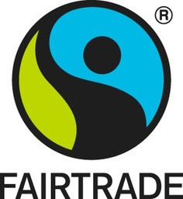
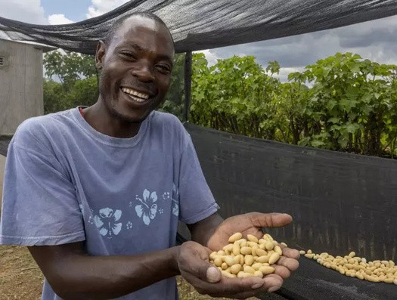
Pray with us:
Dear God, thank you for your gift of the world you created. We thank you for flowers and trees; for animals, for birds and sea creatures; We thank you for sunshine and rain.
We thank you for farmers, workers of the land, wholesalers and for retailers.
God of the harvest, of peace and of hope, we lift before you the struggles of the earth. Give us wisdom to care for your world, courage to seek justice, and have thankful hearts. Amen.

Photo: Ke nyman

