NEWSLETTER SUMMER EDITION ’26

MOVING STORIES
WORLD JUSTICE PROGRAMME
UNITED REFORMED CHURCH

Picture All We Can

Picture All We Can
Feature Story - Israel and Palestine Team Spotlight

Helping Children to overcome difficulties - Omar’s Story
‘DO IT FAIR’ FAIR ON THE PLANET FAIRTRADE FORTNIGHT

The United Reformed Church joined up with All We Can from the Methodist Church to support Palestine and Lebanon. The Jerusalem Princess Basma Centre (JPBC) is one of the appeal’s humanitarian partners, providing rehabilitation services to children with disabilities and their families in Gaza.

Omar was born prematurely in June 2023.
He was diagnosed with epilepsy, and impaired vision. He could neither stand nor stabilise his body. He suffered thyroid issues and severe malnutrition. Due to the ongoing war, his
family could not access medication .Through JPBC, Omar has been able to receive therapy. and take his first steps. He will soon begin speech therapy.

Thank you for supporting children like Omar.
21 September - 4 October
This year’s campaign focuses on fair pay, supporting producers and tackling climate impacts for farmers worldwide.
You can download event ideas via the Fairtrade Foundation web site. https://www.fairtrade.net/uk-en.html


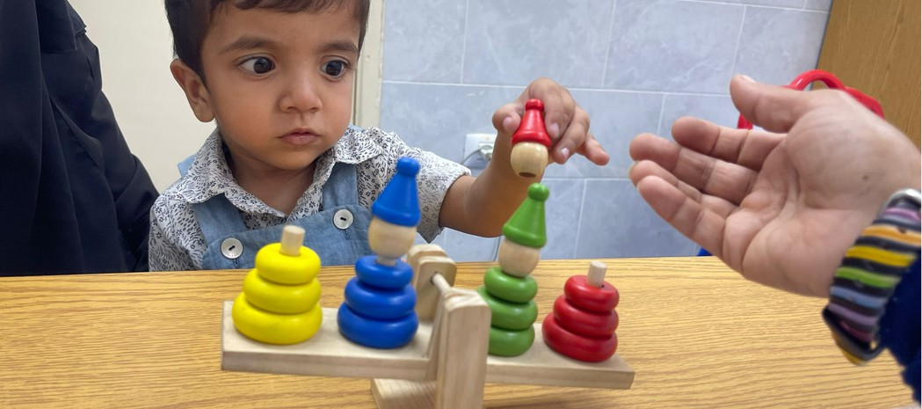



Pray with us: Dear God, thank you for your gift of the world you created.
We thank you for flowers and trees; for animals, for birds and
sea creatures; We thank you for sunshine and rain.
We thank you for farmers, workers of the land, wholesalers and for retailers.
God of the harvest, of peace and of hope, we lift before you the struggles of the earth. Give us wisdom to care for your world, courage to seek justice, and have thankful hearts.Amen.

Photo: nyman
Pray with us: Dear God, thank you for your gift of the world you created.
We thank you for flowers and trees; for animals, for birds and
sea creatures; We thank you for sunshine and rain.
We thank you for farmers, workers of the land, wholesalers and for retailers.
God of the harvest, of peace and of hope, we lift before you the struggles of the earth. Give us wisdom to care for your world, courage to seek justice, and have thankful hearts.Amen.

