NEWSLETTER AUTUMN EDITION ’26

MOVING STORIES
WORLD JUSTICE PROGRAMME
UNITED REFORMED CHURCH

Picture Christian Aid

Feature Story - Bangladesh the Story of Hira Moni Khatun Team Spotlight

Across the globe, women are stepping into roles once considered off-limits. They lead farms, build cooperatives and create businesses in spaces where their presence was not always welcomed.
Early marriage and limited access to education means that many women never get the chance to earn an income.
Hira Moni Khatun - from a remote region in Bangladesh - is breaking through social constraints.
Hira has learned to produce and sell cloth. Along with a group of women they have expanded the business through the use of smartphones. Training in e-commerce has opened new
horizons, allowing them to reach customers beyond her village.
Her confidence has grown, bringing inspiration to other women.
Thank you for your ongoing support to Commitment for Life.

‘Do it Fair’

Fair on the Planet
FAIRTRADE FORTNIGHT

21 September to 4 October
This year’s campaign focuses on fair pay, supporting producers and tackling climate impacts for farmers worldwide. You can download event ideas via the Fairtrade Foundation web site. https://www.fairtrade.net/uk-en.html


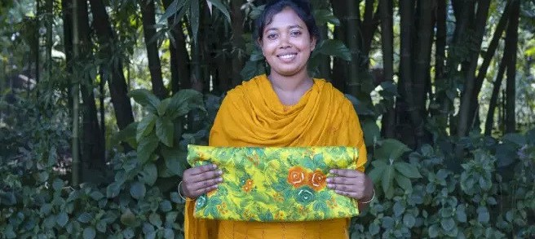
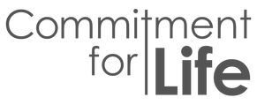


Pray with us:
Dear God, thank you for your gift of the world you created.
We thank you for flowers and trees; for animals, for birds and sea creatures; We thank you for sunshine and rain.
We thank you for farmers, workers of the land, wholesalers and for retailers.
God of the harvest, of peace and of hope, we lift before you the struggles of the earth. Give us wisdom to care for your world, courage to seek justice, and have thankful hearts.Amen.

Pho n Snyman

