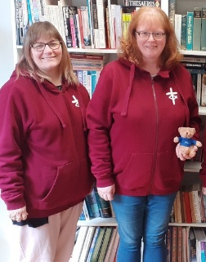
Dear Friends,
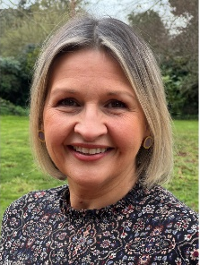
Welcome to July’s bi-monthly. This edition is crammed full of events and opportunities – not to be missed.
We welcome Dr Jo Griffiths who will head Children’s, Youth and Intergenerational Discipleship as of 1 July . Jo brings with her a wealth of experience, skills and passion. We look forward to what the future holds. You can find out more about Jo here: https://urc.org.uk/new-head-of-children-youth-and-intergenerational-discipleship-appointed/

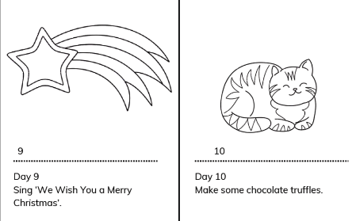
Although it is only July the bookshop will soon be taking orders for the Advent resource. This year’s resource will comprise of an Advent calandar which gets added to each day and which has suggested daily activities and an accompaning story booklet.
Please do keep an eye on emails, the website and social media for updates on how to order.

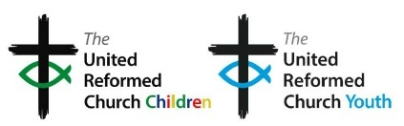

Blessings,
Sharon Lloyd, Programme Officer (Children’s, Youth and Intergenerational Discipleship)

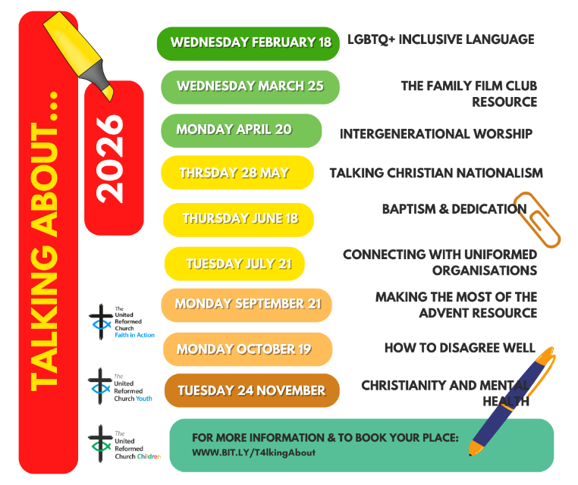

Did you know that most of the talking about sessions can be found on our YouTube channel: https://bit.ly/YTplaylistURC


LUNDIE MEMORIAL AWARD CELEBRATING CHILDREN AND YOUTH PEOPLE

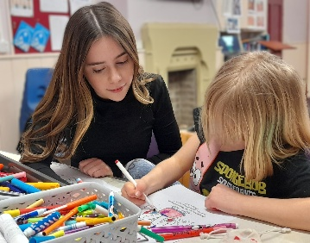
16-year-old Olivia Stokes-Roberts, who was April’s Lundie awardee, was nominated due to her willingness to read in church, participate in the planning for services and a holiday club and recently gained her Master Mariners Award making her a member of the Pilots
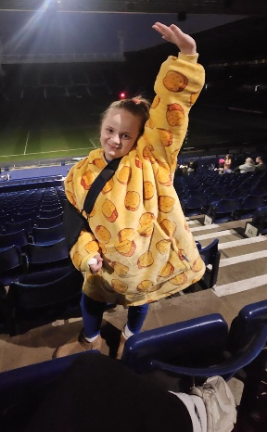
leadership team. Hornsea URC very much value her insights and discussions on the dynamics of the group. plans for an alternative style of worship. Let’s congratulate Olivia for gaining the Lundie Award and pray that she continues to grow in discipleship in the Kingdom of God.

Nine-year-old Alice Coleyshaw was awarded the Lundie certificate in May. Alice participated in a sleepover raising money for a charity supporting the homeless. She also dedicates her time to the tech at church, helping to clear away refreshments after the service and even stepped in as a shepherd for last year’s junior church and youth fellowship service. Alice is an asset to Broadway URC.
Perhaps there is someone in your church who is 25 years or younger who you would like to nominate for this award? Details can be found here: https://urc.org.uk/your-church/family-friendly-church/lundie-memorial-awards/
The Children and Youth Devlopment Officers and equivelant are exploring the URC membership model to understand how well it serves children and young people today. Your feedback will help us assess whether the current approach is fit for purpose and identify opportunities to better support belonging, participation, and discipleship for younger generations. Please share your thoughts, experience and understanding of the current URC membership model in this short survey. There are two separate surveys, one for young people and one for other.
This is the link for young people:
https://forms.gle/z6Qc4mswcyYaA8Jb9
This is the link for other:
https://forms.gle/TuYRSdPgKC3zRUKo8


Children and Youth Programme Enabling Group CYPEG
(formerly Children and Youth Work Committee) are seeking
a convenor to hold and oversee the four yearly meetings
and one 24-hour session as well as a children’s advocate to
represent the voices of children. – get in touch if this is you.

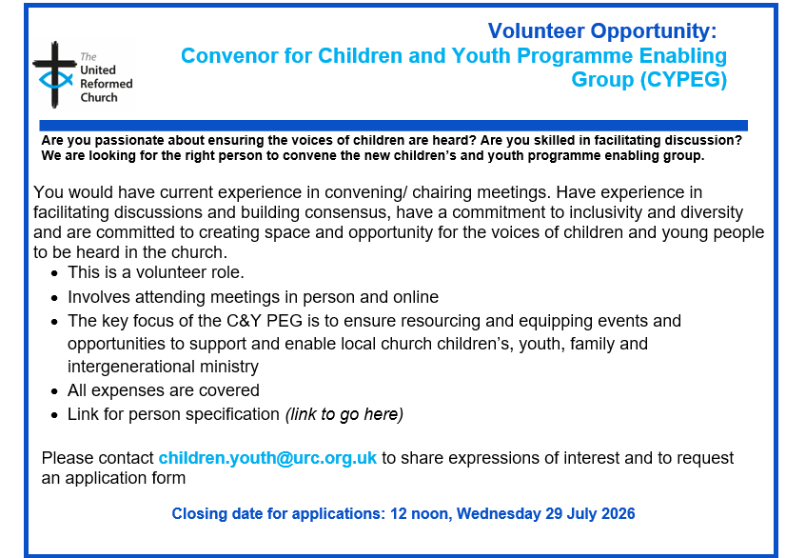

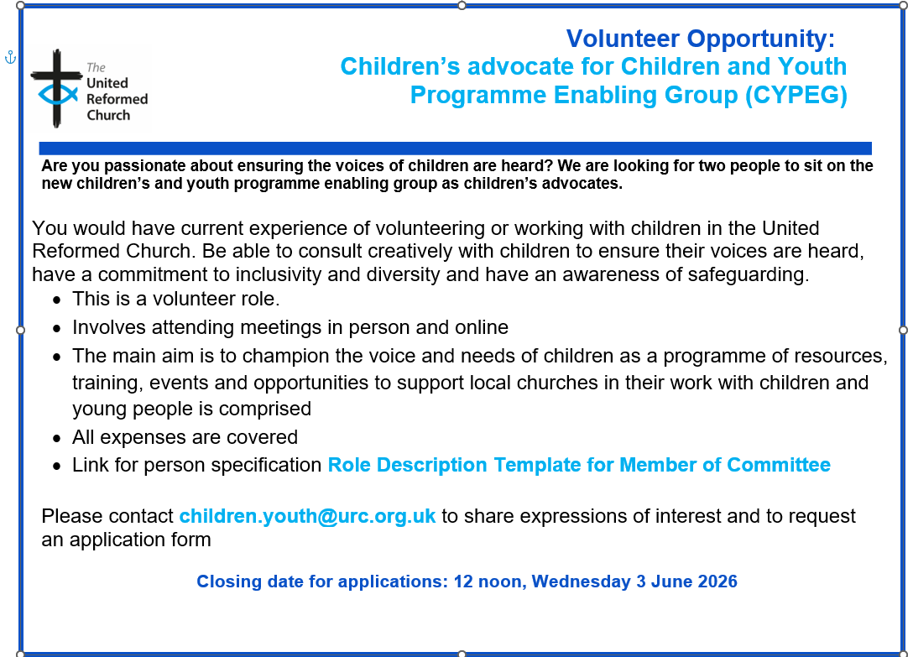

We are delighted with the positive response to the URC Conversation Starter Coasters initiative. We have distributed 78,000 coasters so far! If you would like more, please contact us.
We would like to collect some stories and evidence of how they have been used by local churches and in other ways to help us evaluate the initiative. Please can you send a short report and if possible, any photos with permission to share them through URC Communications to children.youth@urc.org.uk by the end of July 2026.

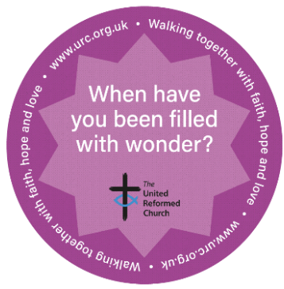
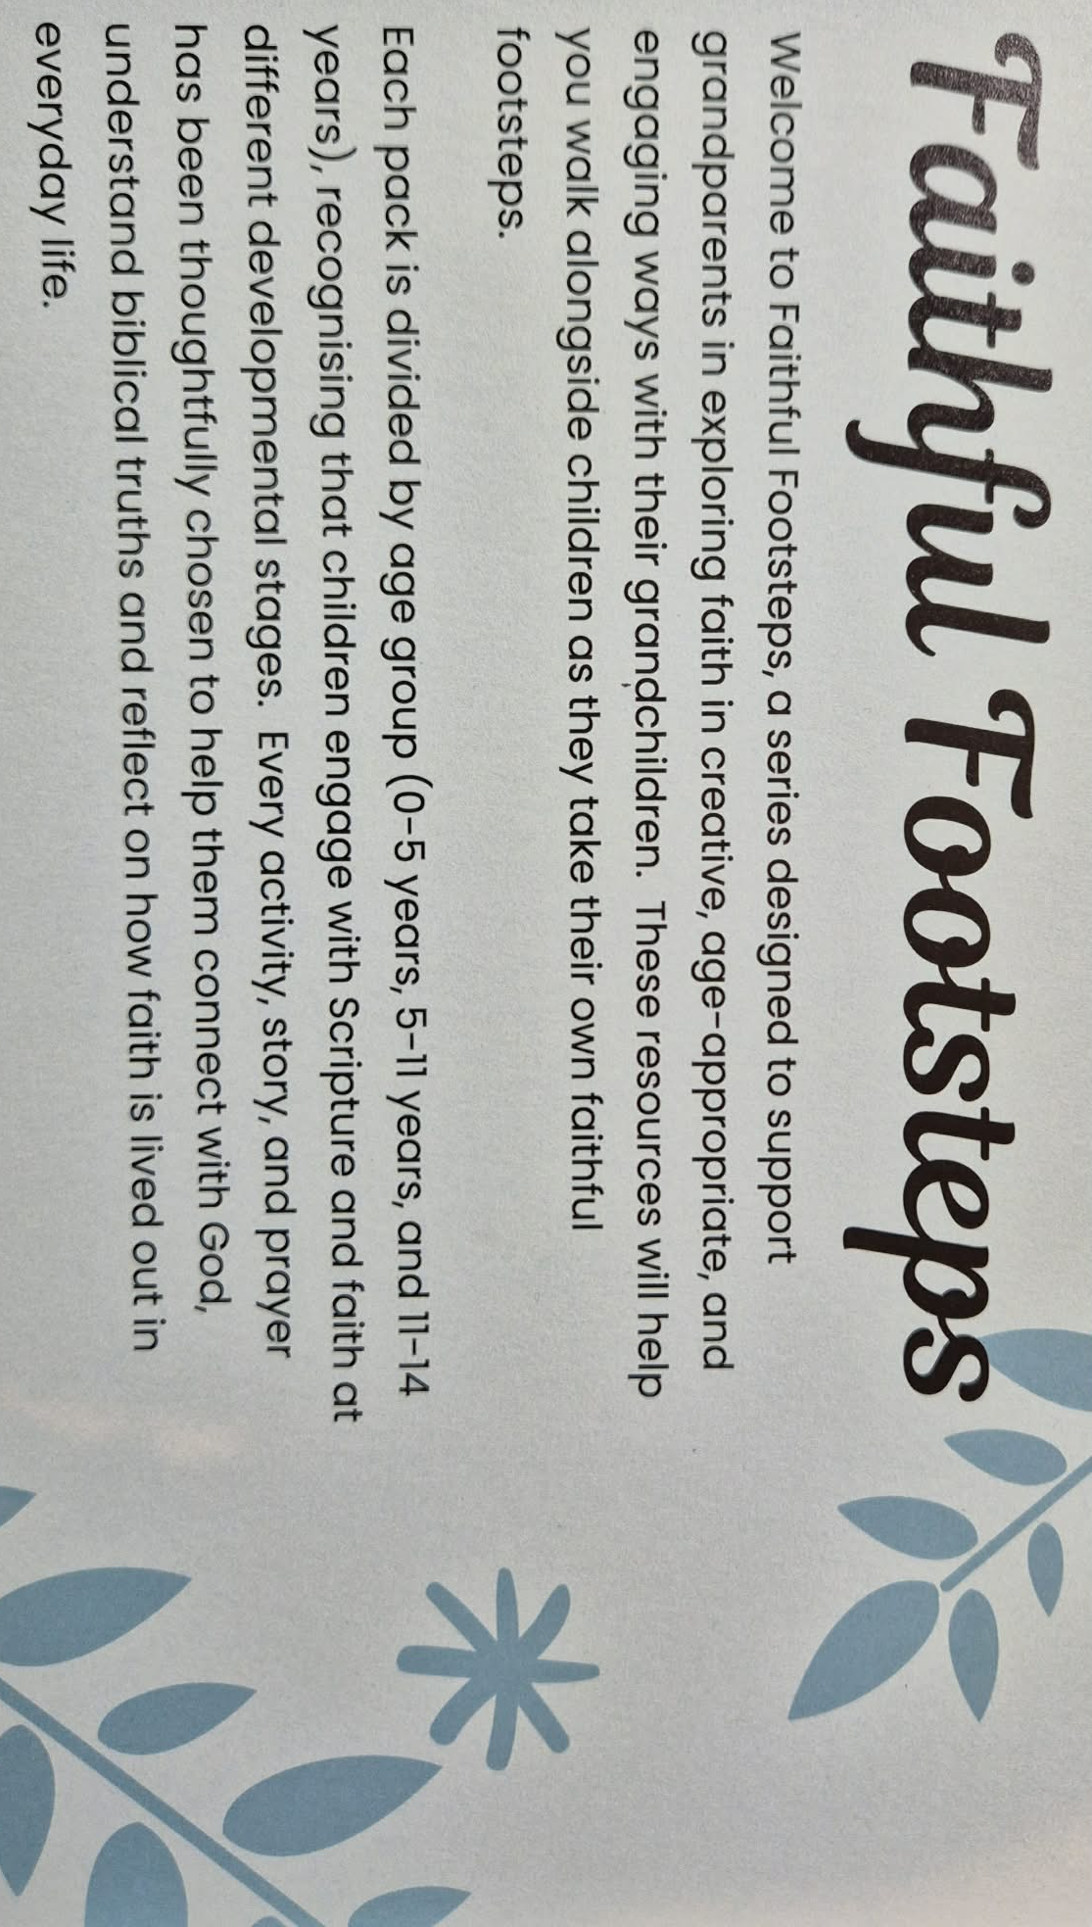
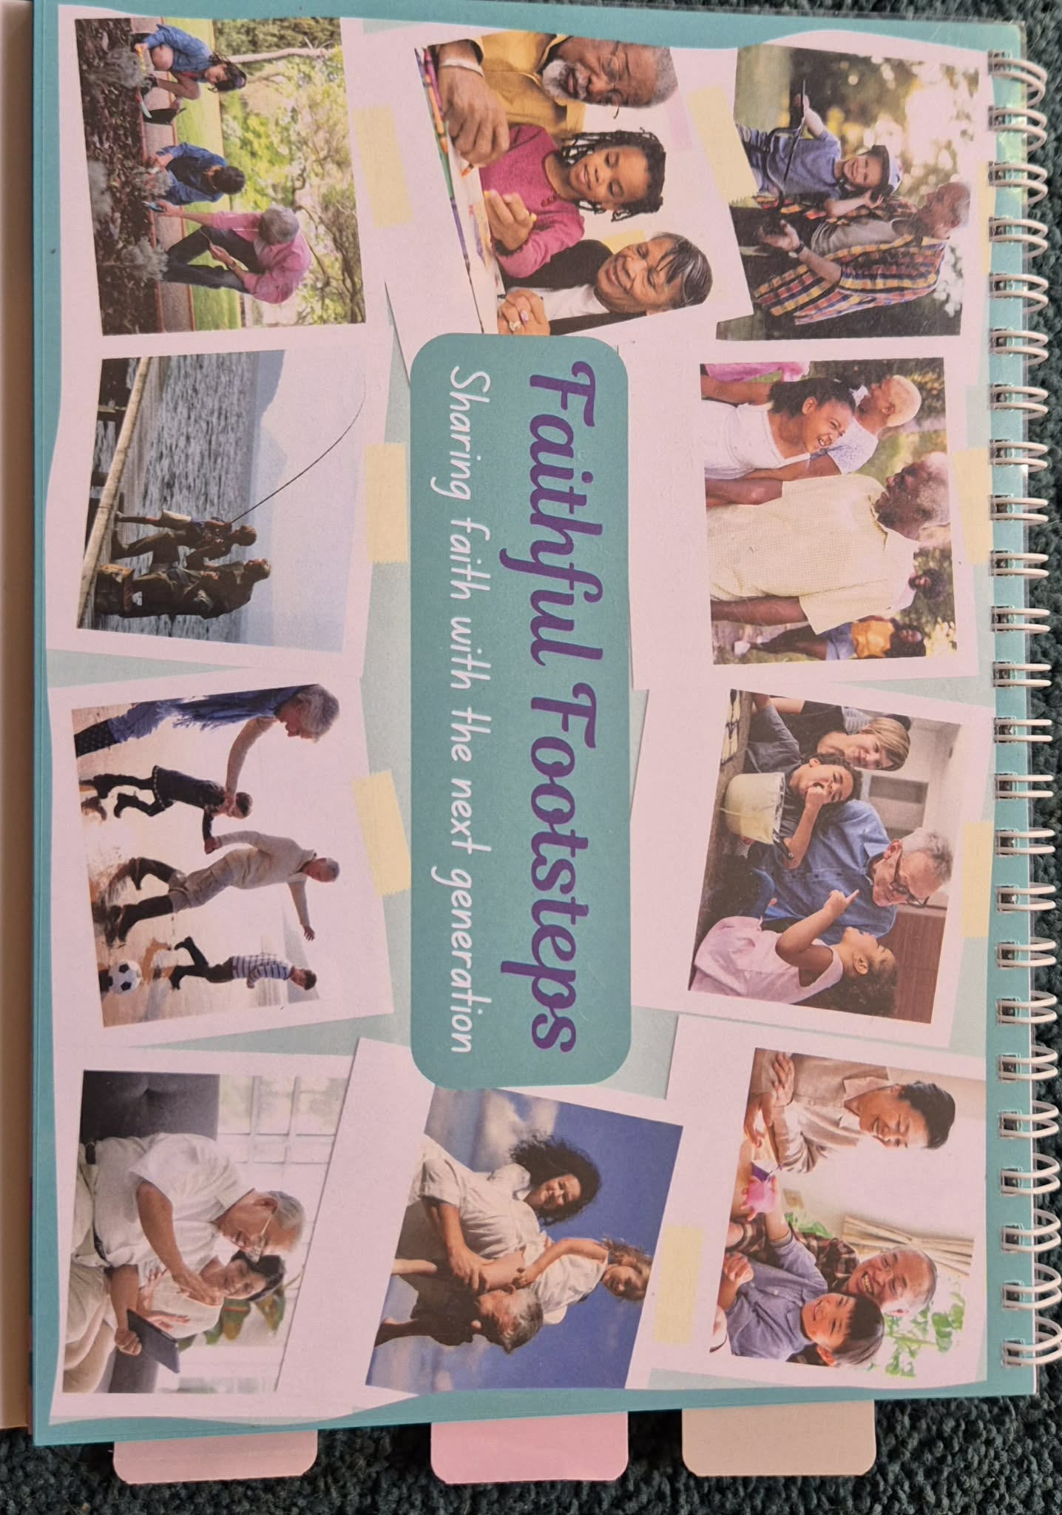
Connected Christian Grandparents conference in the UK...Saturday 3rd October...The day will encourage, equip and inspire all who come - grandparents, grandparent figures or churches who want to learn more about how to better support grandparents in their churches. Special price if you book by 1 September. at Venture Conferencing (formerly MKCC), Milton Keynes, MK6 2TG.
A new resource compiled by several of the CYDO+ team. This can soon be found on the website as a digital download. If you would like a physical copy then get in touch with either your synod, or CYDO+ or Sharon.lloyd@urc.org.uk

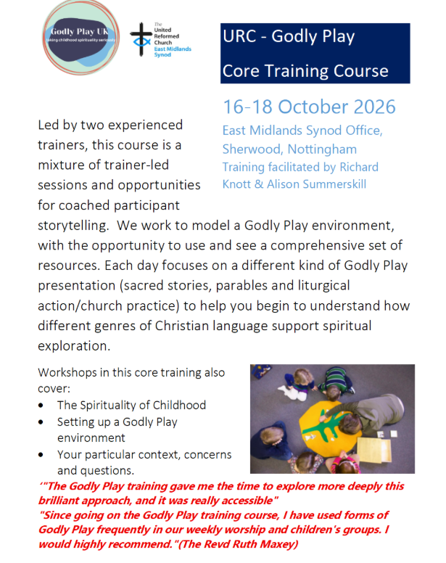

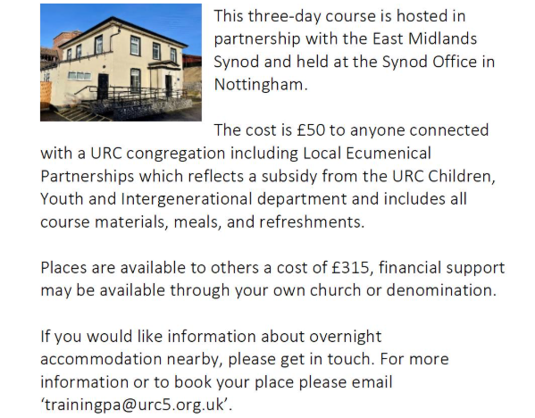
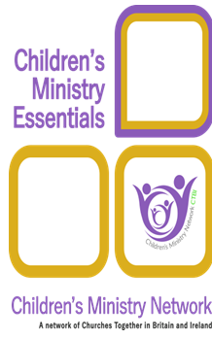
NEW FREE CHILDREN’S MINISTRY TRAINING
Saturday mornings 10am – 12noon - 11 September and 3 October 2026.
Children’s Ministry Essentials is designed for anyone working with children in local churches and consists of 10 modules covering a wealth of topics including child development and spirituality, pastoral care, leadership and teamwork and the role of play. It is designed to deepen your understanding, increase your confidence and develop your skills.
Please watch the video trailer! https://youtu.be/lHGCz8QakFA
Join an online learning group facilitated by our wonderful CYDO+ team. If you are engaging in ministry with children, families or intergenerationally within a URC church or Local Ecumenical Partnership, we are offering free places (normally £80-£100 person). Contact chidren.youth@urc.org.uk to register your interest and for more details.
LOOKING AHEAD - for your diaries or your prayers
21 June 2026 Talking About…..connecting with uniformed organisations
11 September 2026 Ministry Essentials
3 October 2026 Ministry Essentials
1 October 2026 Connected Grandparents conference
16-18 October Godly Play training

Next Bi-Monthly Update: September 2026

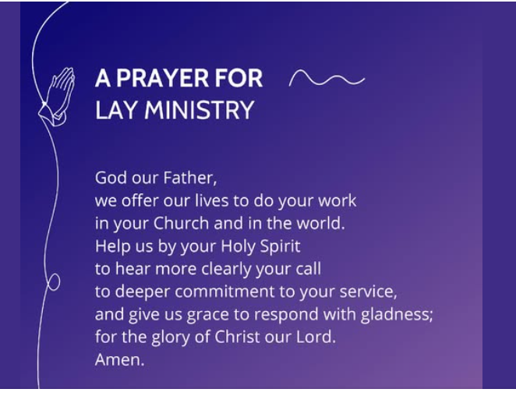
Sourced from The Church of England.

