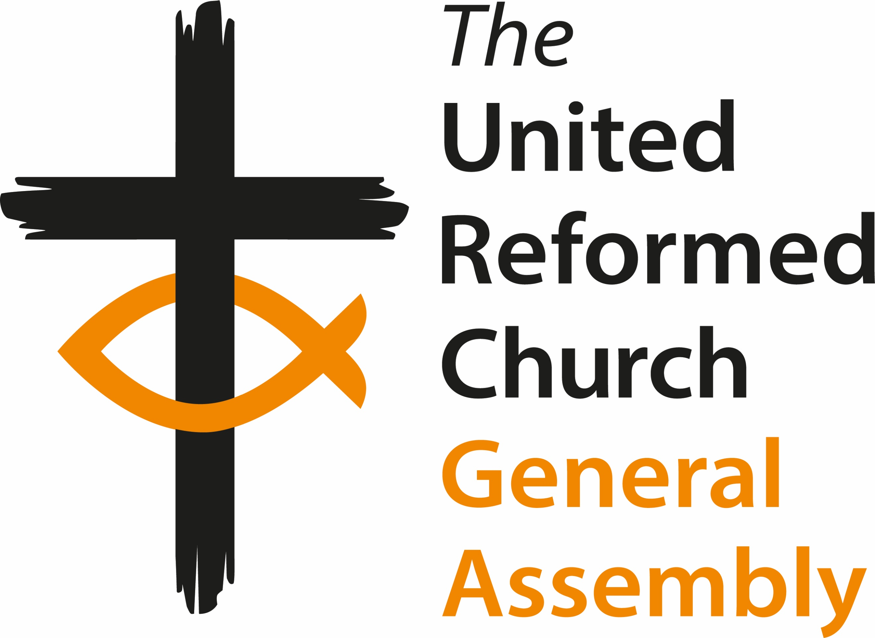
General Assembly
Friday 3 July to Monday 6 July 2026
Agenda

Friday 3 July

12:00 Arrivals and registration
13:00 - 14:00 Lunch
14:00 Welcome and Constitution of Assembly
Opening Worship (including Holy Communion)
Session one
15:15 Introductions and Greeting of Ecumenical Guests
Mock Resolution
Administration
En bloc:
(Extra) Ordinary Hope – Synod Moderator’s Report
Senior Leadership Team Report
A1 – Business Committee Report
AD1- Business/Resources - Church Life Fund Progress Update
B1 – Faith in Action Committee Report
B4 – Faith in Action - Future of Greenbelt
B5 – Faith in Action – Net-Zero Task Group Report
B6 – Faith in Action - Net-Zero Terms of Reference
C4 – Ministries - Active Ministers Policy
C5 – Ministries - Inactive Ministers Policy
C6 – Ministries - Review of Ministers Retirement Age
C7 – Ministries - Process for ill-health early retirement
C8 – Ministries - Competencies and Expected Standards
C9 – Ministries - Reasonable Adjustments
C10 – Ministries - Sickness and Ill-health
C11 – Ministries - Accreditations Sub-Committee Terms of Reference
CD1 – Ministries/Resources - Ministry & Mission Review Task Group update
CH1 – Ministries/ Pastoral Reference and Welfare - Creation of a Ministries Support & Wellbeing Sub-committee
G1 – Nominations Committee Report
H1 – Pastoral References and Welfare Committee Report
I1 – Safeguarding Committee Report
J1 – Worship Faith and Order Committee Report
J4 – Worship Faith and Order - Assisted Dying
J5 – Worship Faith and Order – Permission to Co-opt members
P1 – Wessex Synod - New Synod Name

Nominations - Individual Appointments:
Greeting on Reappointment to the Role

16:00 Break (access to bedrooms)
16:30 Keynote: Dr Krish Kandiah - “The Surprising Power of Hospitality - how to respond to the rise of Christian Nationalism with grace and truth"
17:30 B3 – Faith in Action - Inter Faith
B2 – Faith in Action - Five Marks of Faith in Action
P6 – Mersey Synod - Evangelism
18:30 Dinner
Session two
19:30 Presentation and Group discussions on B7 – Faith in Action - Legacies of Slavery

21:00 Evening prayer

Saturday 4 July

7:45 - 9:00 Breakfast
8:30 A Time of Prayer for General Assembly hosted by GEAR (Chapel)
9:00 Worship & Bible Study Introduction with Revd Dr Peter Green
Session three
09:45 A3 – Business Committee - EM1 Resource Centers for Learning Review
10:45 Break
Session four
11.15 A2 – Business Committee - Fitness to Practice Process –
Presentation by guest speaker Ed Morgan
12.30 Community Awards
13.00 - 14.00 Lunch
Session five
14:00 Presentation of candidates for General Assembly Moderator
for 2027-2028 and vote
C1 – Ministries Committee Report
C2 – Ministries - Sustainability of Stipendiary Ministers in the URC
C3 – Ministries - Three-year review and Strategic Framework for Ministry
P3 – Thames North - The URC’s treatment of ministers arrested for theologically motivated peaceful civil disobedience
Papers removed from En Bloc:
I2 – Safeguarding – Synod Safeguarding Reviews
16:00 Break
Session six
16:30 B7 – Faith in Action - Legacies of Slavery
K1 – URC Youth - Gendered language in the Basis of Union
K2 – URC Youth - The Future Identity, Purpose, and Development of URC Youth
K3 – URC Youth - Welcome Directory
P2 – Wessex Synod - Keeping Trans people safe
Q1 – GA Members - Response to the impact of single-sex court rulings on transgender people and their communities
18:30 Dinner

Session seven
19:30 Parallel Sessions:
- Faith in Action, Nominations, Equality, Diversity, Inclusion & Belonging
- Ministries, Worship Faith and Order, and Safeguarding
- Resources and Church Life Fund
21:00 Evening prayer

Sunday 5 July

7:45-9:00 Breakfast
8:30 A Time of Prayer for General Assembly hosted by GEAR (Chapel)

9:00 Prayer – with Bible Study by Revd Dr Peter Green
Session eight
9:30 Nominations Committee Update
Remaindered Business

10:00 Break
10:30 Worship Service
Session nine
11.45 AB1 – Business/Faith in Action Committees - URC/Methodist Liaison
P5 – West Midlands Synod - Clarifying "pastoral necessity" for lay presidency at the Sacraments
13:00-14:00 Lunch

Session ten
14:00 A3 – Business - EM1 Resources Centers for Learning Review (continued)
Items removed from En bloc:
D1 – Resources Committee Report
D2 - Resources - Investment Committee becoming a Sub-committee of Resources Committee
15:30 Break
16:00 Memorial for Deceased Ministers and CRCWs
Giving Thanks for the Life of Churches that have Closed

Moderator’s Address

Celebrating Jubilee Ministers
Greeting ministers and CRCWs newly received onto the roll

18:30 Dinner

Session eleven
20:00 (Extra) Ordinary Hope – Presentation and Discussion
Items removed from En bloc:
J2 – Worship Faith and Order – Celebration of Creationtide
J3 – Worship Faith and Order - “Nature Faith and Order” - third version
Remaindered business
21:00 Evening prayer

Monday 6 July

7:45-9:00 Breakfast (check out of rooms by 9:00)
8:30 A Time of Prayer for General Assembly hosted by GEAR (Chapel)

9:15 Prayer and Bible Study with Revd Jane Wade

Session twelve
9:45 Moderator Elect 2026-2027 Acceptance Speech
Remaindered business
Miscellaneous Items
Address to the throne
10:45 Break
11:15 Closing Worship - Including the Induction of The Reverend Neil Thorogood as Moderator

13:00-14:00 Lunch and departures

