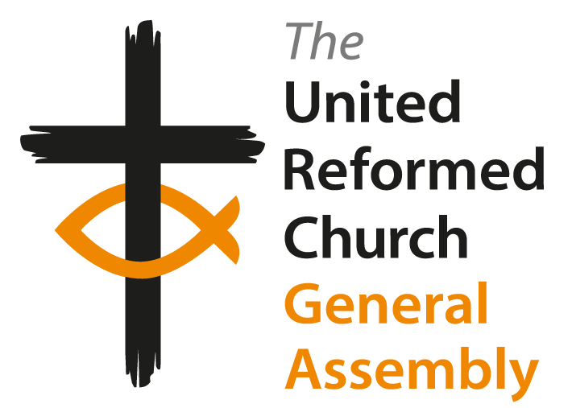
United Reformed Church
General Assembly 2026

Order Paper

Friday 3rd July 2026

Please retain each Order Paper as the material may be relevant on any day of the Assembly

En-bloc business

Papers D1, D2, I2, J2, J3 and J3-1 reached the threshold specified in Standing Orders to be removed from en-bloc business. These will be dealt with in the main agenda of the meeting.

Facilitation Group

Many thanks to those who have agreed to serve as members of Facilitation Groups in accordance with Standing Order 7.7.

Resolution 100

General Assembly appoints

Karen Bell, Tim Crossley, Murray George, Michael Hopkins, Anne Lewitt, Richard Lewney, Zaidie Orr, Lindsey Sanderson, Anne Sardeson, John McNeil Scott, Reuben Watt, and Maya Withall to serve as members of the Facilitation Group for its meeting between 3-6 July 2026 in accordance with Standing Order 7.7.
Proposed by the Business Committee

Election of Moderator of General Assembly 2027-2028

The biography of the candidate is available. Ballot papers will be distributed at the start of the session. This session is not life-streamed.

Resolution 101

General Assembly appoints the Revds Wayne Hawkins and Sally Thomas to serve as tellers for the 2027-2028 election of the Moderator of the General Assembly.
Proposed by the Business Committee

Convenor of Tellers

Resolution 102

General Assembly appoints Morag McLintock to serve as Convenor of Tellers for its meeting 3-6 July 2026.
Proposed by the Business Committee

Minutes of the meeting

Minutes of each session will be available on the website soon after each session has concluded. Please in the first instance give any corrections to the minutes to the minute takers before the published deadline. Minutes will then be checked by the Clerks and presented for adoption at the next convenient opportunity within the business sessions.

Minutes for the sessions taking place on Monday morning will be available on the website, please send any corrections to the minute takers by email andy.braunston@urc.org.uk by 5pm on Wednesday 8th July 2026. It is our usual custom and practice that the minutes of the sessions taking place on the last day of the meeting are adopted by the Officers.

The Officers of the General Assembly are: the General Secretary, Moderator, Clerk, Treasurer and Convenor of the Business Committee.

Resolution 103

General Assembly authorises the Officers of the Assembly to formally agree all unadopted minutes following the close of this meeting.

Appointment of Moderator of Southern Synod

Resolution 104

General Assembly appoints the Revd Paul Robinson to serve as Moderator of the Southern Synod from 1st October 2026 until 30th September 2033.

Mock Resolution

This is a training exercise conducted during the first business session with the aim of enabling members of General Assembly to familiarise themselves with the practicalities of how business is conducted. In a change to previous years this item is scripted with members of General Assembly invited to play themselves where votes are taken. Thanks to representatives from Eastern Synod for assisting with this item.

Parallel Sessions

Parallel sessions will take place as follows during session 7 on Saturday evening. Parallel sessions enable those committees not otherwise presenting business and who have done work that is not otherwise reflected in resolutions to report on their work. Decisions are not taken in parallel sessions.

Parallel session A | Faith in Action and Nominations |  | Chapel | David Grosch Miller
Parallel session B | Ministries, Worship, Faith and Order, and Safeguarding |  | Derbyshire Hall | Kirsty Thorpe
Parallel session C | Resources and Church Life Fund |  | Derbyshire 3 | Nigel Uden

Paper B3 Interfaith Report

The compilers of this report wish to draw the attention of members of General Assembly to the Interfaith Toolkit referred to in the paper. This can be found at https://urc.org.uk/who-we-are/what-we-do/inter-faith/

Paper B6 Net Zero Task Group Terms of Reference

(Page 146) First bullet point should read ‘one member of the Resources Committee’, not ‘one member of the Finance Committee’
(Page 147) First bullet point should read ‘one member of the Finance Committee (functions now subsumed into Resources Committee)’

Paper B7 Legacies of Slavery - Affirming the Will & Finding the Way(s)

Resolution 15

The Faith in Action wish to make the following addition to this resolution.

General Assembly delegates the authority to determine specific funding allocations for each project to the Faith in Action and Business Committees, to be advised by the Legacies of Slavery Task Group, bringing updates to General Assembly via the usual reporting processes.

Paper C1 Ministries Committee report correction

On page 171 of the Book of Reports Claire Nutt’s name should not be under Assembly Accredited Lay Preachers as she was re-accredited in 2022.

Paper D1 Resources Committee

Resolution 27

Resources Committee wish to withdraw this resolution as it is out of order. Many years ago, the Assembly agreed to receive all reports unless it actively voted not to. Also Standing Order 4.6.6 prohibits resolutions simply affirming existing work.

Paper K1

Please amend references to ‘Faith and Order Committee’ to ‘Worship, Faith and Order Committee’.

Paper P2 Keeping Trans People Safe

The resolutions were always intended to be one resolution. Please delete resolutions 54 and 55, and substitute an amended Resolution 53:

Resolution 53

General Assembly notes that, as affirmed in the statement agreed at General Assembly 2023, transgender, non-binary, and gender nonconforming people in the UK find that they are living in an increasingly hostile environment, which means that it is even more important that the church welcomes them, and has appropriate safeguarding measures in place. General Assembly further notes that St Columba's URC Oxford has therefore agreed that it is important to affirm its commitment to the 2023 resolution, and to publicise this on their church website. General Assembly invites other local churches to make similar affirmations, and to indicate their support to the Offices of the General Assembly as part of the Annual Return for publication on the URC website within the “Find a church” tool.

Paper P3 The URC’s treatment of ministers arrested for theologically motivated peaceful civil disobedience

This paper was not ready in time to be included in the Book of Reports. Please check the General Assembly website for this paper. A small number of paper copies have been provided for those needing these.

Paper P4 Recognition of Mission Projects in Thames North Synod

Thames North Synod request that this paper and its accompanying resolutions (56, 57, 58, 59) be withdrawn to enable the Faith in Action and Ministries committees to do more work about all aspects of Mission Projects.

Late Paper - Paper Q1 Response to the impact of single-sex court rulings on transgender people and their communities

This is available on the website. A small number of paper copies have been provided for those needing these.

Photography Notice – United Reformed Church General Assembly

We have designated Assembly photographers and videographers who will be taking photographs throughout this General Assembly for use in church communications—including articles, news items, social media, and YouTube clips—solely for non-commercial, and church-related purposes. These photos may be used in the coming years.

If you prefer not to be included in any photographs used for these purposes, please fill out an opt-out form available at the Comms table or speak to a member of the communications team.

Your privacy is important to us, and we will respect your wishes.

Thank you for your cooperation.

