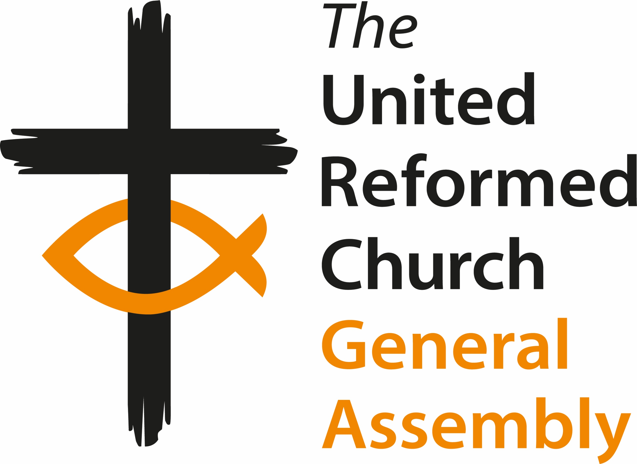
General Assembly
Friday 3 July to Monday 6 July 2026
Agenda - Outline

Friday 3 July
12:00 Arrivals and registration
13:00 - 14:00 Lunch
14:00 Welcome and Constitution of Assembly
Opening Worship (including Holy Communion)
Session one
15:15 Introductions and Greeting of Ecumenical Guests
Mock Resolution
Administration
En bloc
16:00 Break (access to bedrooms)
16:30 Keynote Speech
18:30 Dinner
Session two
19:30
21:00 Evening prayer

Saturday 4 July
7:45 - 9:00 Breakfast
8:30 Prayers with GEAR, The Chapel
9:00 Worship & Bible Study
Session three
09:45
10:45 Break
Session four
11:15
12:30 Community Awards
13:00 -14:00 Lunch

Session five
14:00 Presentation of candidates for General Assembly Moderator
for 2027-2028 and vote
16:00 Break

Session six
16:30
18:30 Dinner

Session seven
19:30 Parallel Sessions
21:00 Evening prayer

Sunday 5 July
7:45-9:00 Breakfast
8:30 Prayers with GEAR, The Chapel
9:00 Bible Study
Session eight
9:30
10:00 Break
10:30 Worship Service
Session nine
11:45
13:00-14:00 Lunch
Session ten
14:00
15:30 Break
16:00 Memorial for Deceased Ministers and CRCWs
Giving Thanks for the Life of URC Churches that have closed
Moderator’s Address
Celebrating Jubilee Ministers
Greeting ministers and CRCWs newly received onto the roll
Greeting new Churches and Mission Projects
18:30 Dinner

Session eleven
20:00
21:00 Evening prayer

Monday 6 July
7:45-9:00 Breakfast (please check out of rooms by 9:00)
8:30 Prayers with GEAR, The Chapel
9:15 Prayer and Bible Study
Session twelve
9:45 Moderator Elect 2026-2027 Acceptance Speech
Address to the Throne
10:45 Break
11:15 Closing Worship including the Induction of the Reverend Neil Thorogood as Moderator
13:00-14:00 Lunch and departures

