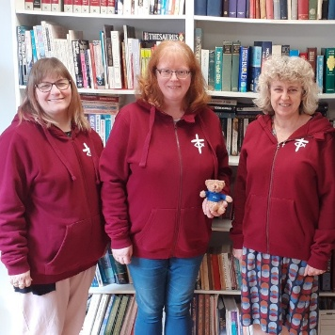
Dear Friends,
By now you will have received and had time to digest all that was included in the March mailing. Should you have missed anything then most things can be found on our website.
I wonder how often you explore the website www.urc.org.uk and the social media pages. Did you know for instance that we have a new area within Children’s and Youth website page focused on intergenerational resources. We have also moved our focus on the Facebook/Instagram page towards a more conversational and supportive space, https://www.facebook.com/groups/512896934320244/ with many of our events being shared on the main URC Facebook/Instagram page.
How ever you access information about the ministry happening within CY&I you can be assured that it is God centred and Biblically based.
In case you missed March’s update here is a message from Sam Richards the Head of Children’s, Youth and Intergenerational Discipleship.

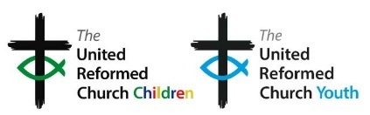
This is my final few weeks in post – but I can’t go without expressing my deep thanks for all the wonderful, life-giving, creative, relational work that goes on across the URC with children, young people and young adults – work that will bear fruit in this season and the next. So, it is not goodbye but rather farewell and adieu as I take my leave.
Blessings,
Sharon Lloyd, Programme Officer Children’s, Youth and Intergenerational Discipleship
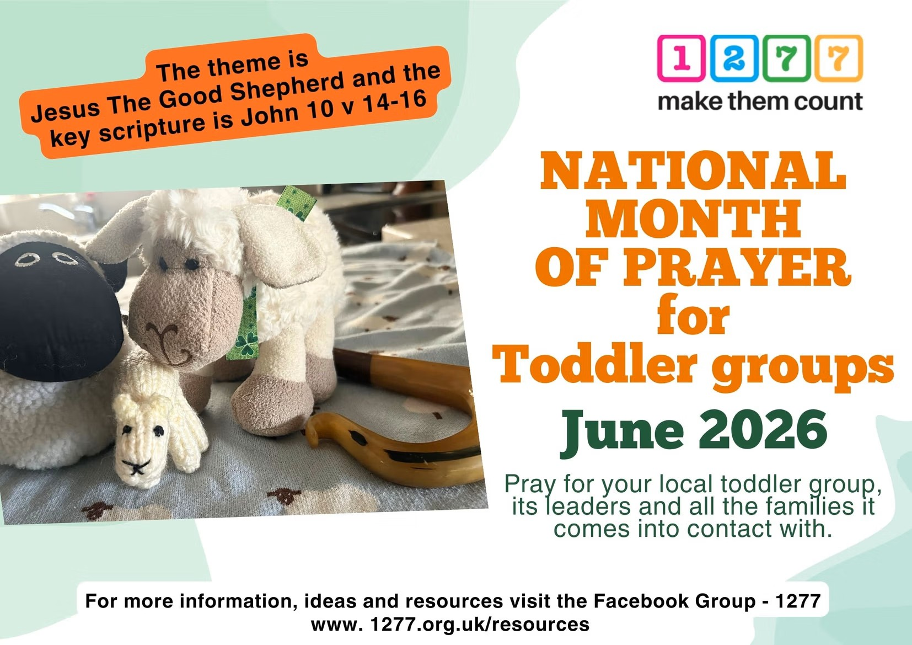
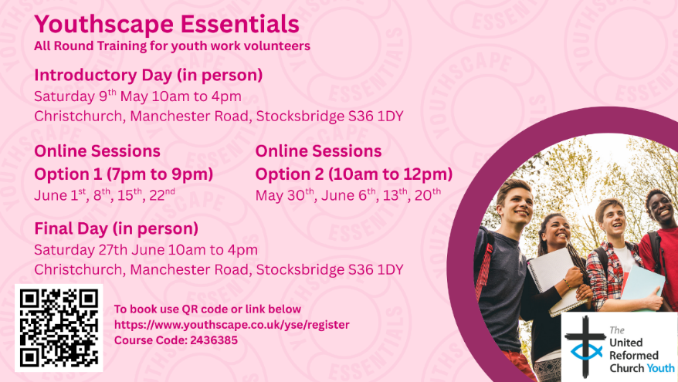

Join members of the CYDO+ team of the United Reformed Church for Youthscape Essentials — an engaging and practical training course for anyone involved in youth work or thinking about getting started. This course helps you grow in confidence, understanding and skill to support young people in your context.
Through the course you’ll explore insights into youth culture, develop core youth work skills, and reflect on your own leadership and faith — all rooted in Scripture and shaped by current research. The flexible format means some sessions will be in person (Saturday 9th May and Saturday 27th June in Stocksbridge) and others online, with options to choose evenings or mornings to suit your schedule. Whether you’re new to volunteering or want a refreshed foundation for your ministry, this course will equip you to work with young people more confidently and intentionally.
Click https://www.youthscape.co.uk/yse/register to book and use Course Code 2436385.

A new short training course for young people stepping into leadership roles in children and youth work. Plus guidance to other recent resources offering a mixture of discipleship and leadership training for young people which could be a natural next step: https://urc.org.uk/your-faith/children-young-people/urc-youth .

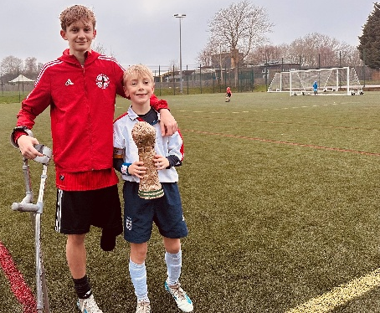

LUNDIE MEMORIAL AWARD CELEBRATING CHILDREN AND YOUTH PEOPLE
March’s Lundie Award was given to a very determined youngster. Eight-year-old Dexter, having been inspired by the story of Charlie, a young footballer who had lost his leg to cancer and desperately in need of some funds to allow him to play in the England men’s national amputee football team, has to date raised a staggering £1,500+ Dexters determination has given Charlies whole team hope and shows what a powerful impact one person’s actions can have.
https://donate.giveasyoulive.com/fundraising/dexters-fundraising-page
National Gathering: Theology Day 20 June 2026
11:00 AM to 5:30 PM

“But I say to you who are listening: Love your enemies; do good to those who hate you; bless those who curse you; pray for those who mistreat you."
What would it look like to take Jesus’s command to do good to those who hate us seriously? Where do we draw the line between loving our enemies, and protecting vulnerable people from harm; is it possible to do both? What seeds of goodness might grow in ground we've written off as barren?
Join SCM for our National Gathering Theology Day as we explore these questions and more on the theme of loving our neighbour in a time of rising violent far-right activity. This event is open to all SCM Members and those eligible for SCM Membership (current student or recent graduate), as well as members of Project Bonhoeffer.
For program and more info: https://www.movement.org.uk/civicrm/event/info?id=129&reset=1
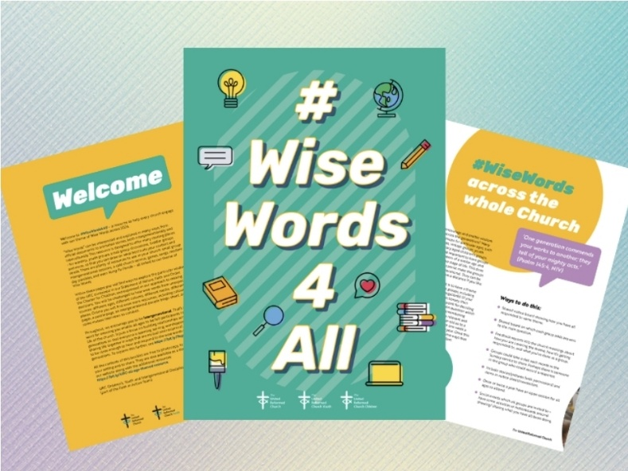
The Children, Youth and Intergenerational theme for 2026 is Wise Words. We take inspiration from this title when compiling our themed resource. #WiseWords4All has a strong intergenerational thread throughout. Full of film night sessions, Bible studies, small group sessions and so much more. Find it on our website under themed resources. If you should post anything on social media in relation to this theme please tag it with the hashing #WiseWords4All https://bit.ly/wisewordsTHEME

We are delighted with the positive response to the URC Conversation Starter Coasters initiative. We have distributed 78,000 coasters so far! If you would like more, please contact us.
We would like to collect some stories and evidence of how they have been used by local churches and in other ways to help us evaluate the initiative. Please can you send a short report and if possible, any photos with permission to share them through URC Communications to children.youth@urc.org.uk by the end of May 2026.
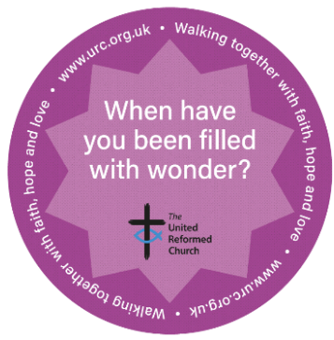

This project is an amazing opportunity for young willing adults and churches to both flourish and grow as well as the chance to explore fresh expressions of church.
A great project to experience living in a community.
Broadstone URC sees itself as a friendly, caring church that also seeks to serve the local community. They have many opportunities for you to help out!
Checkout the link to find out more about the mission house and how to apply!!!!
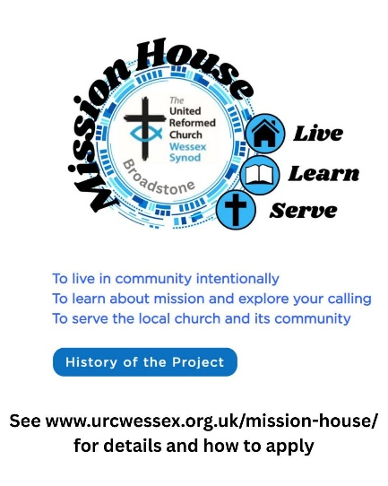
#urc #urcyouth #mission
NEW FREE CHILDREN’S MINISTRY TRAINING
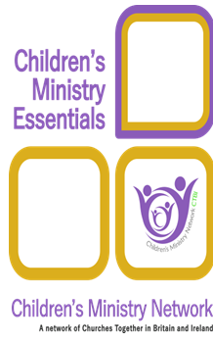
Saturday mornings 10am – 12noon - 9 May, 13 June, 11 September and 3 October 2026.
Children’s Ministry Essentials is designed for anyone working with children in local churches and consists of 10 modules covering a wealth of topics including child development and spirituality, pastoral care, leadership and teamwork and the role of play. It is designed to deepen your understanding, increase your confidence and develop your skills.
Please watch the video trailer! https://youtu.be/lHGCz8QakFA
Join an online learning group facilitated by our wonderful CYDO+ team. If you are engaging in ministry with children, families or intergenerationally within a URC church or Local Ecumenical Partnership, we are offering free places (normally £80-£100 person). Contact chidren.youth@urc.org.uk to register your interest and for more details.
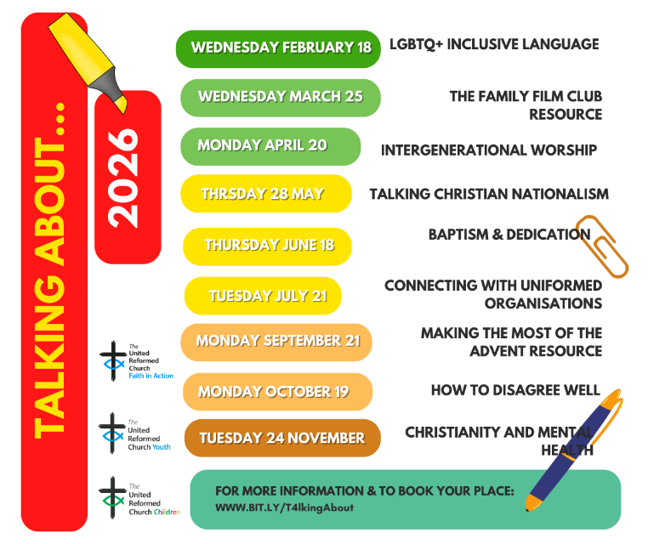

Did you know that most of the Talking About…..sessions are recorded and can be found on our YouTube page. https://bit.ly/YTplaylistURC

LOOKING AHEAD - for your diaries or your prayers
18 June 2026 Talking About…..Baptism and dedication
20 June 2026 National Theology Day
5 to 9 August 2026 Limitless Festival
Next Bi-Monthly Update: July 2026

