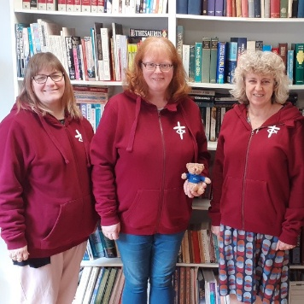
Dear Friends,
If you are a URC local church children’s and youth contact watch out for our mailing at the end of March full of Wise Words (our theme for 2026. It contains the intergenerational themed resource book, URC Youth Assembly 2026 Round-Up, posters for Easter and lots of information about training and opportunities to share with your church.
This is my final few weeks in post – but I can’t go without expressing my deep thanks for all the wonderful, life-giving, creative, relational work that goes on across the URC with children, young people and young adults – work that will bear fruit in this season and the next. So, it is not goodbye but rather farewell and adieu as I take my leave.
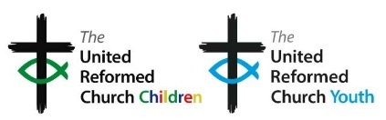

Blessings,

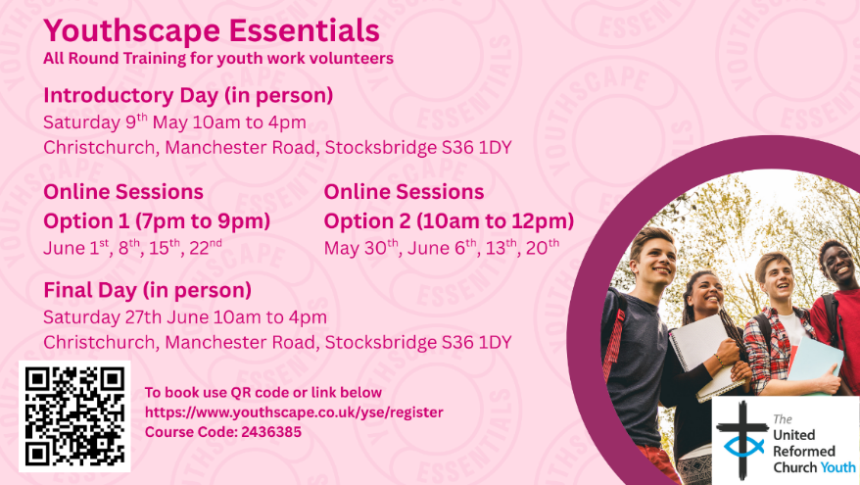
Sam Richards, Head of Children’s, Youth and Intergenerational Discipleship
Join members of the CYDO+ team of the United Reformed Church for Youthscape Essentials — an engaging and practical training course for anyone involved in youth work or thinking about getting started. This course helps you grow in confidence, understanding and skill to support young people in your context.
Through the course you’ll explore insights into youth culture, develop core youth work skills, and reflect on your own leadership and faith — all rooted in Scripture and shaped by current research. The flexible format means some sessions will be in person (Saturday 9th May and Saturday 27th June in Stocksbridge) and others online, with options to choose evenings or mornings to suit your schedule. Whether you’re new to volunteering or want a refreshed foundation for your ministry, this course will equip you to work with young people more confidently and intentionally.
Click https://www.youthscape.co.uk/yse/register to book and use Course Code 2436385.
A new short training course for young people stepping into leadership roles in children and youth work. Plus guidance to other recent resources offering a mixture of discipleship and leadership training for young people which could be a natural next step: https://urc.org.uk/your-faith/children-young-people/urc-youth .

UK Government Consultation “Growing Up in the Online World”

Share your views on how the internet, smartphones and social media are shaping the lives of children and young people. The consultation is exploring issues such as the impact of addictive features like autoplay and infinite scrolling, whether there should be stronger protections or age limits for social media use, and how parents, schools and communities can be better supported to help young people develop healthy online habits.
Please respond using the full consultation survey open to anyone, and encourage your church to use the parent and carer survey and youth survey for young people aged 10–21 before 26 May 2026
https://www.gov.uk/government/consultations/growing-up-in-the-online-world-a-national-consultation

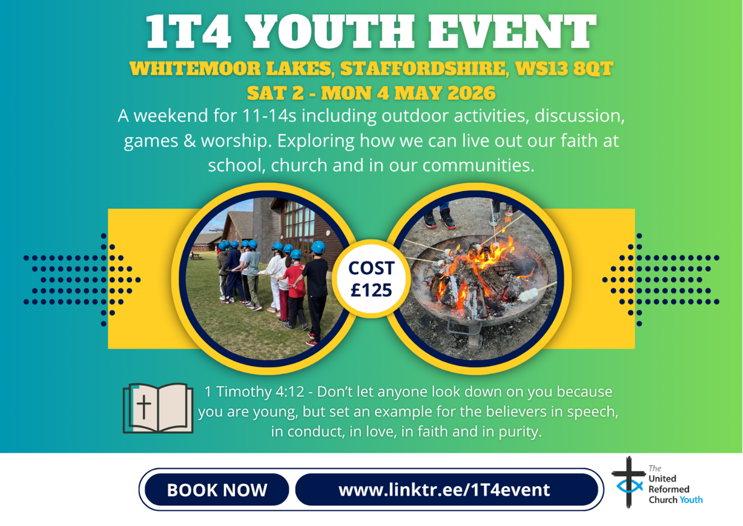
Leaders are welcome to accompany young people that they bring to 1T4
contact children.youth@urc.org.uk for information


Mental Health First Aid (MHFA England) Online Course 21/22/28/29 April 2026
This interactive online training will equip you with the knowledge, practical skills and confidence to recognise signs of poor mental health, approach supportive conversations and guide adults towards appropriate help. You will learn:

• An in-depth understanding of mental health and the factors that can affect wellbeing
• How to recognise warning signs of mental ill-health
• How to approach and support someone in crisis
• Confidence to start conversations and listen non-judgementally
• How to signpost to professional and self-help support
• Your official MHFA England Mental Health First Aider certificate

This course is ideal for anyone supporting adults in workplaces, community settings, churches, volunteer teams or pastoral roles.

The cost is normally £350 but we are subsidising it to £35 to cover the cost of materials.

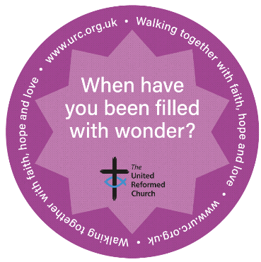
We are delighted with the positive response to the URC Conversation Starter Coasters initiative. We have distributed 78,000 coasters so far! If you would like more please contact us.
We would like to collect some stories and evidence of how they have been used by local churches and in other ways to help us evaluate the initiative. Please can you send a short report and if possible any photos with permission to share them through URC Communications to children.youth@urc.org.uk by the end of April 2026.

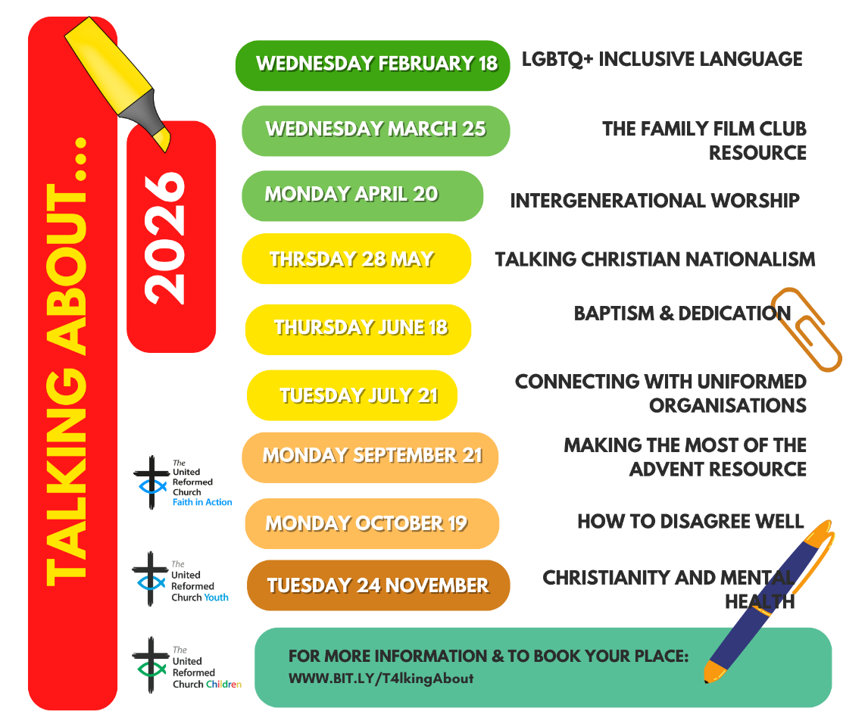
LUNDIE MEMORIAL AWARD CELEBRATING CHILDREN AND YOUTH PEOPLE


February’s Lundie Award was given to a very busy member of URC Youth. 21-year-old James Cole is involved in many areas of life within his Church, from playing the organ, to helping to organise and run social evenings, to facilitating a youth group and a Saturday shop and being part of the finance committee.
James is a shining example that no matter your age it is possible to be involved in of all parts of Church life. May we learn from that example and happily give our time to serve God.
LOOKING AHEAD - for your diaries or your prayers
19 Mar 2026 Children and intercultural church online conference
25 Mar 2026 Talking about……..The family film club resource
2 to 4 May 2026 1T4 youth weekend (for ages 11 to 14)
5 to 9 August 2026 Limitless festival
Next Bi-Monthly Update: May 2026

