NEWSLETTER SPRING EDITION ’26

MOVING STORIES
WORLD JUSTICE PROGRAMME
UNITED REFORMED CHURCH

Photo credit: Zubo Trust Instagram account

Feature Story - Supporting women entrepreneurs

Baskets in Binga
Team Spotlight

Jamaica hurricane appeal
We want to share the excellent news that



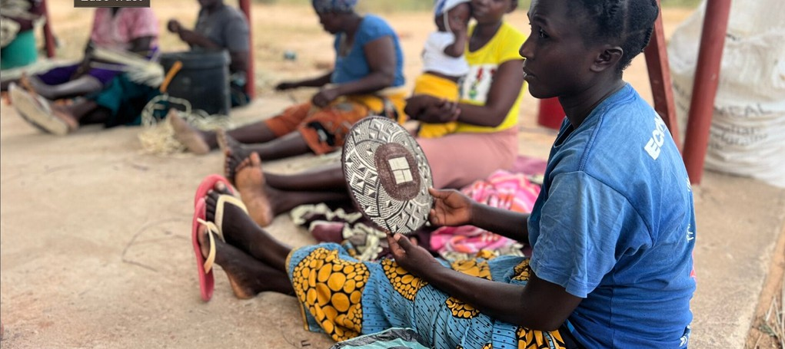




Our very good friends over at All We Can have been brilliant in their support of the Zubo Trust located in Zimbabwe since as far back as 2019.
The Zubo Trust operates in the Binga District of Matabeleland North. The amazing organisation promotes and supports the needs of rural women in the Zambezi Valley to realise their full socio-economic potential. They encourage women to make the most of naturally available resources.
He is risen indeed!
‘God of Easter: Jesus is risen from the dead; Hallelujah! Send love; send wisdom; send courage. May your will be done on earth as it is in Heaven, for the sake of your Son, Jesus Christ, our one, true Life. Amen.’

Photo: Christian Aid
This commitment to social enterprise also benefits children, men, and the wider local community. Pictured are women making and selling their beautifully designed and crafted Tonga palm baskets.
Commitment for Life and All We Can share a common, unshakable drive-in addressing poverty, especially in some of the most exploited regions in the world.

Pray as we work towards sharing best practice in our common work for justice.
the URC has collected over £30,000 to assist our partners CRAF to clean up after Hurricane Melissa. PLEASE NOTE: that we have attempted to thank each person / congregation individually, but at times we just could not work out who made the donation. Apologies if you’ve not been thanked personally, but please know we are grateful!

Photo: Kevin Snyman
Jamaica Hurricane Appeal: make this your Easter egg gift...

