NEWSLETTER SPRING EDITION '26
tor1Life
Commitment

MOVING STORIES
WORLD JUSTICE PROGRA1\1ME UNITED REFORMED CHURCH

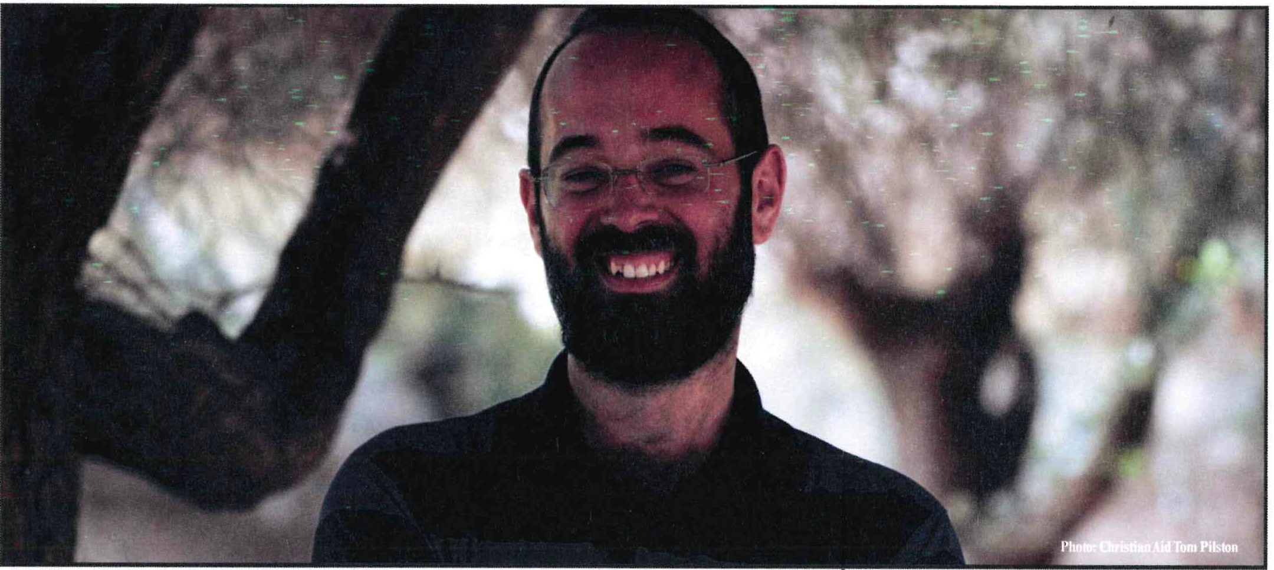
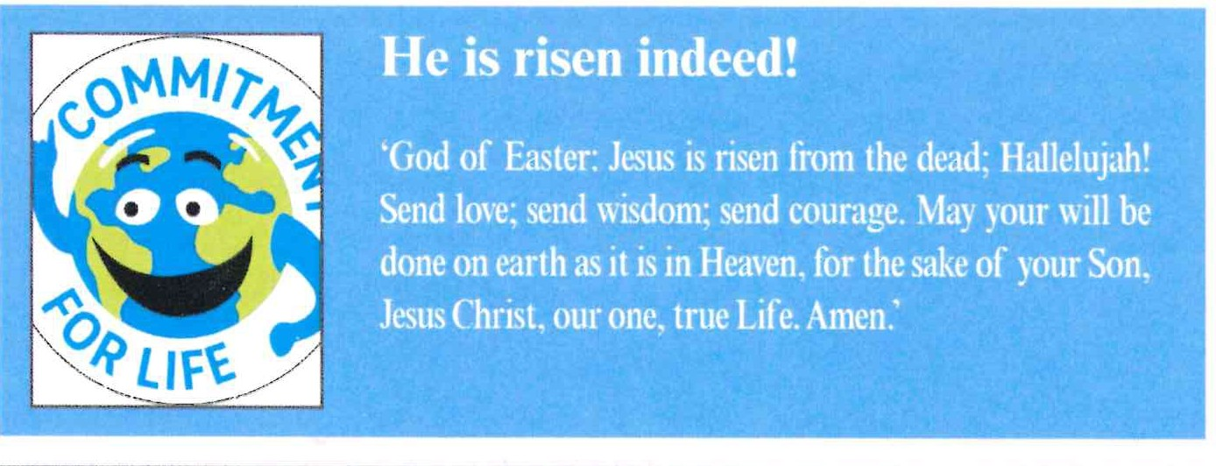
I Feature Story - Israel and the occupied Palestinian territory

'I can do something to change
·It•••'
I Team Spotlight

Jamaica hurricane appeal
We want to share the excellent news that the URC has collected over £30,000 to

Commitment for Life believes that all people are created in the image of a loving, generous God. Each person is fully entitled to freedom, dignity, safety, and equity. We emphatically believe that every Israeli and Palestinian has a right to these things. Their rights are shared and indivisible .
Christian Aid reports that Tzvika Besor (pie.) is a Jewish Israeli living in Tel Aviv. He lives a good life and wants this for all.
'I've never ignored the occupation,' he explains,'ever since I was 11. But what's different now is I can do something to change it.'
Tzvika is a human rights campaigner for our partner ACRI (Association of Civil Rights in Israel). He helped spearhead a mass campaign to connect A-Twaneh village to a good water supply.
We are grateful to you for your support for heroes likeTzvika.
assist our partners CRAF to clean up after Hurricane Melissa. PLEASE NOTE: that we have attempted to thank each person / congregation individually, but at times we just could not work out who made the donation. Apologies if you've not been thanked personally, but please know we are grateful!
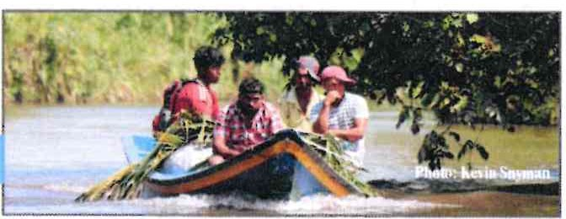

Jamaica Hurricane Appeal: make
� this your Easter egg gift...
[!].:,.,,:.i..�·':.[!]
·n..lw:��---
w��l:E"'.
��
[!]��

