NEWSLETTER SPRING EDITION ’26

MOVING STORIES
WORLD JUSTICE PROGRAMME
UNITED REFORMED CHURCH

Nickil and Rani Photo: Peter Musgrave

Feature Story - Climate change affects every part of Bangladesh

‘This is their hope...’
Team Spotlight

Jamaica hurricane appeal
We want to share the excellent news that


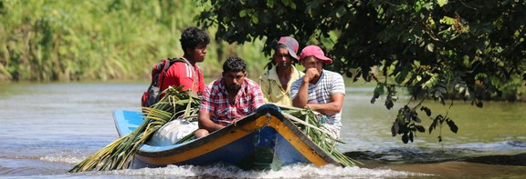
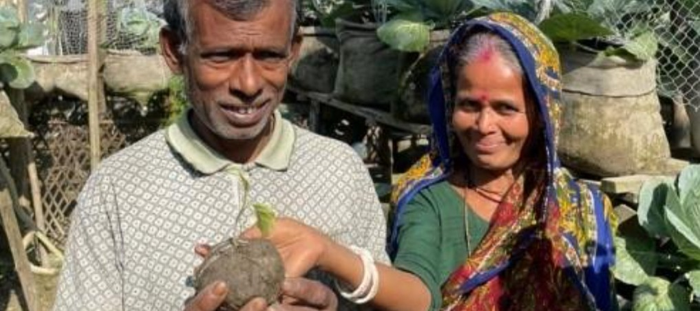




In 2025, Peter Musgrave (Vine URC,
Ilford) visited the banks of the River Jamuna. ‘I always thought climate change happened on the coast of Bangladesh, but this visit showed me that it is in fact happening much further inland.’

The Jamuna River is huge and is continuously eroding, removing large slices of land on one side and then depositing the silt further downstream.
Gosaibari town is 5 km from the Jamuna River. But river erosion has destroyed
He is risen indeed!
‘God of Easter: Jesus is risen from the dead; Hallelujah! Send love; send wisdom; send courage. May your will be done on earth as it is in Heaven, for the sake of your Son, Jesus Christ, our one, true Life. Amen.’

Photo: Pixabay
Nickil and Rani’s home four times already.

‘Nickil and Rani are holding a seedling in their hands,’says Peter.‘This is their hope. They keep some for themselves while they sell others in the bazaar.’ Nickel and Rani run a demonstration plot where local people can learn and copy vegetable gardening suited to climate adaptation.

A big thanks to avid Commitment for Life supporters like Peter!
the URC has collected over £30,000 to assist our partners CRAF to clean up after Hurricane Melissa. PLEASE NOTE: that we have attempted to thank each person / congregation individually, but at times we just could not work out who made the donation. Apologies if you’ve not been thanked personally, but please know we’re grateful!

Photo: Kevin Snyman
Jamaica Hurricane Appeal: make this your Easter egg gift!

