NEWSLETTER
WINTER EDITION ‘25/26

MOVING STORIES
WORLD JUSTICE PROGRAMME
UNITED REFORMED CHURCH

Feature Story - Shoemaking in Zimbabwe

Team Spotlight
Photo: Christian Aid

Together we walk: a fairer future starts with us

Meet the Changemakers
This edition, we spotlight Fr Fadi Diab, Rector of St Andrew’s Episcopal Church, Ramallah, Palestine. Fadi encourages us


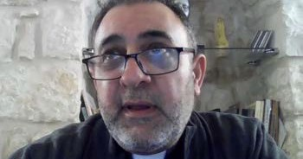
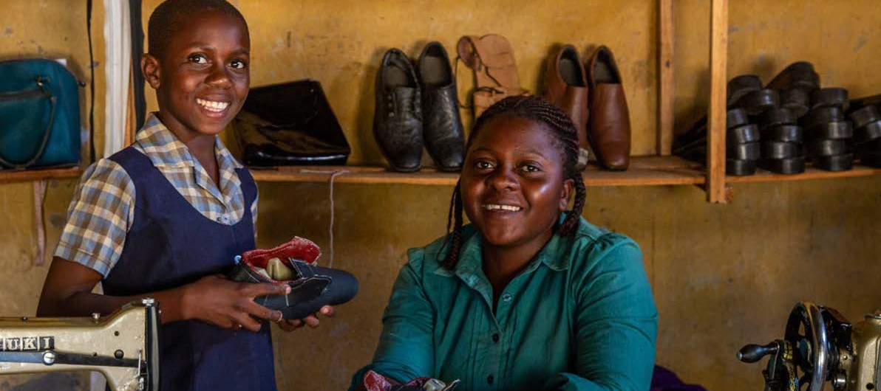
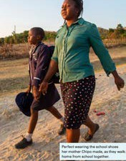


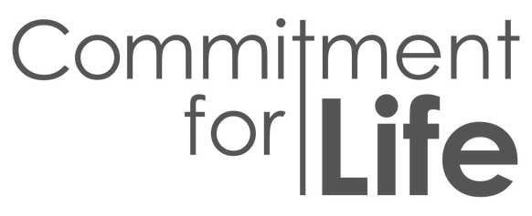
With support from Commitment for Life,
Chipo received training in leatherwork. She also received training in leadership and business skills. This gave her renewed confidence as well as a diversified income.

Mornings are busy for Chipo. She helps her daughter, Perfect, get ready for school that is situated a few miles down a dusty road.
“When I made some sandals for my
husband, school shoes for my daughter, and a handbag for my mother, I felt so happy,” said Chipo. “I saw this goat and bought it with money from my leatherwork. I am happy that it is me who made the shoes which my daughter puts on.”

Stories of changed lives are a blessing and why we choose to commit to justice.
Pray without ceasing...
‘God of Light: send light; send love; send wisdom; send justice. May your will be done on earth as it is in Heaven, for the sake of your Son, Jesus Christ, our one, true Light.Amen.’

Photo: Christian Aid
to support the“Palestine Kairos II: Faith in a Time of Genocide” - search “Palestine Kairos II time-of-genocide”.

Photo: Kevin Snyman

Quick Update
Jamaica Hurricane Appeal: make this your Christmas / New Year present!

