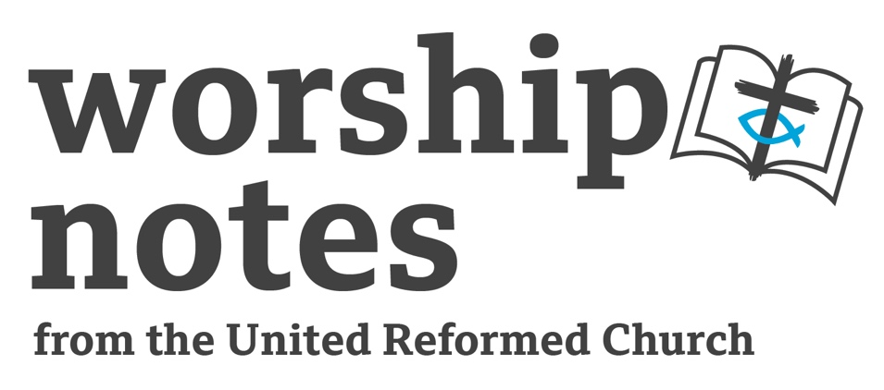
Good Friday
2026
The Revd Dr
John McNeil Scott

Note

Good Friday is the saddest day of the year and none of our theologies can fully fathom the enormity of God’s death on the Cross – an instrument of cruel torture. John McNeil Scott has designed this service to start and end in silence with no “stage directions”. He suggests music in various places; in the digital service we have had some hymns as well. The Performing Rights Society makes no charge for the playing of recorded music in worship. We also suggest pictures which might be projected so as to give a point of focus. The church should be bare and stark. Poems are by Geoffrey Rust and reprinted under the terms of his permission. Readers should take especial care with the poems as they can be tricky. They should be well practiced before the service.

Opening Music Adagio for Strings - Barber

Reading
Then the governor's soldiers took Jesus into the Praetorium and gathered the whole company of soldiers around him. They stripped him and put a scarlet robe on him, and then twisted together a crown of thorns and set it on his head. They put a staff in his right hand and knelt in front of him and mocked him. "Hail, king of the Jews!" they said. They spat on him, and took the staff and struck him on the head again and again. After they had mocked him, they took off the robe and put his own clothes on him. Then they led him away to crucify him. As they were going out, they met a man from Cyrene, named Simon, and they forced him to carry the cross. They came to a place called Golgotha (which means The Place of the Skull). There they offered Jesus wine to drink, mixed with gall; but after tasting it, he refused to drink it. When they had crucified him, they divided up his clothes by casting lots. Above his head they placed the written charge against him: THIS IS JESUS, THE KING OF THE JEWS. Two criminals were crucified with him, one on his right and one on his left. Jesus said, "Father, forgive them, for they do not know what they are doing."

from Matthew 27 27-37 and Luke 23 33-34

accomplices

father forgive them
they didn't know what I was doing
when I slipped into humanity disguised
my light shone in a darkness
they could not comprehend

forgive them all
my dear, dull accomplices
who don't know the cost
of an immortal’s suicide

they tried to keep us
from this meeting here

forgive the crowd
making the necessary choice of Barabbas

forgive Pilate’s wife
whose conscience nearly ruined everything

forgive Judas
his kiss of death

father forgive them
they don't know what we are doing

forgive them
they didn't know what they were building

we were architects
and these rough beams were cut
to meet our most exacting standards

forgive them
they don't know what will be executed here

how might they understand
these hammer blows would be
the final acts of our first creation

like workmen at the launch
of some great enterprise of state
they come to watch
the ceremony of our fierce ambition

and as they hoist me up to you
before this brutal act of love
extinguishes my mortal life completely
father forgive them
they don't know what they're doing

Music Kojo No Tsuki (Moon over the Ruined Castle) - Rentaro Taki
Or the hymn My Song is Love Unknown

Reading
One of the criminals who hung there hurled insults at him: "Aren't you the Christ? Save yourself and us!" But the other criminal rebuked him. "Don't you fear God," he said, "since you are under the same sentence? We are punished justly, for we are getting what our deeds deserve. But this man has done nothing wrong." Then he said, "Jesus, remember me when you come into your kingdom”. Jesus answered him, "I tell you the truth, today you will be with me in paradise."
from Luke 23 39-43

thief

What would you steal from me, thief?
These Romans took my clothes. My friends

ran off with their loyalty. My priests
have filled their pockets with my people.

I’ve nothing left but you, my captive audience.
It took a lot to nail you down to gain

your full attention. All your life
you worshipped at the altar of desire

only to find it is a god unsatisfied
by less than everything. In all your crimes

you were the victim and now you find
a god is dying next to you, and you

so skewered you cannot even
stretch a hand out to ask for mercy. Smile,

thief: you are the archetype, the first
to take his cross up and then follow me.
Nothing is what it seems. Your prayer
was answered long ago, and you will see

breaking and entering done here
on a cosmic scale. Will I remember you?

I tell you the truth, today
you will be with me in paradise.

Music La Delaissado – Cantaloube
or the hymn O Sacred Head Now Wounded

Reading
Near the cross of Jesus stood his mother, his mother's sister, Mary the wife of Clopas, and Mary Magdalene. When Jesus saw his mother there, and the disciple whom he loved standing nearby, he said to his mother, "Dear woman, here is your son," and to the disciple, "Son, here is your mother." From that time on, this disciple took her into his home.
from John 19 25-27

son

Woman, as I prepare
to slip the leash of time
for a moment your grief
reels me back in; the sword
pierces us both
but you alone will feel then
the pain I feel now,
watching a mother
watch a son die. Before
you gave birth to me
I AM, and at a word
I made time flow
like tears: but what
could I in my eternity
know of such a loss as yours? Timeless
I became humankind—
there was no other way
to learn the meaning
of this moment. Soon
I will have gained
eternity again; you have
the meantime, and I will
not leave you comfortless.
Beside you is one
whom I have loved
more than a brother:
Dear woman, here is your son.
Son, here is your mother.
Music to listen to Stay with Me, Watch and Pray (Taizé)
or join in with
Reading
From the sixth hour until the ninth hour darkness came over all the land. About the ninth hour Jesus cried out in a loud voice, "Eloi, Eloi, lama sabachthani?"--which means, "My God, my God, why have you forsaken me?"
from Matthew 27 45-46
wager

To be human is to deal with death
so I have wagered all to taste the fruit

of this desolate new Eden. To be human
is to court the risk of failure, and so I

embrace this tree of knowledge of despair.
And to be human is to know that God

may be illusion, so I have made myself
human enough to doubt and disbelieve.

What else is left for God to understand?
Faith is the gamble of a dying man.

The condemned son cries out into the dark
guessing his father hears, yet will not come.

What kind of love is this that keeps such silence?
My God, my God, why have you forsaken me?
Reading
Knowing that all was now completed, and so that the Scripture would be fulfilled, Jesus said, "I thirst."
from John 19:28
animal

nothing
up my sleeve
there’s no sleeve
look on
your naked God
look on
your reflection
this is
the tree
of life
you need me
I chose
to need you —
to love you
God became
animal
help me
I thirst

Music to listen to O Lord Hear my Prayer (Taizé)
or join in with

Reading
A jar of wine vinegar was there, so they soaked a sponge in it, put the sponge on a stalk of the hyssop plant, and lifted it to Jesus' lips. When he had received the drink, Jesus said, "It is finished."
(John 19 29-30)

masterpiece

I saw it first, this bloody work of heart,
conceived in my mind’s eye in the beginning,
or what you call the beginning. Time
was the canvas I prepared to paint on.
I drew its outline in the life of Abraham,
my palette history, its colours mixed
in Israel’s rise and fall. I worked from life:
against a landscape of an Eden spoiled
my people with their untamed rebel hearts
stared out through masks of beauty scarred with sin.
Painstaking detail. Light and darkness. Then
the hardest thing I ever did: love
was daubed with every brush-stroke of the Spirit
on the unforgiving texture of the soul.
Finally to shape the central figure
I needed human hands. I laboured with Mary
to bring the enterprise to birth. Three more decades
of preparation were meticulous—
it is not irony that I was framed
and hung up here to die: it is the point.
I am the artist and the portrait too,
painting out at last in the blood of God
a perfect self-expression: my still life.
This is my masterpiece and it is finished.

Music Surely He hath borne our griefs (Handel)

Reading
At the ninth hour the curtain of the temple was torn in two. Jesus called out with a loud voice, "Father, into your hands I commit my spirit."
from Luke 23 45-49
legacy

I have travelled light
so that the leaving should be easier.

What I bequeath is left according to your will
and this new testament. I leave a church

to be built on a broken rock. I leave
nothing written down. I heard my words

blown freely on the winds of Galilee
to seed the hearts of men. I leave no money,

debts or property, no house for shrine,
no artefact for relic. I leave just

the remnants of a meal. My cloak
is cast aside and gambled for. I leave

no tomb to raid, no corpse to disinter
no fingerprints, no blood, no DNA.

I could have gained the world,
but nothing now stands between us

but this one last legacy: because
it is written, because

it holds the only power with which
the trap of human death will be unsprung

and because until I give it up to you
it cannot be returned to anyone

father into your hands
I commit my spirit.

Reading
Show me your ways O Lord; teach me your paths.
Guide me in your truth for you are God my Saviour
from Psalm 25

Closing Music Clair de Lune – Debussy

Suggested Pictures

Cover / Start Picture What Our Lord Saw from the Cross
James Tissot (1836-1902)

Accomplices Picture Christ Crucified
Velázquez 1632

Thief Picture Christ on the Cross
Eugène Delacroix 1835

Son Picture Stabat Mater
Gentile da Fabriano (1400-1410)

Wager Picture Jesus Mafa Crucifixion
1973

Animal Picture Christ Crucified
John Petts (1914-1991

Masterpiece Picture Crucifixion
Paolo Veneziano 1340-1345

Legacy Picture Crucifixion
Frank Wesley (1923-2002)

