NEWSLETTER
WINTER EDITION ‘25/26

MOVING STORIES
WORLD JUSTICE PROGRAMME
UNITED REFORMED CHURCH

Feature Story - Girls excel at schools in Bangladesh

Team Spotlight
Photo: Pixabay

Together we learn: a fairer future starts with us

Meet the Changemakers
This edition, we spotlight Fr Fadi Diab, Rector of St Andrew’s Episcopal Church, Ramallah, Palestine. Fadi encourages us



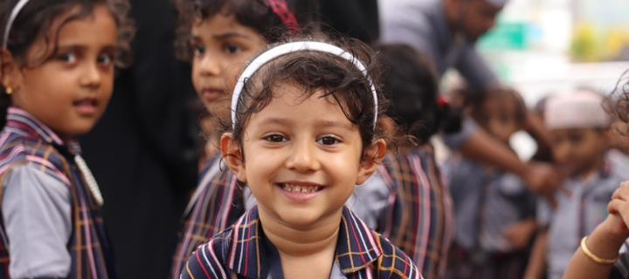
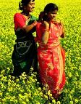


Government stats show that girls do much
better than the boys in the Bangladeshi Secondary School Certificate (SSC) examinations.
Girls are doing better than boys year on year. The pass rate of the girls was 1.53 percentage points higher than that of the boys across eight educational boards. Officials say that the girls generally are more attentive. “Girls are spending more time in studies than boys.”
Pray without ceasing...
‘God of Light: send light; send love; send wisdom; send justice. May your will be done on earth as it is in Heaven, for the sake of your Son, Jesus Christ, our one, true Light.Amen.’

Photo: Pixabay
Our Christian Aid partners focus quite
intentionally on the upliftment of women and girls in Bangladesh. This is because women take such an active role in the well-being of communities. They make excellent co-collaborators in support community cohesion and in addressing the underlying causes of vulnerability, and for investing in livelihoods and care.
Your support allows women and girls to thrive in Bangladesh.
to support the“Palestine Kairos II: Faith in a Time of Genocide” - search “Palestine Kairos II time-of-genocide”.

Photo: Kevin Snyman

Quick Update
Jamaica Hurricane Appeal: make this your Christmas / New Year present!

