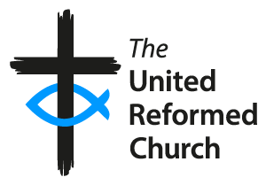

The United Reformed Church
Community Project Awards 2026

Entry Form

Up to three awards to be won for distinctive projects that make a positive contribution to the local community

Sponsored by | In association with | and
 |  | 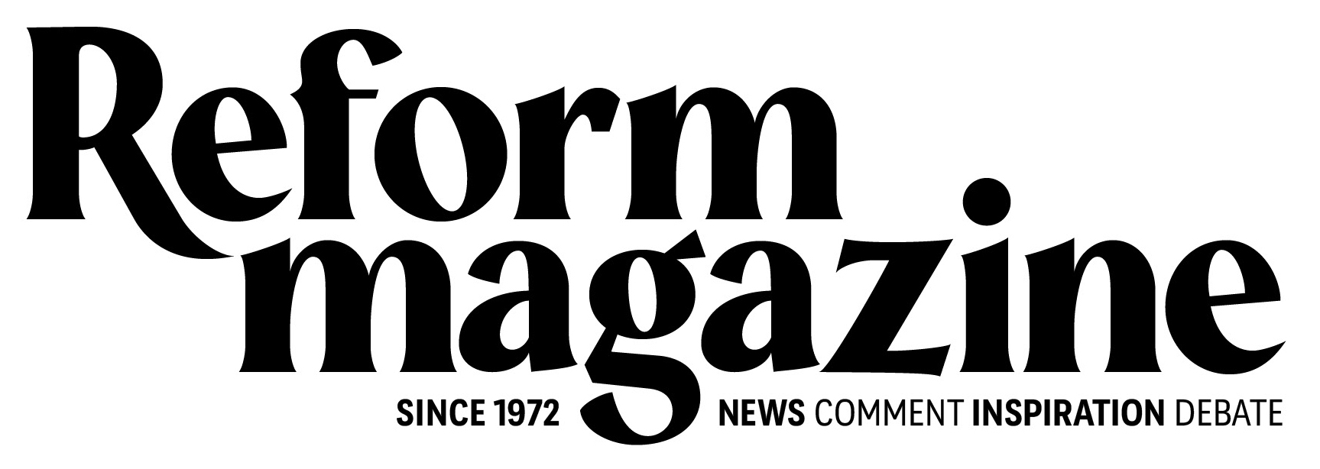

To be awarded at the United Reformed Church General Assembly at the Hayes Conference Centre, Swanwick, on Saturday 4th July 2026. By entering the awards, you agree that representatives from your project can attend on this date to receive the award should the project win.

Please read the Rules for Entrants

Name of church:
Name of project:

Rules for Entrants:
- No more than one entry will be accepted for any one project.
- To be eligible, a project must be run in the UK by members of the congregation of a United Reformed Church or by a local ecumenical project where the United Reformed Church is present.
- Recipients (winners) of Community Project Awards from 2016 onwards are not eligible to enter the 2026 Awards.
- The Awards are intended as a form of recognition and are not intended to provide start-up finance.
- Entries must be received by Friday, 20 February 2026.
- A selection committee will draw up a long list of entrants. These long-listed projects have their application form reviewed following which the committee will select a number of projects for a visit by judges. On completion of the visits, up to three projects will go forward as the shortlist for an award. The decision of the selection committee is final, and the selected projects will be notified soon after the final judges’ meeting has taken place. The committee reserves the right to select fewer than three projects if, in their opinion, these guidelines are not met, or application forms/entries are not of the required standard.
- A short film about the work of the winning projects will be produced by the end of June 2026. By applying, entrants confirm that if shortlisted they will take all necessary steps to protect vulnerable people, including children, and have sought and obtained the necessary approvals and written consents:
for filming taking place at their premises and,
from parents or guardians for the appearance of any children likely to be featured in the films or any promotional material.
- Films made of shortlisted entrants may not be used by the respective projects for their own promotional purposes until after the awards ceremony. The films must remain in their original and unaltered form unless prior written permission allowing changes to be made has been obtained from the communications department of the United Reformed Church.
- Should an entrant that has been shortlisted withdraw from the awards, then they forfeit the right to use any photos, videos and they will not receive the financial award.
- The promoter of the Awards is the ‘United Reformed Church’ (registered office is Church House, 86 Tavistock Place, London, WC1H 9RT) and sponsor of the awards is ‘Congregational’ (‘Congregational’ is a trading name of Integra Insurance Solutions Ltd. Registered office: Currer House, Currer Street, Bradford BD1 5BA. Registered in England and Wales Registered number 06760260).
- The copyright and other intellectual property rights of all material brought into existence in connection with the Community Project Awards 2025 are the property of Integra Insurance Solutions Ltd. This includes but is not limited to, all photographs and material appearing on the United Reformed Church website (www.urc.org.uk) and Congregational website (www.congregational.co.uk). The copyright of all films made of shortlisted entrants is the property of the United Reformed Church.
- Entrants must agree to one or two representatives to attend the Awards Ceremony, which will take place during the General Assembly of the United Reformed Church, on Saturday 4 July 2026, at lunchtime at The Hayes Conference Centre, Swanwick, Derbyshire.
- As a condition of winning an award, entrants must agree to any reasonable requests on the part of ‘Congregational’ and/or Reform Magazine and/or the communications department of the United Reformed Church, to participate in any promotional events connected with the competition such as interviews or photographs.
- The total prize fund is up to £10,000 and this will be allocated to the projects shortlisted for final judging. The amounts awarded to each of the winning projects will be at the sole discretion of the judges.
- The United Reformed Church and ‘Congregational’ reserve the right to amend these ‘Rules for Entrants’ as circumstances may require from time to time without prior notice to the entrants.
- By entering the Community Project Awards 2025 the entrant accepts and agrees to abide by these ‘Rules for Entrants’, which may be amended from time to time.
- Information and data provided by entrants whether ‘personal’ or ‘non-personal’ will be held for up to three years and used by the United Reformed Church and ‘Congregational’ to administer the awards programme and in respect of any related promotional activities.
Completed entries must be received by 5pm on Friday 20 February 2026
Completed entry forms should be sent to:
awards@urc.org.uk
Community Project Awards, Communications Department, United Reformed Church House, 86 Tavistock Place, London, WC1H 9RT

Please complete all sections. Please offer as much information as possible without being overly wordy. Please give a flavour of the project through this application form. Please ask others for help with the form if needed. Please include photos of the project if available.

Contact Details

Your name and church
Named contact for correspondence:
Name and address of sponsoring United Reformed Church:
Position in church (if applicable):
Role in project:

Your address
Correspondence address:
Contact phone number:
Contact email address:

Please provide the name and contact details of someone who is willing to be a referee for the project
Name:
Contact phone number:
Contact email address:
Relationship to the project:

- Describe your project in detail, outlining its main aims and objectives and indicating how you believe this project could be replicated by others.

- If your project won one of the awards, please describe how you would you use the prize money to develop the project further

- Please list the typical activities undertaken at the project, giving details of their time and frequency, showing numbers of attendees and a description of the type of work done

- What is/was the maximum annual budget available to fund the project:

At start-up: £
For ongoing capital costs: £
For annual running costs: £

Please list the major sources of finance for the project:

- Please provide/attach a summary of last financial year’s accounts (if any)

- Details of people involved in the running of the project

How many paid staff?
How many church volunteers?
How many other volunteers?
Total number involved:

- Emphasising what is different because of the project, please detail any practical benefits to the community

- Detail the involvement of the church with the project, and how the mission of the church is demonstrated through its work

Signature:

Date:

Completed entries must be received by 5pm on Friday 20 February, 20256

Completed entry forms should be sent:

By email: awards@urc.org.uk

By post: Community Project Awards, Communications Department,
United Reformed Church House, 86 Tavistock Place, London, WC1H 9RT.

