Zoom Guidance for a meeting

- If you haven’t downloaded the Zoom computer program, it creates a far easier experience if you do so, visit www.zoom.us/download to do this.
- If you already have the computer program, please ensure it is updated by clicking ‘Check for updates’, there’s a video tutorial here: http://bit.ly/updatingzoom
- If you use an iPad, tablet, or phone, you will already have the relevant app that will usually be suitably updated.
- You will be muted throughout the meeting. Please keep yourself on mute unless you are speaking. To unmute, click the unmute button in the bottom left corner of your screen (usually top-right for iPads). If you’re dialling in by telephone, press * and then 6 to unmute yourself.
- We may make use of Zoom’s ‘Spotlight’ function, to spotlight a speaker. But you can change this at any time by clicking the ‘View’ button in the top right-hand corner of your screen (sometimes the word view might not be there, but an icon will be). On an iPad/phone, you can swipe left or right to cycle between views. You can also “pin” a video (make your own speaker view) on a computer by clicking the three dots in the top right corner of anybody’s video.
- You will need to rename yourself when you enter the meeting (see ‘How do I rename myself?’)

How will the chair know if I want to speak?
To maintain good order during the meeting, We will be using the ‘Raise Hands’ function on Zoom to do this. The raise hands button can be found by clicking on ‘Reactions’ (see Fig. 1 below) at the bottom of your screen. On an iPad/Tablet/phone, these are found by tapping ‘More’. If you are dialling in by telephone, you press * and then 9.

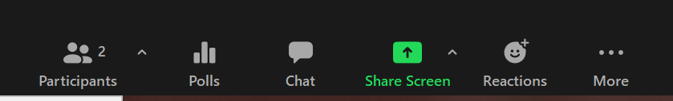

Figure 1: Bar at the bottom of your screen (PC and Mac apps only)

When you click ‘Raise Hand’ it will remain raised until you press it again (it will then say Lower Hand). Please keep your hand raised until you are called to speak, unless you do not wish to speak anymore, then lower it. But be prepared to speak, still, in case the chair has not noticed you have lowered your hand again!

There is a possibility that, on some devices, the ‘Raise Hand’ button could be in the ‘Participants’ tab (see Fig. 1 for where this is).

The Moderator will call you to speak, you will unmute your own microphone (bottom left corner), speak, and re-mute yourself afterwards. If not, we can re-mute for you.

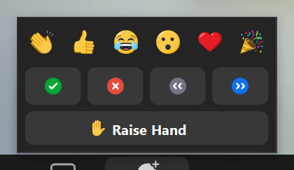
If you wish to raise a point of order, please simply unmute and say ‘Point of Order’.
Figure 2

From time-to-time, the Moderator may use the ‘tick’ and ‘cross’ to take the temperature of the meeting, or as an indication of something. This is not a formal vote, but used as a tool. It will be made clear to you when this is being used.

Can I use the chat to say something?
The chat will not be monitored by the moderator or any of the tech team for business purposes. If you wish to raise a point, please do so verbally. You may chat privately with the tech team if there is an issue, but do note, they’re a busy team!

How do we vote?
We will be using polls to record official votes. Polls are as the name suggest! The Moderator will make it clear what you are being asked to vote on.
- If there are two voting members of Assembly in your household, you will need to use separate devices. If this is not possible, please let us know ahead of time.
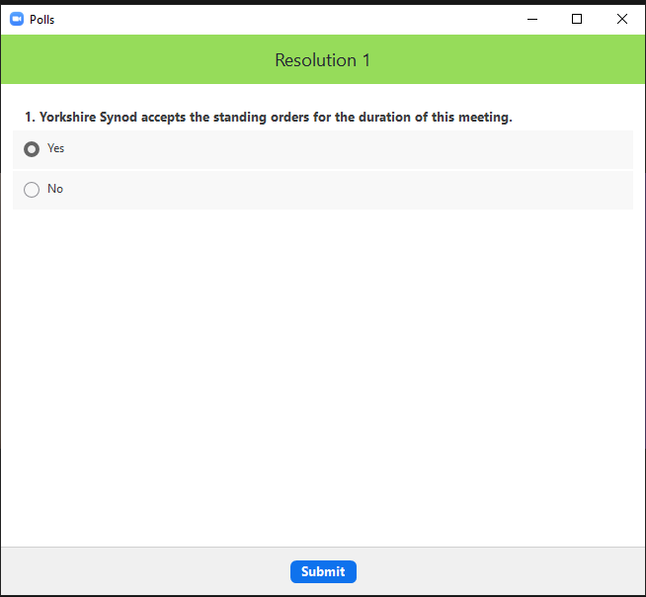
- When the poll is going to take place, it will appear on your screen like in Figure 3.
Figure 3
- Click on the option you wish to vote for, double check it’s correct, and then click submit. You cannot change your vote once it is submitted.
- If the poll doesn’t appear on your screen or flashes off. Click the ‘Polls’ button at the bottom of your screen. (Figure 1).

How do I rename myself?
You will, ideally, need to rename yourself for the meeting, with a ‘V’ at the beginning of your name if you are a voting member. Or ‘N’ if not. To rename yourself:
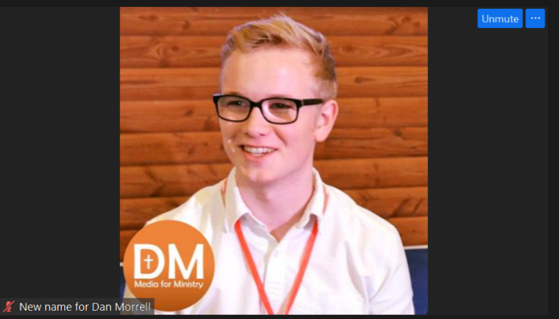
- If you’ve joined the meeting on a computer, move your mouse to hover over your own video, you will usually be second along from the left on the top row. When you hover over it, you will see three dots in a blue box appear in the top right hand corner of your video.
- Click on this box and a menu will open up. Click on the rename option and a new box will pop up. Type in your new name then click ‘Ok’.

If you’re on an iPad, or other tablet, or a phone. Tap ‘Participants’ at the top, and then tap on your name to rename yourself.

Naming examples N Dan Morrell
V Dan Morrell

Note ‘names’ are limited to 64 characters.

