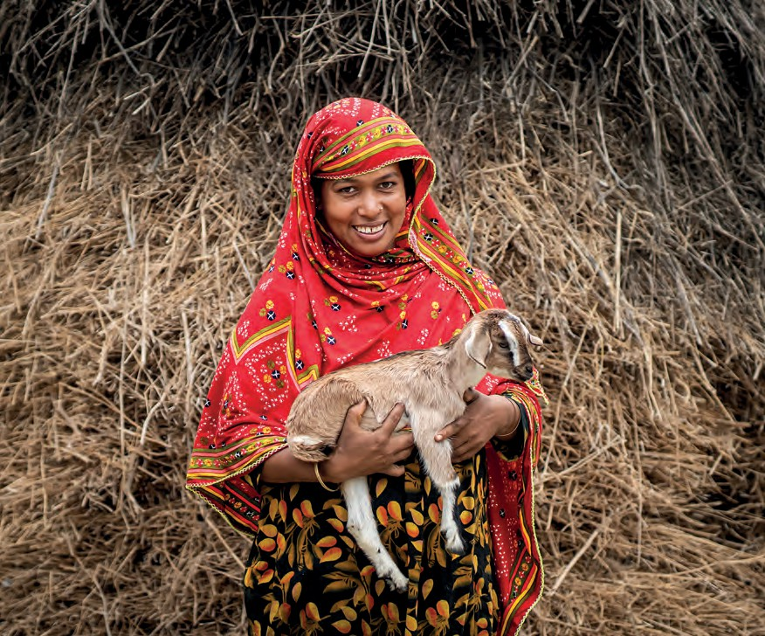




2026
Credit: Rumi Begum, Bangladesh, Christian Aid

Hope in the making
Prayer Partners
We offer these prayers and images to use in your services of worship, church magazines etc, to encourage and guide your prayers for global justice. We suggest using one per month, but feel free to mix things up.

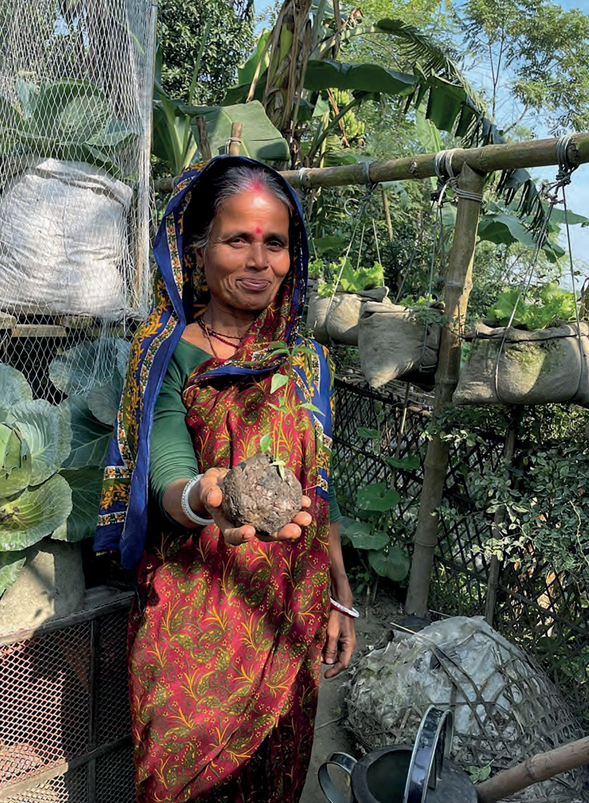

Prayer for Bangladesh
By Peter Musgrave

Hope-making God, friend of the poor,
We pray for the beautiful land and people of Bangladesh.
We grieve for
the loss of the forests the rising sea levels the depleted soil
the polluted air
the pressure of human population.

Create hope for those who have lost land and livelihood due to floods, river erosion and cyclones,
and been displaced to the slums of Dhaka.

Offer hope to the land, depleted by pesticides and fertilisers. Bless those working to heal it.

Give hope to leaders working to create a new government which works for all the people.

Inspire hope through women and men who show that change is possible.

Spread hope through the faithful and patient work of community organisations which work with few resources.
Nurture hope through Christian Aid and others who bring international resources to strengthen and encourage local initiatives.

Grow hope among those building relationships between Muslims, Hindus, Buddhists and Christians, and between Bengalis and minority ethnic groups.

God of hope, in all these ways be with and bless the people and land of Bangladesh.
Amen.

Prayer for Zimbabwe
By Ana Gobledale

Mwari* [Um-wah-ree], Ruler of the Universe, hear our prayers for your people.
Nkulunkulu** [Un-koo-loon-koo-loo], hear our prayers for your land.
Eternal One, hear our prayers for Zimbabwe.
As the stones stand tall, bring strength to your people.
As the mighty Zambezi River roars, bring renewal to your land.
As generations have walked, lead Zimbabwe into glory.
Like a star in your universe, may Zimbabwe shine. Like the ‘Fruit Basket of southern Africa’ it once was,
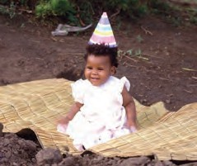
may the land prosper.
Like their ancestors, may your people walk in hope.
Hear our prayer for Zimbabwe, land of beauty and majesty, land of promise and possibility, land of richness and prosperity.
Forgive our participation in its ravage.
Forgive our misguided and harsh judgment of poverty.

Credit: Ana Gobledale

Credit: Ana Gobledale

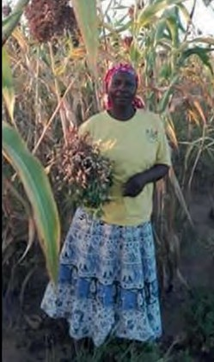
Forgive our ability to ignore the consequences of our choices.
Open our hearts and minds to lessons from Zimbabwe, harsh lessons about environmental decimation,
important lessons about community, co-existence and cooperation.
Love Force, unite us with our brothers and sisters in Zimbabwe. Connect us through prayer, song and action.
Mwari, Nkulunkulu, hear our prayer.

Amen.
*Shona name for God, from eastern Zimbabwe
**Ndebele name for God, from western Zimbabwe


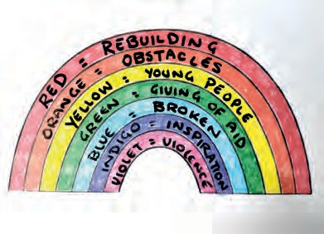
Action Prayer of Hope with Greta

Rainbow Prayer
Equipment – paper, coloured pens or paints
The Bible often uses symbols to represent hope. One of these is the rainbow. Draw or paint a rainbow using the seven colours.
As you colour each of the bands say a prayer:
Red = Rebuilding. Pray for those who have lost their homes, communities and livelihoods due to conflicts, wars, occupations, climate and natural disasters. Pray for those who need to return and to rebuild their homes and lives. Pray for free access to materials, finances, and resources to aid with this process.
Orange = Obstacles. Pray that all obstacles are removed from stopping people living together in harmony – political, financial, and practical obstacles.
Yellow = Young People. Pray for all young people and children who have seen too much destruction and sadness. May they know God’s love and peace, and the hope that things will get better.
Green = Giving of Aid. Protect the gifts of aid (food, water, building, medical, and school supplies) being sent from other nations that they will safely reach those in need.
Blue = Broken. Pray for those who are hungry or left injured and disabled by war. Pray for those who have lost loved ones.
Indigo = Inspiration. Pray that nations will be inspired to find ways to work together for peace and justice. Pray that God’s kingdom of love and peace will come very, very soon.
Violet = Violence. Pray for an end to wars, genocide, starvation, thirst, lawlessness, and racism. Pray that peace will break out across the whole world.

Pray
Dear God, thank you for rainbows that act as a visible reminder of your promises to us of love, hope, and a fresh start after difficult and challenging times. In Jesus’ name. Amen.

Prayer: Hope in the midst of poverty
By Pat Poinen, a member of the URC and the Windrush generation

God of our weary years, you have journeyed with us through struggle and strength.
From the islands and nations of our birth
to the shores where we planted new roots in faith.
God of our ancestors, may your Holy Spirit descend upon us. We remember those whose lives are still marked by poverty –
families denied opportunity, children going hungry, elders left behind by systems that fail to care.
We carry them in our prayers, and in our hearts. We know that poverty does not have the final word. Hope is rising – in the laughter of a child fed,
in the courage of communities demanding justice, in the daily resilience of those the world overlooks.
Lord Jesus, make us part of your work of restoration. Help us to be bearers of hope –
not only in word, but in action;
not only in charity, but in solidarity.

Lord, grant us collective faith and hope to overcome injustices imposed by those in power in our world.
With faith rooted in your promises, we pray in the mighty name of Jesus. Amen.

“So do not fear, for I am with you; do not be dismayed, for I am your God. I will strengthen you and help you;
I will uphold you with my righteous right hand.” Isaiah 41:10

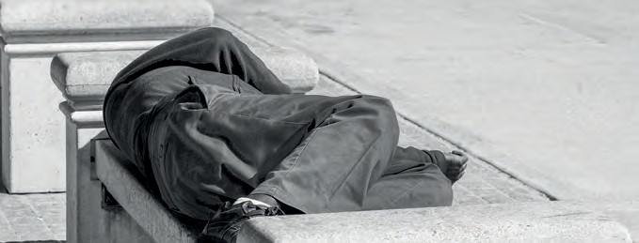
Credit: AdobeStock

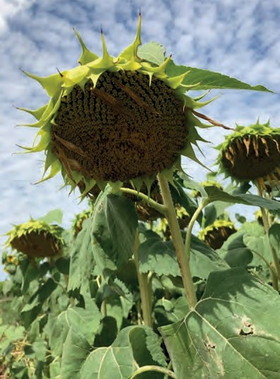
A prayer for Transcarpathia
Prayer Partners 2026 • page 7
By Geoffrey Clarke, URC
God, in whom we find our peace, we pray for all whose lives and localities are impacted by war.
In particular we pray:
  - for those displaced by the war in Ukraine;
  - for families and friendships where the young have fled for safety and the elderly remain;
  - for the impact of the declining population that remains.

Giving thanks for our partnership in Christ with our sisters and brothers
in the Reformed Church in Transcarpathia and the Reformed Church in Hungary,
we pray for those offering social care through the Diaconal Coordination Centre,
that through their work hope will continue to be tangible in the lives who need it most:
  - for the baking and distribution of loaves of bread;
  - for the farm, that it may continue to be a source of provision;
  - for the elderly care home.
Through the sharing of food and clothing
may those displaced by war find refreshment and a new sense of belonging.

Bless, we pray, the Reformed Church in Transcarpathia, that through the small seeds of hope planted in faith, transformation may bloom in the region:
that war may be eclipsed by the abiding peace of Christ, in whose name we pray,

Amen.
Image credit: G S Clarke, Sunflower at Mont-lés- Seurre, Bourgogne-Franche-Comté, France

Prayer Partners 2026 • page 7

Hope in the Making – Environmental Concerns
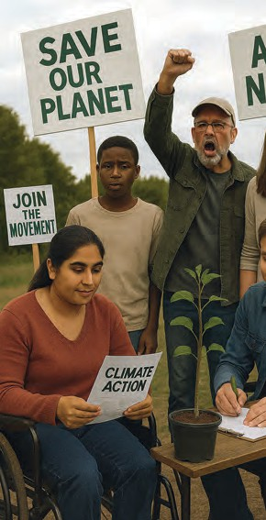
By Liz Styan, Zion URC North Allerton

Forests felled or burnt, destroying homes, habitat and carbon sinks.
Floods kill and lay waste.
Droughts sap life and livelihood, bringing hunger and migration.
Plastics and chemicals fill our rivers and oceans, causing death.
The earth cries out in distress but power denies, belittles and
prevaricates with self-interest at heart.
God, this is way too big for me!
Yet, you call us to be salt, light or yeast. Small, seemingly insignificant ingredients, but ones that transform and change
everything…. including us!
You encourage us to join with others to guide and enable,
And you promise to be with us every step of the way.
Thank you for signs of Hope in the Making:

Credit: Sara Foyle

A small apple tree planted defiantly in the face of opposition, the woman refusing single-use plastics or to buy produce out
of season,
small groups working on inspirational local projects, farmers turning to regenerative ways
campaign groups providing inspiration, information and opportunities to write, sign up or march in protest.
Charities working on alternatives for communities and ecosystems affected by climate chaos or environmental degradation.
Help us to seek you out and follow, wherever you may be found.
Amen.

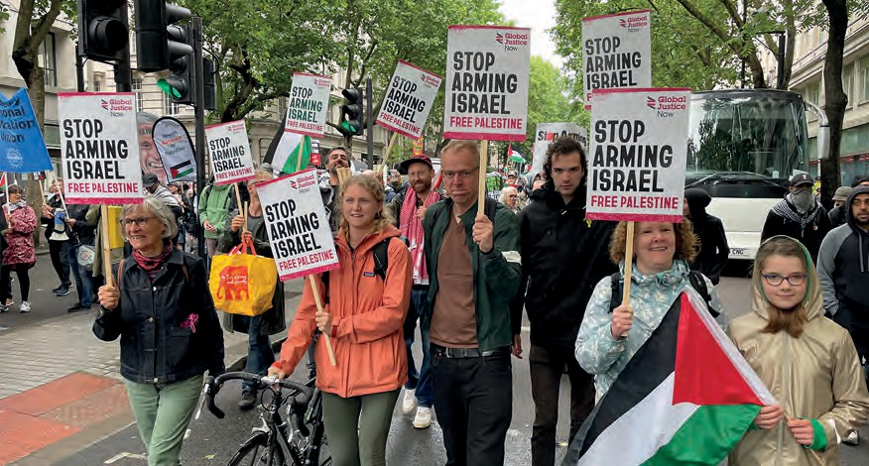
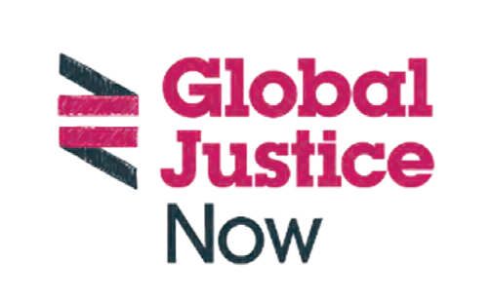
Prayer for Global Justice Now
Prayer Partners 2026 • page 9
By Ruby Puckering

Dear God,
Hope is a driving force for us at Global Justice Now, now more than ever. We come to you weary, looking for hope in a world overwhelmed by conflict and violence. We hope for an end to war and the suffering it brings, and for the courage to stand against the forces of oppression and injustice.
We pray for the people of Gaza, and all those who suffer daily under the weight of state violence and oppression. Give them strength and resilience in the face of horror, and help us to stand in solidarity with them as they struggle for freedom and justice.
We ask for your guidance in our efforts to address the root causes of conflict, including the unchecked power of corporations
that fuel climate change and perpetuate inequality. Help us to challenge their greed and exploitation, and to create a world where all people can live with dignity and respect.
We see hope in the work of activists across the world, who tirelessly advocate for a more just and peaceful world. Bless their efforts and multiply their impact, so that together we may build a world where peace reigns, hope is restored, and all people can thrive.

Amen.
Credit: Global Justice


- Prayers from Christian Aid Prayers written for Christian Aid’s 80th Anniversary service
We give thanks for the staff and volunteers of Christian Aid who,
for the past eighty years, have given of themselves in the support of the most vulnerable across the world. We pray for those
who continue to work to bring dignity and hope where there is inequality and despair, that they might know the strength and power of the Holy Spirit.

We give thanks to God for the gift of his creation, and all that gives us hope and sustains us in our work. We pray for all supporters of Christian Aid and for our partner organisation, that those who work in the midst of danger and difficulty might be upheld by the love of Christ.

Let us pray for all those who are wounded by conflict, injustice and poverty; for all who are at risk or in distress this day and who are unable to live full and flourishing lives. We pray for that day when peace will reign over the earth, and all people will be known, loved, and valued as God’s children.

A prayer from Christian Aid partner Peter Nasir, General Secretary of the East Jerusalem YMCA
God of justice and mercy,
we cry out for a world where all are treated as equals,
where no one is oppressed, and dignity belongs to all people. Break the chains of injustice.
Lift up the weak and humble the powerful. Make love our foundation.
Let peace and justice flow like a river that never runs dry.
Amen.


Prayer for Palestine
By Samar Hashweh, Methodist Liaison Office, Jerusalem

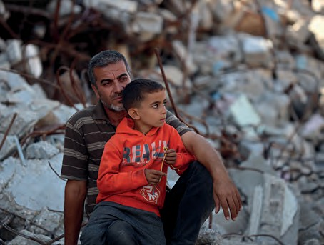
God of resilience and love,
We come before you with hearts that ache for Palestine, a land steeped in history
and yet marked by enduring conflict. We see the pain in the eyes of those who have lost their homes, their loved ones, and their sense of security.
Credit: Christian Aid
The weight of the past is heavy, and the present is
fraught with uncertainty. Yet, even in this challenging reality, we hold fast to the belief that hope can take root and flourish.
We pray especially for the young people of Palestine, who carry the dreams of a future they have yet to fully experience. May they find solace and strength amidst the difficulties, and may opportunities for growth and peace become tangible realities in their lives.
We remember the families striving to maintain hope in the face of adversity, their resilience a testament to the enduring human spirit. May they be surrounded by support and see glimpses of a brighter tomorrow. We also lift up the voices of those who tirelessly work for justice and reconciliation, often in the face of great obstacles.
Grant them wisdom, courage, and unwavering determination as they labour for a more just and peaceful future.
We recognise that hope is not a passive waiting but an active process of building, sowing, and nurturing. Empower us to be instruments of your hope in the making, through our prayers, our advocacy, and our solidarity with the people of Palestine. May our collective efforts contribute to a future where justice prevails, where peace reigns, and where the inherent dignity of all is upheld. We trust
in your promise of renewal and your unwavering love for all your creation. Amen.

A prayer for Churches Reparation Action Forum (CRAF)
By Gordon Cowans
God of grace and hope,
God whose power is not limited by time and space in this time and at this place, we praise you.
We praise you this day in all the places of the Caribbean for every evidence of your sacred promise
to never leave us or forsake us.
Generations of faithful ancestors urge us to stand firm in hope in you. We pray with thankful hearts for those who have gone before us, lighting the path,
living and fighting for freedom and dying before its full consummation. We thank you for their inspired and inspiring lives.
As we plant our feet on the rock of faith, help us nurture every life that yearns for you.
Continue to show yourself in the out-breaking of life-sustaining energy in a people of resilience and hope.
We lament the legacy of poverty which continues to this day to rob so many of life’s potential.
We pray for people who struggle with the insufficiency of nutritious food,
inadequate housing, educational opportunity, health services,
security from entrenched violence and vulnerability to earth’s climate emergency. On you we continue to depend,
in you, we hope
by your power we strive to rise from the ashes of the past.

Bless your people across this globe as we strive together in hope to contribute to a new day of justice, reconciliation and peace.
In Jesus’ name,

Amen.

Image credit: Karen Campbell, Ocho Rios, Jamaica



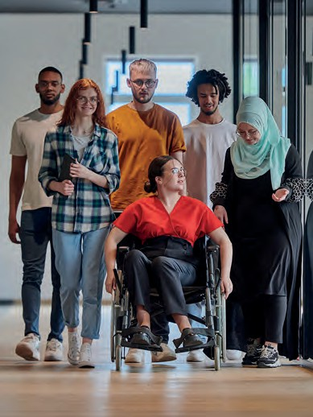
Prayer for Interfaith understanding
Prayer Partners 2026 • page 14
By Peter Colwell

O God beyond our imagining, greater that the vastness of the universe,
yet more intimate to us than we can possibly conceive, your love is stronger than any suffering or torment,
your arms stronger than any crippling anxiety,
your touch warmly comforting amidst tears.

We come into your presence,
eager to unload all the things that trouble us,
and eager to partner with you in the weaving of hope.

Credit: AdobeStock

We come with prayers for your suffering children in places of conflict and war:
all the places where tears and blood soak the very soil that ought to bring forth flowers.
We pray for all those afraid as the language of hatred pervades political language.

Open our hearts, we pray,
to our neighbour whose religion is different and strange to ours, that we might receive blessings from them;
may we see them as partners in peace building,
dutiful friends in searching for flowers of hope amidst stoney ground, allies in the struggle for justice.

And be with us as we witness to your love which knows no bounds. Amen.

Prayer Partners 2026 • page 14

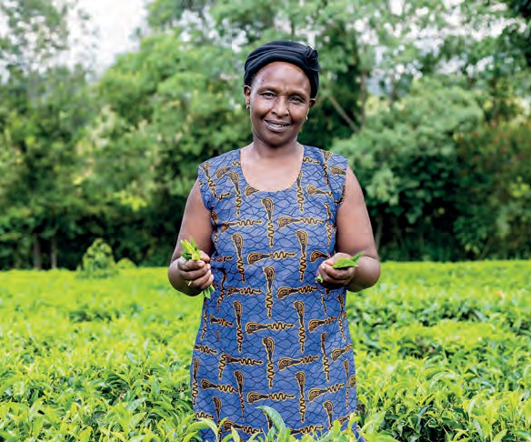

Prayer Partners 2026 • page 15

Prayer for Trade Justice
By the Revd Michael Harrison and Eleanor Harrison
OBE, Fairtrade Foundation
Dear Lord, who prayed “give us today our daily bread”, we give thanks for those who work to produce our food and pray they may be given fair reward for their labours.
We pray for those who grow the things we love that can’t be grown in the UK, including our favourite cup of tea, coffee and bananas. We pray for communities where a fair price sends children to school and supports basic health care.
Credit: Vincent Owino / Fairtrade Foundation
We pray that you will guide the fair trade movement in its efforts to secure a fair deal for those whose bargaining power is weakest.
We pray for supermarkets, brands and other retailers that they will recognise all the people involved in the produce they buy and the produce they sell, and that sustainable communities and a sustainable planet depend on fairness for everyone in our food supply chains.
We pray for shoppers here in the UK facing cost of living challenges, that they will recognise that fairness is for everyone.
When we come together socially and share a cuppa, in church, at parties or events, help us to remember to BREW IT FAIR.

Amen.

Linner Ruto, tea farmer at FINTEA Growers Co- operative in Kenya

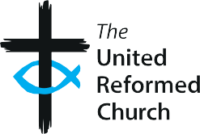





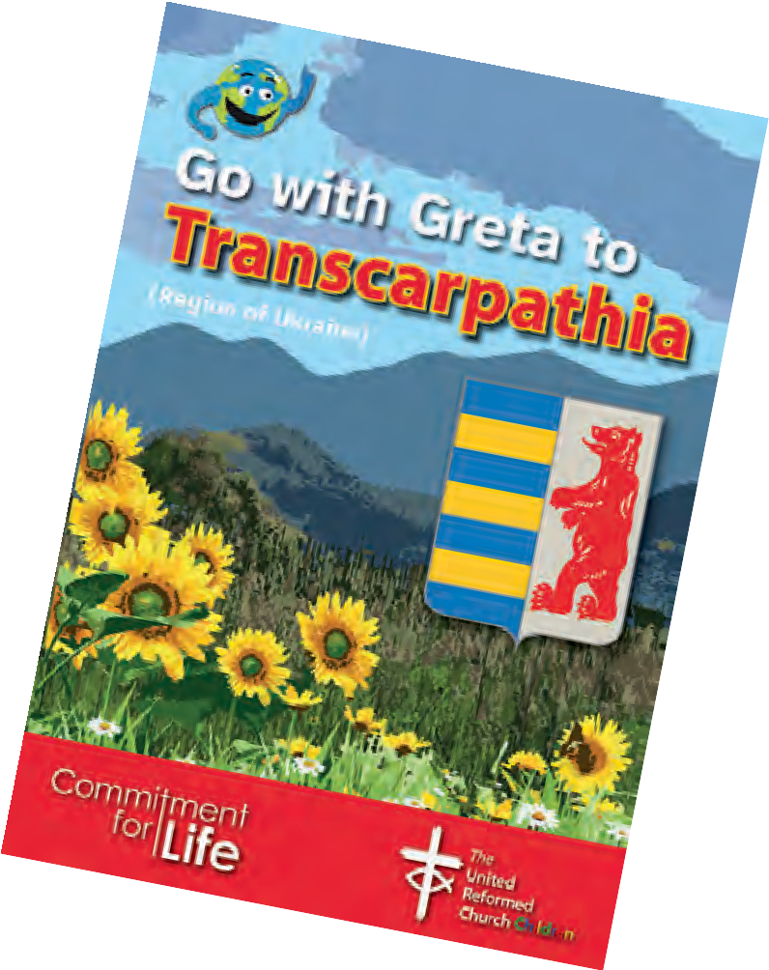
Further resources
More ‘Go with Greta’ material can be found at the URC’s children and youth work pages: urc.org.uk/go-with-greta-and-connect

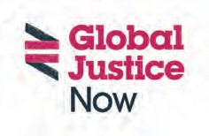
These prayers and photos can be reproduced for non-commercial use

www.urc.org.uk/cfl

Working with Christian Aid and Global Justice Now
The United Reformed Church, 86 Tavistock Place, London WC1H 9RT www.urc.org.uk

The United Reformed Church Trust (URC Trust) is a limited company in England and Wales (Registered Number 135934) and a charity (1133373).
Christian Aid is a charity in England and Wales (1105851) and company (5171525) and in Scotland number (SC039150) and company (5171525).
Global Justice Now is a charity (1064066) and company (2098198).

