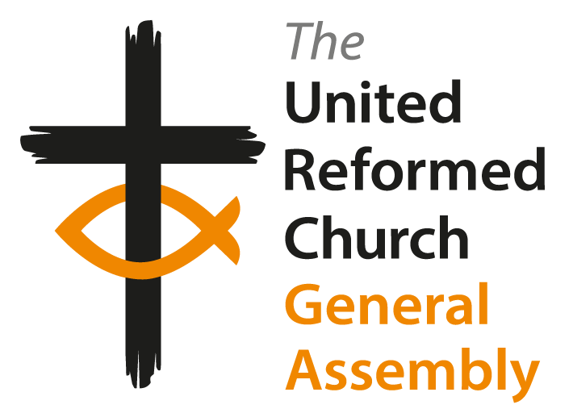
United Reformed Church
Extraordinary meeting of General Assembly 2025

Order Paper

Friday 14th November 2025

Please retain each Order Paper as the material may be relevant on any day of the Assembly

Apologies

The following members of General Assembly have sent apologies for this meeting.

Committee Convenors and URC Trust chair: Mark Robinson, Pippa Hodgson, Nick Mark

Past Moderators: Tessa Henry-Robinson, Michael Jagessar, Stephen Orchard, Kirsty Thorpe

Resource Centres for Learning: Adam Scott

Synod representatives:

Northern
Trevor Jamison, Ryan Sirmons, Alvin Ponnudurai

North Western
Mike Walsh

Mersey
Christopher Garforth-Fife, Emma Jackson

East Midlands
George Mwaura, Andrew Bodsworth

Eastern
Nigel Uden

South Western
Rachel Coward, Alex Mabbot

Thames North
Malon John, Amarachi Uzoka

Southern
Lisa Boatri

Scotland
Jan Adamson, Stewart Cutler, Margaret Fairgrieve

Ecumenical and International representatives: Rosemary Frew (The Church of Scotland), Francesca Nuzzolese (The Waldensian Church, Italy)

Changes to the Roll

Members of General Assembly who have eyes to the rules will be aware that the Roll of the General Assembly is set immediately before ordinary meetings of General Assembly. Because this is an extraordinary meeting, the starting point for membership of this meeting is the same as that of the most recent ordinary meeting last July.

In respect of synod representatives at General Assembly, the individuals sent by their synods are personally appointed. Synods have discerned who is called to represent them and in a variety of different ways, have resolved who they wish to send. This is why it is not possible to make changes to the synod parts of the Roll of General Assembly in between ordinary meetings.

Other people at the General Assembly are members of it by virtue of an appointment that they hold. In these cases it is a particular role that is a member of General Assembly rather than a personal appointment held by an individual. Extraordinary meetings of the General Assembly are rare events in the life of the United Reformed Church and it is the custom and practice of the denomination that where holders of particular posts have changed in between an ordinary meeting and an extraordinary one, that the new post holder attends rather than someone who is no longer exercising a particular role.
In respect of these changes, General Assembly is asked to note the following:

1. Moderator: Ms Catriona Wheeler
5. Deputy General Secretary The Revd Jenny Mills
Faith in Action
6. Deputy General Secretary The Revd Nicola Furley-Smith
Ministries
10. Business Committee Convenor Mrs Irish Sirmons
11. Faith in Action Committee Ms Pippa Hodgson, Mrs Sarah Lane Cawte,
The Revd Samantha Sheehan
19. Immediate Past Moderator The Revd Timothy Meadows
34. United Reformed Church Chaplain The Revd Stuart Turner
to HM Forces
249. Reformed Church in Hungary Ms Júlia Berecz

Resolution 48

General Assembly notes that the holders of several offices and roles, which are members of General Assembly ex officiis, have changed since the General Assembly last met in July 2025. General Assembly confirms the consequent changes to the July 2024 Roll of Assembly.
Proposed by the Clerk; Seconded by the Assistant Clerk

Facilitation Group

Many thanks to those who have agreed to serve as members of Facilitation Groups in line with Standing Order 7.7.

Resolution 49

General Assembly appoints Nneoma Chima, Susan Durber, Geoff Felton, and Martha McInnes to serve as members of the Facilitation Group for its meeting between 14-16 November 2025 in accordance with Standing Order 7.7.

Proposed by the Clerk; Seconded by the Assistant Clerk

Minutes

General Assembly owes a debt of thanks to Morag McLintock for the preparation of the minutes this weekend. Draft minutes of each session will be posted on the URC website soon after it is concluded. In the first instance please contact Morag with any amendments. Final drafts will then be checked by the Clerks. Minutes will be presented for adoption at the next practicable opportunity following this process. As is custom and practice, General Assembly is invited to authorise the Officers of the Assembly to verify the accuracy of the final version of the Minutes pending publication in a supplementary Record of Assembly.

The facilitated sessions planned for Saturday evening and Sunday morning will not be formally minuted beyond a short entry recording that the General Assembly met in this way.

Resolution 50

General Assembly authorises the Officers of the Assembly to check the accuracy of the minutes, and to arrange for their publication in a supplementary Record of Assembly.
Proposed by the Clerk; Seconded by the Assistant Clerk

Amendment to Resolution 33

The Church Life Review Steering Group wish to bring an amended version of this resolution.

Assembly affirms the proposed distinction between lay work and ordained/commissioned ministry, and instructs Church Life Fund Committee to uphold this distinction and seek advice from the Accreditation sub-committee where necessary.

Proposed by the Business Committee

Amendment to Resolution 39

Amendments are proposed to Resolution 39 in Paper A7. This is acceptable to the proposers and if General Assembly is minded to accept the change will become the substantive resolution.

- General Assembly instructs Ministries Committee to update the Accreditation sub-committee Terms of Reference to accommodate the proposed application and review model. Assembly requests that updated Terms of Reference are brought before Assembly in 2026.
- General Assembly instructs Faith in Action Committee and Ministries Committee to promote new Christian Communities and develop the mechanisms by which they might be recognised as a Mission Project or local church of the URC, in collaboration with Church Life Fund Committee.
- General Assembly encourage synods to identify where these communities might be developed, in collaboration with Church Life Fund Committee.

Proposed by the Revd Lythan Nevard; Seconded by the Revd Steve Faber

