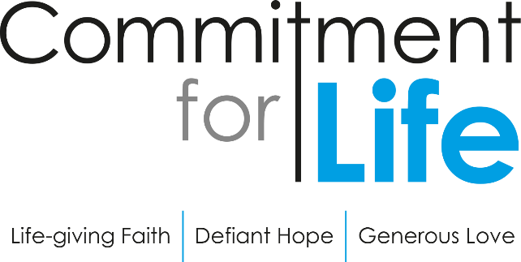
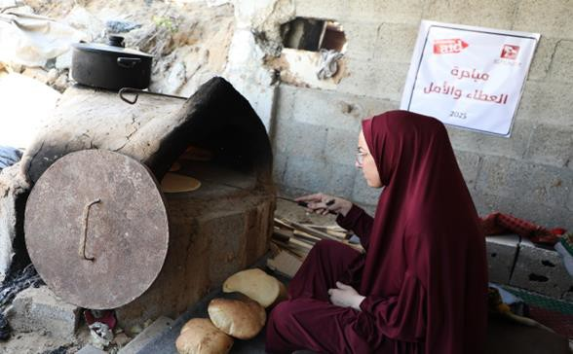
Baking bread to cope with crisis

Autumn Update Israel and occupied Palestinian territory

Gaza continues to be in the grip of a profound humanitarian emergency. Israel’s blockade of food, fuel, medicine and essentials has left people on the brink of famine.
The relentless military offensive has killed over 65,000 people and displaced almost 2 million more. In recent months accessing aid has become incredibly difficult and dangerous. Women, and especially widows are struggling to access what they need for their families.

Women are baking bread for their families and community amid a food scarcity crisis, providing much needed dignity as well as nutrition.

Christian Aid’s partner, the Women’s Affairs Centre (WAC) have started a clay ovens initiative to help meet the urgent need for food and to provide hope and opportunities for women.
As part of the initiative, women have taken full responsibility for supervising all stages of the project which reflects the resilience and capacity of the community in responding to their circumstances.
The ovens and the ingredients are provided by WAC. This allows widows in the community to access the oven and bake bread which is then sold at a symbolic price (below the inflated prices seen across Gaza).
The women involved in the project have spoken about what this
initiative has meant to them.
"After losing our home and sense of security, even a loaf of bread became a dream… The Clay Ovens initiative brought back a part of our lives and restored our feeling that we can provide for our children with dignity."
"We used to wait in line for hours at the ovens and sometimes return empty-handed… Now the fire is ours, the bread comes from our own
The Restore Campaign
For too long the UK Government has backed the world’s biggest polluters and greediest corporate lenders, whose reckless actions are fueling the climate and debt crises – robbing communities of their futures.
It doesn’t have to be this way. Join God’s world to restore creation and see the flourishing of all people. Find out more: caid.org.uk/restore.
hands, and the joy in our children’s
eyes is greater than anything."
"The bread we once struggled to find now comes out of our hands… The Clay Ovens initiative not only filled our stomachs but also filled our hearts with hope."
Thank you for your continued support and prayer which is providing food and a sense of hope and dignity to women living through the crisis in Gaza.

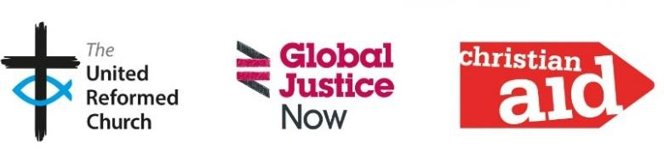
www.bit.ly/URCFL Facebook @comm4life
Commitment For Life, 86 Tavistock Place, London WC1H 9RT Tel 020 7916 8638
Eng and Wales charity no. 1105851 Scot charity no. SC039150 Company no. 5171525 Christian Aid Ireland: NI charity no. NIC101631
Company no. NI059154 and ROI charity no. 20014162 Company no. 426928. The Christian Aid name and logo are trademarks of Christian Aid. © Christian Aid October 2025. Christian Aid is a key member of Act Alliance. Photo Credit: Christian Aid/WAC

