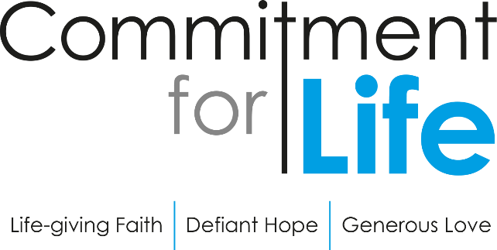
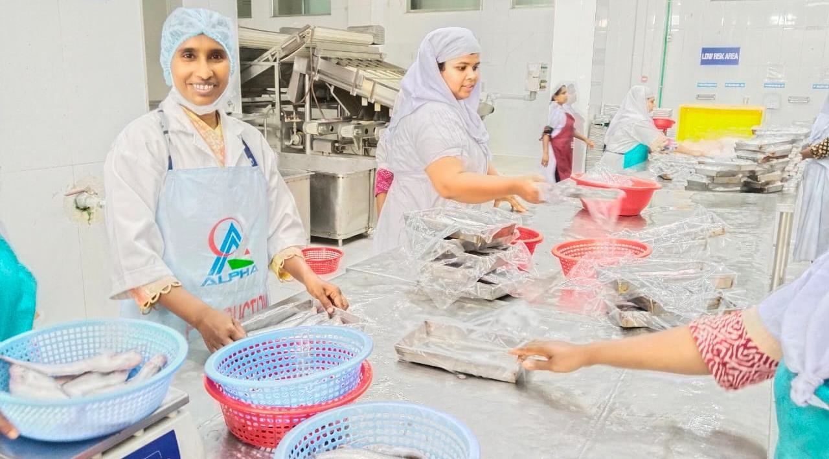
Courage and Leadership

Autumn Update

Bangladesh

For many women in the coastal areas of Bangladesh, working conditions and climate change cause vulnerability and suffering.
Low wages, limited awareness of rights and a lack of access to benefits offered by the government all make life more challenging for women. This was the situation facing Shiuli Begum from Chhoto Khajura in Bagerhat District.

Shiuli at the seafood factory where she was able to secure a pay rise for female workers after rights training from Christian Aid partner KN.

Shiuli works in a factory processing fish and seafood. She grew up in a family with five siblings supported by her mother. When her mother passed away Shiuli had to leave school to help provide for the family and she started working in a seafood processing factory.
Shiuli’s earnings helped to educate her siblings. She later married and had a baby boy but is now raising her young son alone.
Christian Aid partner Karmojibi Nari (KN) started a training programme in Bagerhat among seafood and agricultural workers and Shiuli joined their training sessions. The meetings helped women learn about organisation, leadership skills and rights.
Shiuli said “Karmojibi Nari made us aware of our rights and showed us the way to claim them.”
Following the training Shiuli led a movement demanding increased wages for female workers and she secured a rise from 2BDT to
3.5BDT per unit.
Shiuli also helps vulnerable people in her community. She volunteers at a clinic and helps people to access government support like disability benefits and allowances for widows and the elderly. She has also helped organisations providing cows and latrines.
Shiuli has now moved on from the seafood factory and is working as
The Restore Campaign
For too long the UK Government has backed the world’s biggest polluters and greediest corporate lenders, whose reckless actions are fuelling the climate and debt crises – robbing communities of their futures.
It doesn’t have to be this way. Join God’s world to restore creation and see the flourishing of all people. Find out more: caid.org.uk/restore
a caretaker at the local kindergarten. She hopes to stand with those who are vulnerable, raise awareness about rights. She is bringing up her son to be an honest and educated young man. She says, “Just as I fought for others’ rights, I want to continue standing for people and fighting for women’s rights.”
Thank you for your support through Commitment for Life which is empowering women to raise their voices for justice and develop leadership skills.

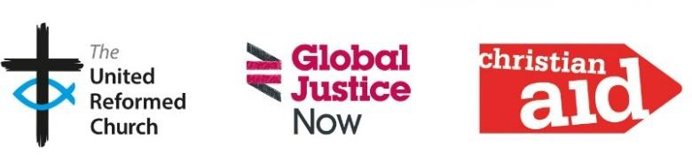
www.bit.ly/URCFL Facebook @comm4life
Commitment For Life, 86 Tavistock Place, London WC1H 9RT Tel 020 7916 8638
Eng and Wales charity no. 1105851 Scot charity no. SC039150 Company no. 5171525 Christian Aid Ireland: NI charity no. NIC101631
Company no. NI059154 and ROI charity no. 20014162 Company no. 426928. The Christian Aid name and logo are trademarks of Christian Aid. © Christian Aid October 2025. Christian Aid is a key member of Act Alliance. Photo Credit: Christian Aid/WAC

