
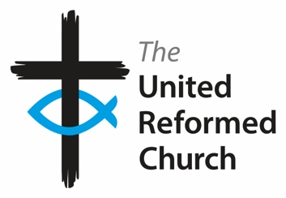
Tuesday 23 September, 2025

UK Recognition of Palestinian Statehood: A Step Toward Justice and Peace
The UK Prime Minister, Sir Keir Starmer, has formally announced the UK's recognition of the State of Palestine. This marks a significant and welcome shift in British foreign policy, moving away from using recognition as leverage in negotiations, and instead affirming the Palestinians’ inherent right to self-determination and equal participation in peace talks.
This decision, in line with similar moves by other nations, increases international pressure on Israel over its occupation policies and the ongoing crisis in Gaza, which many experts, including most recently, the United Nations Independent International Commission of Inquiry on the Occupied Palestinian Territory, including East Jerusalem, and Israel, have described as genocide.
Critics, including the Israeli government, argue that this recognition rewards terrorism and undermines peace. However, the Prime Minister made it clear that Hamas must have no role in any future government. Importantly, millions of Palestinians have resisted occupation through non-violent means for generations – this recognition is a long-overdue acknowledgment of their peaceful struggle.
We welcome this new stance by the British Government and urge it not only to recognise Palestinian statehood but also to use every diplomatic channel to secure an immediate ceasefire, humanitarian access, and a renewed commitment to a just peace.
Revd Richard Andrew,
President of the Methodist Conference, Methodist Church in Britain

Revd Dr John Bradbury,
General Secretary, United Reformed Church

Matt Forsyth, Vice-President of the Methodist Conference, Methodist Church in Britain

