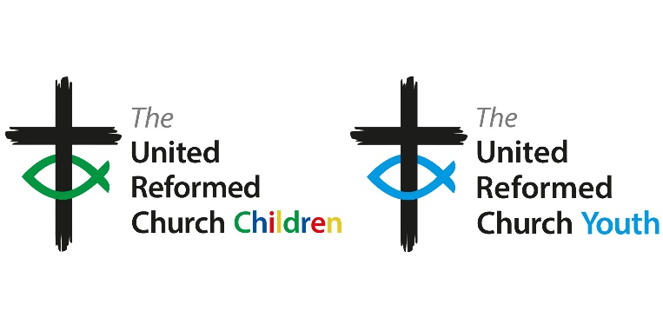

**Person Specification for Member of Children’s and Youth Programme Enabling Group**

**Role: Children’s Advocate**

|  |  |  |
| --- | --- | --- |
| **Requirements** | **Essentials** | **Desirable** |
| Experience and knowledge | * Current experience working with children in a local church context * A commitment to the discipleship development of children and young people | * Part of wider network of children’s work * Some training in children’s work * Willingness to advocate for children within and outside the workings of the Children’s and Youth Programme Enabling Group * An understanding of the structures of the URC |
| Skills and abilities | * Ability to consult creatively with children aged 0-12 * Working collaboratively with a diverse range of people * IT skills – Microsoft Office, Zoom and email | * Ability and confidence to speak during committee style meetings and challenge existing thinking and structures as appropriate |
| Other | * Member of the United Reformed Church * A commitment to inclusivity and diversity * Awareness of safeguarding and its golden thread through the life of the church | * Able to attend one residential (24 hour) meeting per year plus two other online/hybrid meetings * Able to serve for two years |