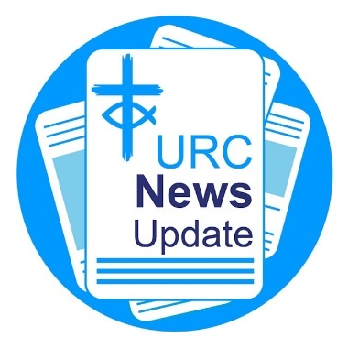News Update August 2025

Keeping you informed with the latest news from around the URC.

General Assembly 2025

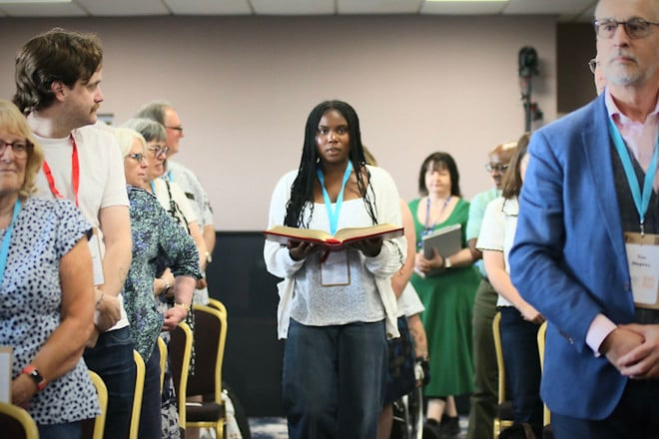

General Assembly 2025 took place on 4-7 July at The Hayes Conference Centre in Swanwick. Round-ups of all the business discussed and the decisions made on each day of the meeting are available on the [news pages of the URC's national website](https://eur01.safelinks.protection.outlook.com/?url=https%3A%2F%2Furc-news.org.uk%2Fc%2FAQi9nAcQvs7TARiQ6YjmASDSmoUpVHCy3sh3DchT0wrH9BtFQQisNP3GloTsI4SWJ3VK7Sg&data=05%7C02%7Csara.foyle%40urc.org.uk%7C7b271b786a8f4bfa123808ddcb9468c4%7C3fd368e1f1d74a1e8e4045a843b55e89%7C0%7C0%7C638890560474526394%7CUnknown%7CTWFpbGZsb3d8eyJFbXB0eU1hcGkiOnRydWUsIlYiOiIwLjAuMDAwMCIsIlAiOiJXaW4zMiIsIkFOIjoiTWFpbCIsIldUIjoyfQ%3D%3D%7C0%7C%7C%7C&sdata=ZcH9fr7TXJNxH%2F62CdqzJFDNoem4POQ89F7IcjL52dI%3D&reserved=0). Some highlights can be found below.

Moderator 2025-2026 inducted

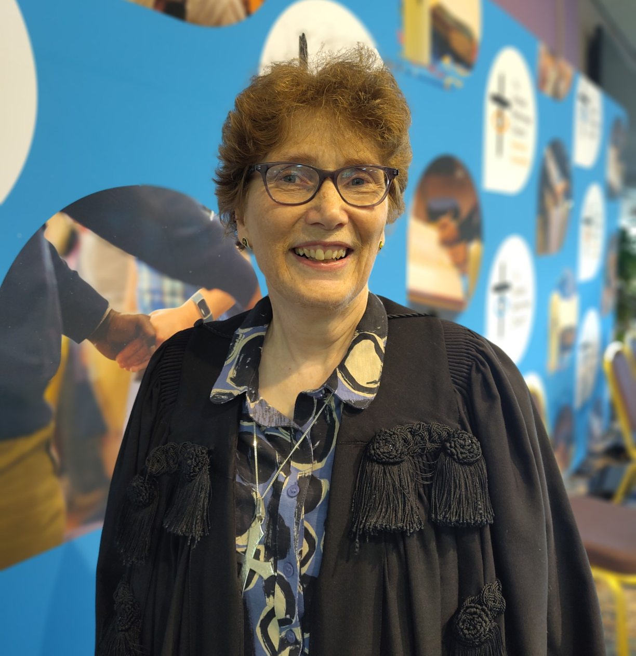

Catriona Wheeler, an Elder and Church Secretary at Trinity URC Lincoln, was inducted as Moderator at the 2025 meeting of the United Reformed Church General Assembly, held at the Hayes Conference Centre in Swanwick from 4-7 July. Catriona will chair the General Assembly’s November 2025 and July 2026 meetings. The Revd Neil Thorogood, former Principal of Westminster College in Cambridge, was elected as Moderator from 2026-2027. [Learn all about Catriona](https://eur01.safelinks.protection.outlook.com/?url=https%3A%2F%2Furc-news.org.uk%2Fc%2FAQi9nAcQvs7TARiQ6YjmASCD9oMp0BxQ-qWoU70vnF_queb34eU6pdhj--NT3QRJuvkikis&data=05%7C02%7Csara.foyle%40urc.org.uk%7C7b271b786a8f4bfa123808ddcb9468c4%7C3fd368e1f1d74a1e8e4045a843b55e89%7C0%7C0%7C638890560474540739%7CUnknown%7CTWFpbGZsb3d8eyJFbXB0eU1hcGkiOnRydWUsIlYiOiIwLjAuMDAwMCIsIlAiOiJXaW4zMiIsIkFOIjoiTWFpbCIsIldUIjoyfQ%3D%3D%7C0%7C%7C%7C&sdata=Sbv4INjRhbBohThkDZhp315HzeLjBrVZ2YO%2B%2BOPh3TA%3D&reserved=0).

Place for Hope

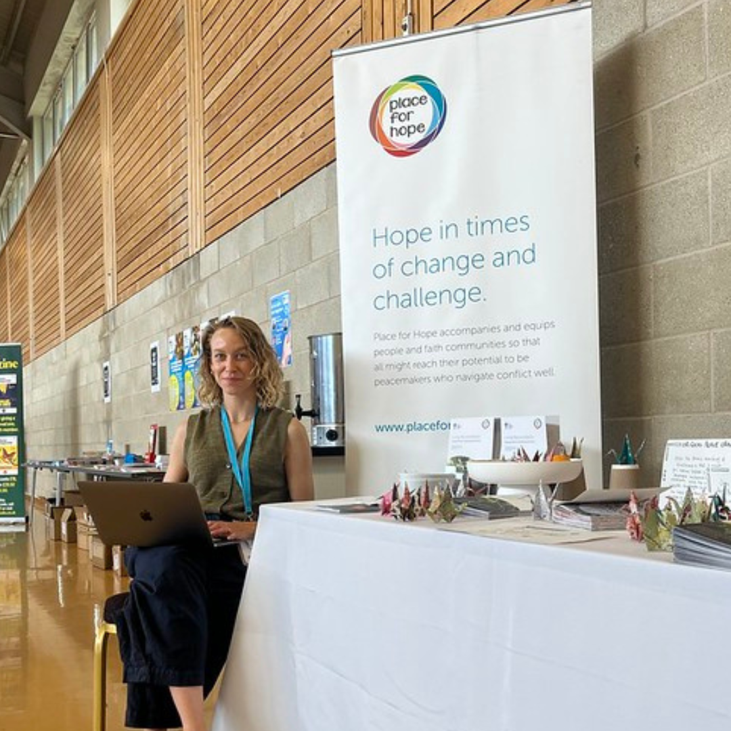

The URC's mediation team, trained by Place for Hope, launched at General Assembly. The five-year Living Reconciliation Partnership between the organisation and the URC was agreed at Assembly Executive in February 2024. At General Assembly, Martha Hunt, leader of Living Reconciliation Programme, spoke of her excitement at reaching this point and said that the objective was to embed a culture of peace-making in the URC. [Learn more about the partnership](https://eur01.safelinks.protection.outlook.com/?url=https%3A%2F%2Furc-news.org.uk%2Fc%2FAQi9nAcQvs7TARiQ6YjmASCQrIYpLCLNlwAQQw7wKbud0UyzE7YjgalhOpJaY6_gBkUwgUI&data=05%7C02%7Csara.foyle%40urc.org.uk%7C7b271b786a8f4bfa123808ddcb9468c4%7C3fd368e1f1d74a1e8e4045a843b55e89%7C0%7C0%7C638890560474554314%7CUnknown%7CTWFpbGZsb3d8eyJFbXB0eU1hcGkiOnRydWUsIlYiOiIwLjAuMDAwMCIsIlAiOiJXaW4zMiIsIkFOIjoiTWFpbCIsIldUIjoyfQ%3D%3D%7C0%7C%7C%7C&sdata=BkCpxoqCrRBTqwi5C72GCiUHYph0lZ66obSfbJy8NMk%3D&reserved=0).

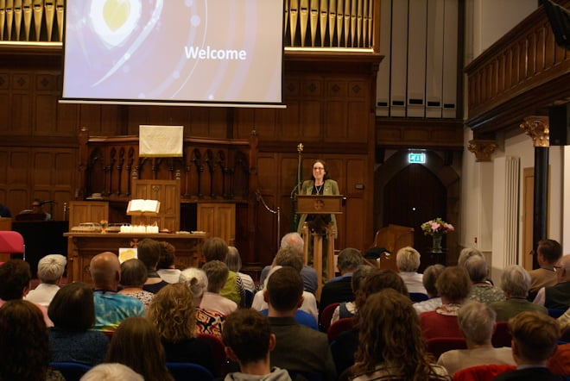Celebration marks 25th anniversary of the National Synod of Scotland

More than 100 people gathered on 14 June at St Matthew’s Church in Perth to celebrate 25 years of the National Synod of Scotland. Drawing on the words of theologian Jürgen Moltmann, the event encouraged participants to prepare themselves and their communities for God's promises through the resurrection of Christ. Guests from across the wider URC — including representatives from Wales, Northern and Mersey Synods, URC Communications, the Church Life Review team, Christian Aid, and A Place for Hope — joined in a day of workshops, worship, and fellowship. Sessions explored themes such as justice, storytelling, intergenerational ministry, and joyful singing, with a keynote Communion reflection from the Very Revd Sally Foster-Fulton, Church of Scotland General Assembly Moderator. The gathering was both a milestone celebration and a powerful reminder of the hope that continues to inspire the Synod’s life and witness.

Northern College merges

|  |
| --- |
|  |
| |  |  |  |  |  | | --- | --- | --- | --- | --- | | |  |  |  |  | | --- | --- | --- | --- | |  |  |  |  | | |

Northern College, a URC Resource Centre for Learning, is joining with Northern Baptist Church and the Luther King Centre to become Luther King Theological College. Along with the URC, the college will serve Baptist and many more Christian denominations and churches. Watch the video above for more information.

Lundie Memorial Award

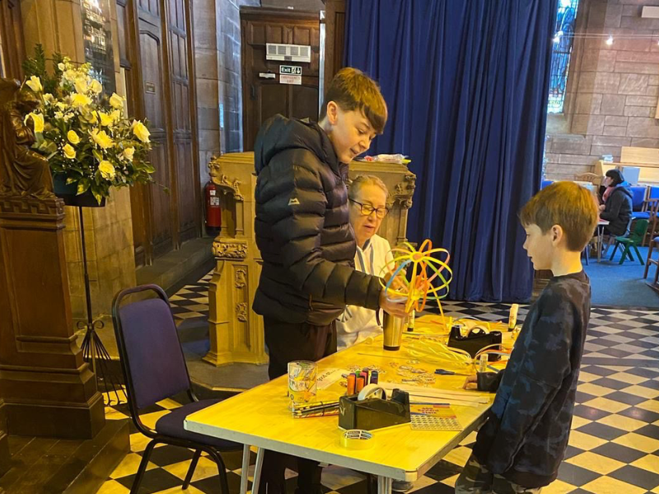

James Ineichen, 14, from Mersey Synod, has gained June’s Lundie Memorial Award. Nominated by Susan Frowe, Elder and Messy Church leader at Christchurch Port Sunlight, James is praised for his natural teaching skills and the joy he brings to working with children. “The children love working with James,” Susan says. “And it’s clear he loves working with them too.” Congratulations, James — a well-deserved recognition for your dedication and gift for inspiring others. [Learn all about James' efforts](https://eur01.safelinks.protection.outlook.com/?url=https%3A%2F%2Furc-news.org.uk%2Fc%2FAQi9nAcQvs7TARiQ6YjmASD_nYQpVCls6-YNgtbAIjAQ9SdM0bwPFq-ixi_xsyqvUQ9iHFI&data=05%7C02%7Csara.foyle%40urc.org.uk%7C7b271b786a8f4bfa123808ddcb9468c4%7C3fd368e1f1d74a1e8e4045a843b55e89%7C0%7C0%7C638890560474596085%7CUnknown%7CTWFpbGZsb3d8eyJFbXB0eU1hcGkiOnRydWUsIlYiOiIwLjAuMDAwMCIsIlAiOiJXaW4zMiIsIkFOIjoiTWFpbCIsIldUIjoyfQ%3D%3D%7C0%7C%7C%7C&sdata=oswJkaMSv4dFrFisp3YIddZvIGBXDF0Rg%2BovgzP9x8o%3D&reserved=0).

World Communion of Reformed Churches celebrates 150th anniversary

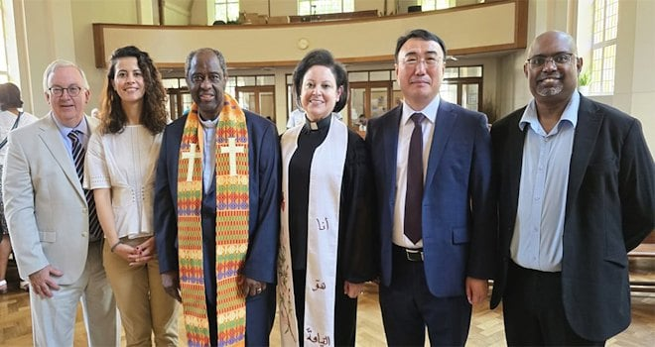

The World Communion of Reformed Churches (WCRC) celebrated 150 years of faith, unity and hope in a moving service held on 12 July. Hosted by the URC at its American International Church in the Thames North Synod, the anniversary highlighted the power of music as an act of resistance and renewal amid a fractured world. Learn how this global communion continues to inspire justice, inclusivity and perseverance as it looks to the future, [visit the WCRC website](https://eur01.safelinks.protection.outlook.com/?url=https%3A%2F%2Furc-news.org.uk%2Fc%2FAQi9nAcQvs7TARiQ6YjmASCMmIcpPRaTv4_6GmQOoDW_jdzENFXzs299TJG3d4E9_YaTP4Y&data=05%7C02%7Csara.foyle%40urc.org.uk%7C7b271b786a8f4bfa123808ddcb9468c4%7C3fd368e1f1d74a1e8e4045a843b55e89%7C0%7C0%7C638890560474610553%7CUnknown%7CTWFpbGZsb3d8eyJFbXB0eU1hcGkiOnRydWUsIlYiOiIwLjAuMDAwMCIsIlAiOiJXaW4zMiIsIkFOIjoiTWFpbCIsIldUIjoyfQ%3D%3D%7C0%7C%7C%7C&sdata=t09WLmv9tOBXJD3cFmTazu5C6bHdyBqewuWQ6yVq5vA%3D&reserved=0).

*Image: WCRC*

Explore the Bible's big story with new course

The Bible Society's *Bible Course New Edition* is now available. This new and improved, free small group resource can help individuals and churches discover how Bible characters, stories, and themes are connected, from Genesis to Revelation. Join more than 140k people who have already done the Bible course, made up of eight sessions with films, a course Guidebook and a Digital Hub. [Register for free](https://eur01.safelinks.protection.outlook.com/?url=https%3A%2F%2Furc-news.org.uk%2Fc%2FAQi9nAcQvs7TARiQ6YjmASCP-IQpkFQGlaN8Xd26lRjO8nHhcMaCWjW-hDha2yBenhquGKY&data=05%7C02%7Csara.foyle%40urc.org.uk%7C7b271b786a8f4bfa123808ddcb9468c4%7C3fd368e1f1d74a1e8e4045a843b55e89%7C0%7C0%7C638890560474624313%7CUnknown%7CTWFpbGZsb3d8eyJFbXB0eU1hcGkiOnRydWUsIlYiOiIwLjAuMDAwMCIsIlAiOiJXaW4zMiIsIkFOIjoiTWFpbCIsIldUIjoyfQ%3D%3D%7C0%7C%7C%7C&sdata=HmbbwwSSzWj1kbzly0JvrCqzt4TU9S92n7kCj5TAwvE%3D&reserved=0).

Prayers around Terminally Ill Adults (End of Life) Bill

The URC is offering prayers to help congregations navigate issues around assisted dying. On 20 June, MPs narrowly approved the landmark Terminally Ill Adults (End of Life) Bill by 314 votes to 291. If passed into law, the Bill could bring major social change by giving terminally ill adults in England and Wales the legal right to end their own lives. [Use the prayers](https://eur01.safelinks.protection.outlook.com/?url=https%3A%2F%2Furc-news.org.uk%2Fc%2FAQi9nAcQvs7TARiQ6YjmASCRuoQpBpbaYVJfew3jNLWfcE210jdXWBRh-njAqA9EvF0M6hY&data=05%7C02%7Csara.foyle%40urc.org.uk%7C7b271b786a8f4bfa123808ddcb9468c4%7C3fd368e1f1d74a1e8e4045a843b55e89%7C0%7C0%7C638890560474637706%7CUnknown%7CTWFpbGZsb3d8eyJFbXB0eU1hcGkiOnRydWUsIlYiOiIwLjAuMDAwMCIsIlAiOiJXaW4zMiIsIkFOIjoiTWFpbCIsIldUIjoyfQ%3D%3D%7C0%7C%7C%7C&sdata=6d1z%2BziQUe2Zbf6YmswnR8mEQ%2B5u%2FNk%2F8sCuIISZ6c8%3D&reserved=0).

URC presence at mass climate lobby

Five of the URC’s network of Green Apostles and the Thames North Synod Moderator the Revd George Watt, along with the Revd David Coleman, Chaplain for Eco Congregation Scotland, joined with 5,000 people to urge the UK government to "Act Now, Change Forever’ on climate justice. The mass lobby was organised by the Climate Coalition, the UK’s largest group of individuals and organisations dedicated to tackling climate change and restoring nature, with input from Faith for the Climate. The Joint Public Issues Team had a presence there too. MPs were invited to meet with groups of constituents to discuss leadership, local action and impacts, the popularity of action on climate change and a just transition away from fossil fuels to a truly green, sustainable economy. Individuals and churches can still get involved more locally in upcoming events during "Lobby Week’" taking place between 13-20 September. [Learn more about the Climate Coalition](https://eur01.safelinks.protection.outlook.com/?url=https%3A%2F%2Furc-news.org.uk%2Fc%2FAQi9nAcQvs7TARiQ6YjmASDT5oUpplMEXJtBen_xz1f3jFSwnV8HfrzrAdP0UtLI8gdcOM0&data=05%7C02%7Csara.foyle%40urc.org.uk%7C7b271b786a8f4bfa123808ddcb9468c4%7C3fd368e1f1d74a1e8e4045a843b55e89%7C0%7C0%7C638890560474652625%7CUnknown%7CTWFpbGZsb3d8eyJFbXB0eU1hcGkiOnRydWUsIlYiOiIwLjAuMDAwMCIsIlAiOiJXaW4zMiIsIkFOIjoiTWFpbCIsIldUIjoyfQ%3D%3D%7C0%7C%7C%7C&sdata=maw7syxcszIjdP6HuBP6Spe1jK4oXbf5fDE2Khyu5Z8%3D&reserved=0), [including free summer workshops that are available](https://eur01.safelinks.protection.outlook.com/?url=https%3A%2F%2Furc-news.org.uk%2Fc%2FAQi9nAcQvs7TARiQ6YjmASDT5oUpplMEXJtBen_xz1f3jFSwnV8HfrzrAdP0UtLI8gdcOM0&data=05%7C02%7Csara.foyle%40urc.org.uk%7C7b271b786a8f4bfa123808ddcb9468c4%7C3fd368e1f1d74a1e8e4045a843b55e89%7C0%7C0%7C638890560474652625%7CUnknown%7CTWFpbGZsb3d8eyJFbXB0eU1hcGkiOnRydWUsIlYiOiIwLjAuMDAwMCIsIlAiOiJXaW4zMiIsIkFOIjoiTWFpbCIsIldUIjoyfQ%3D%3D%7C0%7C%7C%7C&sdata=maw7syxcszIjdP6HuBP6Spe1jK4oXbf5fDE2Khyu5Z8%3D&reserved=0).

Download or print News Update

A downloadable version of News Update, formatted for print, and for churches to copy and paste into church newsletters or magazines will be available within a week of this edition being published. [Download your printable version of News Update](https://eur01.safelinks.protection.outlook.com/?url=https%3A%2F%2Furc-news.org.uk%2Fc%2FAQi9nAcQvs7TARiQ6YjmASD444MpefYbK3S4XnLV9LrYSzm4hcvTIm9RuER3JRGbAc4GoU0&data=05%7C02%7Csara.foyle%40urc.org.uk%7C7b271b786a8f4bfa123808ddcb9468c4%7C3fd368e1f1d74a1e8e4045a843b55e89%7C0%7C0%7C638890560474668137%7CUnknown%7CTWFpbGZsb3d8eyJFbXB0eU1hcGkiOnRydWUsIlYiOiIwLjAuMDAwMCIsIlAiOiJXaW4zMiIsIkFOIjoiTWFpbCIsIldUIjoyfQ%3D%3D%7C0%7C%7C%7C&sdata=pKOCnAv9Vsp%2FtNkFDrHsrP0WZjUdTV0r1ch%2B%2BpPvSdg%3D&reserved=0).

Share your good news

If you have a good news story that can inspire, raise hope or show God's work in action then please let URC Communications know. We would love to help share your news across the denomination and in local news outlets. [Email the URC Comms Team](mailto:pressoffice@urc.org.uk) or call 07976 753 950

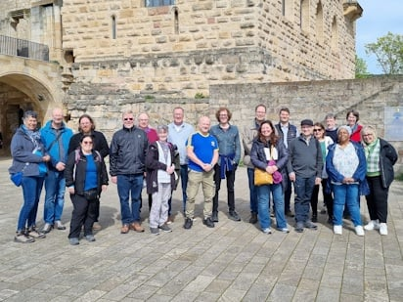Friends of the Pfalz webinar

Does your church have links with the German Evangelische Kirche der Pfalz (Evangelical Church of the Palatinate)? Mission's next webinar for Friends of the Pfalz will take place on Thursday 25 September at 7pm: please join to hear stories and updates on the link between our two churches. Friends of other European churches (for example the Eglise Protestante and the Waldensian Church in Italy) would be very welcome as the team seeks explore deepening connections in Europe. Please email [mission@urc.org.uk](mailto:mission@urc.org.uk) for the Zoom link.

This month in *Reform* magazine

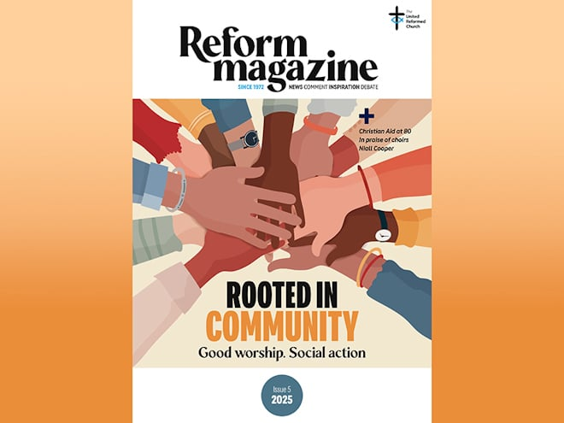

The work of “prophetic activism” runs powerfully through the latest edition of *Reform*. Niall Cooper, stepping down after 28 years as Director of Church Action on Poverty, argues that churches have more power to bring about change than they realise. A group of church members quiz Lib Dems leader Ed Davey on climate change, and in the first of our reports on the 2025 winners of the URC’s Community Project Awards, volunteers at a meal-sharing project in Flintshire describe how it’s sometimes the simple ideas that have the greatest lasting power. In *Reform’s* Bible study, 'Chapter and Verse', Laurence Wareing asks what prophetic action should look like today, and we mark the 80th anniversary of the aid agency Christian Aid with an interview with Andrew Tomlinson of Christian Aid Scotland. Elsewhere, Kevin Snyman is worried that “many Christians seem unaware of the dangers of selling off key aspects of their faith to empire”, Sam Richards says “intergenerational church” is the future, regular columnist Sheila Maxey learns from taking a back seat, and Paul Kerensa berates AI’s ability to turn private grief into clickbait. The Issue 5/2025 edition of *Reform* is out now. [Subscribe to *Reform* digitally or in print](https://eur01.safelinks.protection.outlook.com/?url=https%3A%2F%2Furc-news.org.uk%2Fc%2FAQi9nAcQvs7TARiQ6YjmASCV2Icpteep6amwSyL2_v8usDXMASzMNkadMW1ejWwcaeEUoA0&data=05%7C02%7Csara.foyle%40urc.org.uk%7C7b271b786a8f4bfa123808ddcb9468c4%7C3fd368e1f1d74a1e8e4045a843b55e89%7C0%7C0%7C638890560474682913%7CUnknown%7CTWFpbGZsb3d8eyJFbXB0eU1hcGkiOnRydWUsIlYiOiIwLjAuMDAwMCIsIlAiOiJXaW4zMiIsIkFOIjoiTWFpbCIsIldUIjoyfQ%3D%3D%7C0%7C%7C%7C&sdata=JzcGUmW%2BUvVaTalaJ0SOhyprSUVjGPG9vwfDSJH9UPg%3D&reserved=0). For any queries, please [email the *Reform* team](mailto:reform@urc.org.uk).

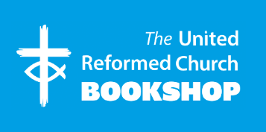

Please order online using the URC Bookshop’s easy-to-use website [www.urcshop.co.uk](http://www.urcshop.co.uk) or by calling 020 7916 8629.

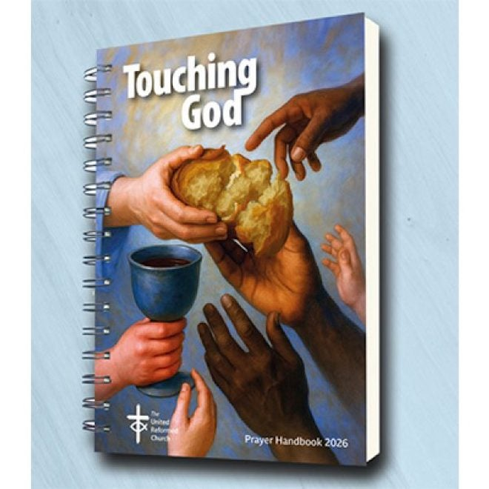

[*Touching God – The 2026 URC Prayer Handbook*](https://eur01.safelinks.protection.outlook.com/?url=https%3A%2F%2Furc-news.org.uk%2Fc%2FAQi9nAcQvs7TARiQ6YjmASCf9okp0a7Ar1U5xYsIT18t6I1wdFxy1XNRJRUYscsG6n0fAgI&data=05%7C02%7Csara.foyle%40urc.org.uk%7C7b271b786a8f4bfa123808ddcb9468c4%7C3fd368e1f1d74a1e8e4045a843b55e89%7C0%7C0%7C638890560474709226%7CUnknown%7CTWFpbGZsb3d8eyJFbXB0eU1hcGkiOnRydWUsIlYiOiIwLjAuMDAwMCIsIlAiOiJXaW4zMiIsIkFOIjoiTWFpbCIsIldUIjoyfQ%3D%3D%7C0%7C%7C%7C&sdata=PKmAGLlUE2u853diSm5hO3kC8YgxAiYPR3oc7W9bQ7I%3D&reserved=0) (preorder). Available from early Setpember, the 2026 URC Prayer Handbook is the first from new editors Susan Durber and Jonnie Hill. It comes in A5 and A4 Lectern editions. The prayers in this 2026 edition come from many diverse writers, both from within and beyond the URC. All of them are shaped by scripture; the lectionary-based prayers in the first part, but no less the prayers for worship together and private devotion in the second part. £6.99 – £14.99 + p&p.

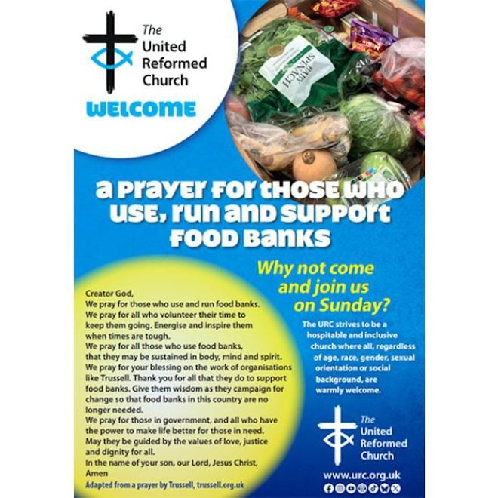

[Food banks prayer poster](https://eur01.safelinks.protection.outlook.com/?url=https%3A%2F%2Furc-news.org.uk%2Fc%2FAQi9nAcQvs7TARiQ6YjmASCywYUpEG7gSS_C1BCLlk3CoAPrVwXykFP0zFl2B3hG4dr447Q&data=05%7C02%7Csara.foyle%40urc.org.uk%7C7b271b786a8f4bfa123808ddcb9468c4%7C3fd368e1f1d74a1e8e4045a843b55e89%7C0%7C0%7C638890560474722541%7CUnknown%7CTWFpbGZsb3d8eyJFbXB0eU1hcGkiOnRydWUsIlYiOiIwLjAuMDAwMCIsIlAiOiJXaW4zMiIsIkFOIjoiTWFpbCIsIldUIjoyfQ%3D%3D%7C0%7C%7C%7C&sdata=w4tt5FzuUneM0mP1TSnu0chWJb6x%2FlxMEkxLGE2OspY%3D&reserved=0) - A free poster for you to place in rooms used by those who use, run and support food banks, aimed at connecting volunteers and users of food banks with the church with a dedicated prayer and an invitation to Sunday worship. Printed in A2 size with A3 on the reverse to suit your needs. Postage and package apply. A poster for [uniformed organisations meeting in churches](https://eur01.safelinks.protection.outlook.com/?url=https%3A%2F%2Furc-news.org.uk%2Fc%2FAQi9nAcQvs7TARiQ6YjmASCzwYUp-weHwjbESfcK3hmqc5_HAph0Cdl72TuQBv3hBaARUiA&data=05%7C02%7Csara.foyle%40urc.org.uk%7C7b271b786a8f4bfa123808ddcb9468c4%7C3fd368e1f1d74a1e8e4045a843b55e89%7C0%7C0%7C638890560474735593%7CUnknown%7CTWFpbGZsb3d8eyJFbXB0eU1hcGkiOnRydWUsIlYiOiIwLjAuMDAwMCIsIlAiOiJXaW4zMiIsIkFOIjoiTWFpbCIsIldUIjoyfQ%3D%3D%7C0%7C%7C%7C&sdata=BA%2FhMSftEEXcdG1FN%2B%2FGScVWGQQ3N5WESf8P4BHkngY%3D&reserved=0), those at [weight loss clubs](https://eur01.safelinks.protection.outlook.com/?url=https%3A%2F%2Furc-news.org.uk%2Fc%2FAQi9nAcQvs7TARiQ6YjmASC0wYUp8D8VDrATcJRRQhJvtH9CmGXaux7QeEVRxzthz2GxVoU&data=05%7C02%7Csara.foyle%40urc.org.uk%7C7b271b786a8f4bfa123808ddcb9468c4%7C3fd368e1f1d74a1e8e4045a843b55e89%7C0%7C0%7C638890560474748389%7CUnknown%7CTWFpbGZsb3d8eyJFbXB0eU1hcGkiOnRydWUsIlYiOiIwLjAuMDAwMCIsIlAiOiJXaW4zMiIsIkFOIjoiTWFpbCIsIldUIjoyfQ%3D%3D%7C0%7C%7C%7C&sdata=5x3Oc3CJVgGwL4uuz%2BSfsEkCdo0%2FetrhpwKU%2FYEMdjc%3D&reserved=0), and for [environmental groups](https://eur01.safelinks.protection.outlook.com/?url=https%3A%2F%2Furc-news.org.uk%2Fc%2FAQi9nAcQvs7TARiQ6YjmASCi9okpdJa2XGKcnHrGJeYEAotrkwqXouaFNlU9O6TU01rwYgE&data=05%7C02%7Csara.foyle%40urc.org.uk%7C7b271b786a8f4bfa123808ddcb9468c4%7C3fd368e1f1d74a1e8e4045a843b55e89%7C0%7C0%7C638890560474761138%7CUnknown%7CTWFpbGZsb3d8eyJFbXB0eU1hcGkiOnRydWUsIlYiOiIwLjAuMDAwMCIsIlAiOiJXaW4zMiIsIkFOIjoiTWFpbCIsIldUIjoyfQ%3D%3D%7C0%7C%7C%7C&sdata=BPjK6q4c1cyJDju%2FyHLyxSOHaLhfQDVoJobtdM18eIE%3D&reserved=0) is also available.



[Advent 2025 Resource](https://eur01.safelinks.protection.outlook.com/?url=https%3A%2F%2Furc-news.org.uk%2Fc%2FAQi9nAcQvs7TARiQ6YjmASDpwIUpdW8qtxDWNWJ-QIr9pc0plkKSV_HNqMtM-Ap6p2UgzEc&data=05%7C02%7Csara.foyle%40urc.org.uk%7C7b271b786a8f4bfa123808ddcb9468c4%7C3fd368e1f1d74a1e8e4045a843b55e89%7C0%7C0%7C638890560474773963%7CUnknown%7CTWFpbGZsb3d8eyJFbXB0eU1hcGkiOnRydWUsIlYiOiIwLjAuMDAwMCIsIlAiOiJXaW4zMiIsIkFOIjoiTWFpbCIsIldUIjoyfQ%3D%3D%7C0%7C%7C%7C&sdata=C2aix1U4fma0tgf43woplj4l6NXLDrAFOljfvJRFAfw%3D&reserved=0) - a gift for churches to give to families. A box of postcard sized cards—one for each day in Advent. Featuring characters from the Christmas story with fun facts and activity ideas on the reverse. Designed to be reusable, displayed like bunting or in other ways, the box includes a DIY nativity set. Pre-order at £4.25-£4.50 per pack (plus p&p) by 1 September to avoid disappointment. Contact children.youth@urc.org.uk to enquire if there is a grant towards the cost.



[2026 URC Pocket Diaries](https://eur01.safelinks.protection.outlook.com/?url=https%3A%2F%2Furc-news.org.uk%2Fc%2FAQi9nAcQvs7TARiQ6YjmASDqwIUpx48_yPMwmbs-uCSX3T7Tr1_wvDmTswoWjMO_PwcgwlU&data=05%7C02%7Csara.foyle%40urc.org.uk%7C7b271b786a8f4bfa123808ddcb9468c4%7C3fd368e1f1d74a1e8e4045a843b55e89%7C0%7C0%7C638890560474786639%7CUnknown%7CTWFpbGZsb3d8eyJFbXB0eU1hcGkiOnRydWUsIlYiOiIwLjAuMDAwMCIsIlAiOiJXaW4zMiIsIkFOIjoiTWFpbCIsIldUIjoyfQ%3D%3D%7C0%7C%7C%7C&sdata=PmGOjmH4FVzuyu1p%2FrWqrCFisNRP9jmz65FnI%2FXrsuY%3D&reserved=0), available in blue or red, includes the following: calendars to 2028, year planners to 2028, notable dates for the URC and the wider Church, metric measures, Lectionary readings, Assembly officers and URC staff, useful addresses, Assembly committee details, and more. £9 +p&p.



[Welcome from your Elder cards](https://eur01.safelinks.protection.outlook.com/?url=https%3A%2F%2Furc-news.org.uk%2Fc%2FAQi9nAcQvs7TARiQ6YjmASC5wYUpS16EsEflYF00drGXGg1zFRLai7O7c4-C5_FgmhV5Wio&data=05%7C02%7Csara.foyle%40urc.org.uk%7C7b271b786a8f4bfa123808ddcb9468c4%7C3fd368e1f1d74a1e8e4045a843b55e89%7C0%7C0%7C638890560474799620%7CUnknown%7CTWFpbGZsb3d8eyJFbXB0eU1hcGkiOnRydWUsIlYiOiIwLjAuMDAwMCIsIlAiOiJXaW4zMiIsIkFOIjoiTWFpbCIsIldUIjoyfQ%3D%3D%7C0%7C%7C%7C&sdata=PUk5JqjKs%2FSxGzvgyErSHhYXv2CCE8f2mtoEwPZ%2B9vw%3D&reserved=0) - A pack of 25 cards for Elders to introduce themselves to the members they help to look after, or to remind church members about who their Elder is annually, or for after an election of Elders. With space on the reverse to write the member’s name, the Elder’s name and contact details. See images for details. £2.99 +p&p.

Synod news

National Synod of Wales

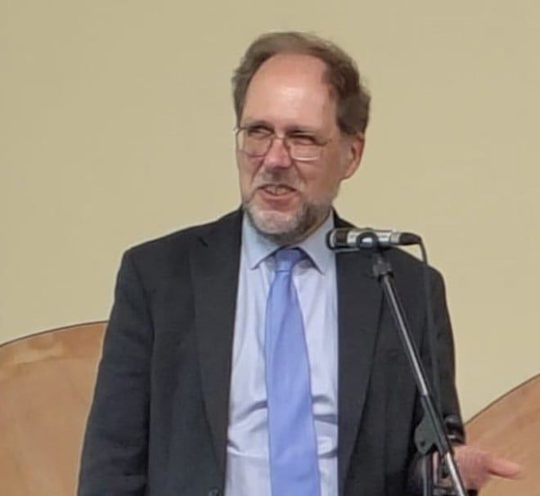

The Revd Gethin Rhys, serving in Cardiff, has been honoured with one of Wales' highest honour, a Blue Robe by Gorsedd Cymru in Wrecsam. The awards recognise Welsh cultural figures who are honoured for their contributions to the Welsh language and public life. [Learn more](https://eur01.safelinks.protection.outlook.com/?url=https%3A%2F%2Furc-news.org.uk%2Fc%2FAQi9nAcQvs7TARiQ6YjmASDfpoQpt9sLnW5ouOfupVmqSG3HocU3jL8Uu5MvRiPEj2FfzDQ&data=05%7C02%7Csara.foyle%40urc.org.uk%7C7b271b786a8f4bfa123808ddcb9468c4%7C3fd368e1f1d74a1e8e4045a843b55e89%7C0%7C0%7C638890560474812676%7CUnknown%7CTWFpbGZsb3d8eyJFbXB0eU1hcGkiOnRydWUsIlYiOiIwLjAuMDAwMCIsIlAiOiJXaW4zMiIsIkFOIjoiTWFpbCIsIldUIjoyfQ%3D%3D%7C0%7C%7C%7C&sdata=z%2BQ68m0WHMpIPAEZU8kb0OvohihPGGXqRHRcWMeK1TE%3D&reserved=0).

Mersey

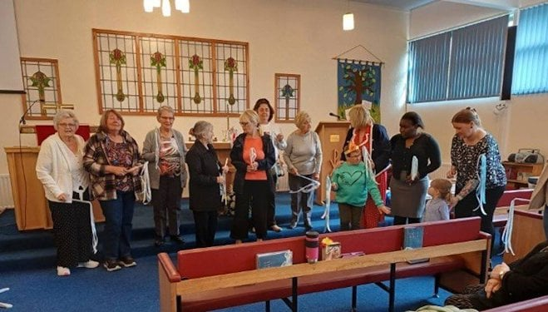

Peasley Cross URC recently celebrated five years of bringing its Sunday congregation and families together through Messy Church. This followed the Messy Church format with a time of celebration, songs, stories, crafts and food.

Eastern

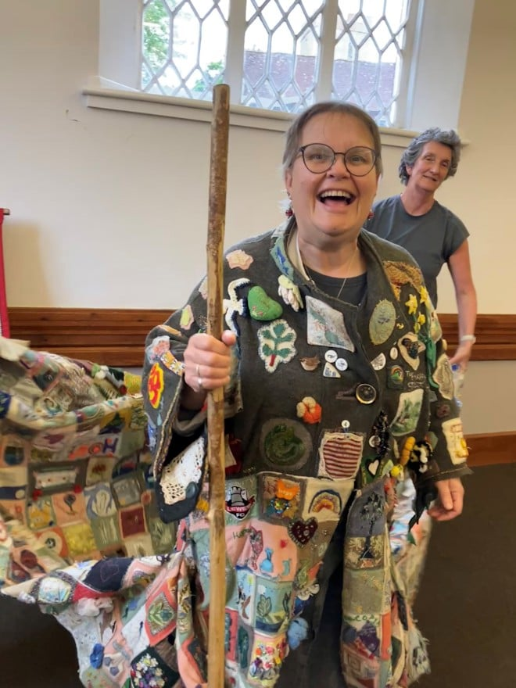

Maldon URC welcomed the Coat of Hopes in June, offering hospitality to its accompanying pilgrims. Created by artist Barbara Keal for COP26 in 2021, the patchwork coat carries hopes for climate action. Three pilgrims, led by Helen Locke, walked with the coat through Essex, stopping in Maldon for storytelling, song, and reflection. The Revd Anne Sardeson called the experience “powerful,” capturing both the weight of crisis and the warmth of community. The visit was hosted by Maldon URC’s Eco Church group.

Southern

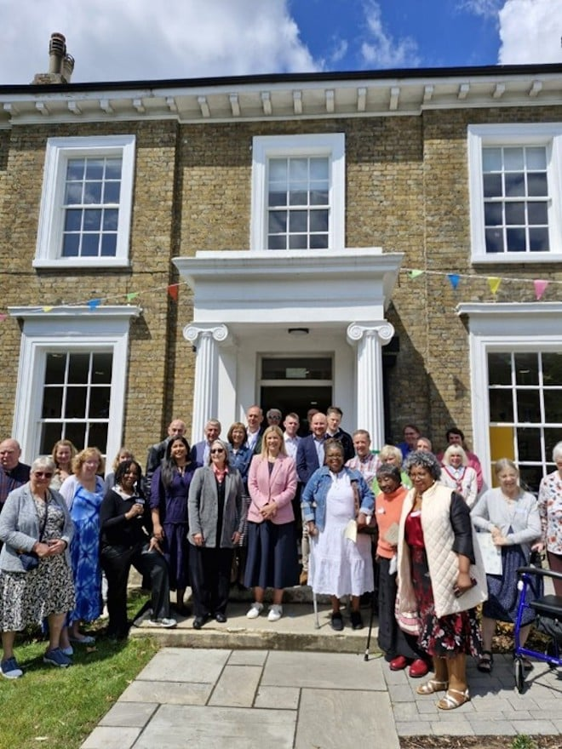

The Grove Centre Church in Sydenham, South London officially opened its newly refurbished Grove Centre House in June. The church, which is a combined Baptist and URC, has always endeavoured to be a “A Place for People”. The building was previously inaccessible, tired and failing to meet the direct needs of our many user groups. The project, which has been 16 years in the planning and delivery, has transformed the facility into a bright, airy and fully accessible space with a lift providing access to offices and meeting spaces on the first floor.

What's On

Talking faith day

Join East Midlands Synod for a free day of inspiration and fellowship on 13 September at St Martins House Conference Centre in Leicester from 10am-3pm. The day will explore the Synod's focus of *Talking Faith*. With opening worship and keynote by the Revd Louise Franklin, Revd Stuart Radcliffe, and Emma Jackson, plus workshops from the Revds Martin Ferris, Lindsey Brown, and others. The day ends with a short Bible study. All are welcome! Spaces are limited. [Book your place](https://eur01.safelinks.protection.outlook.com/?url=https%3A%2F%2Furc-news.org.uk%2Fc%2FAQi9nAcQvs7TARiQ6YjmASCQuoQpUjvlwiaOGd2Ghvlb1brqcDTPk5uynyaSTPiC6uUd-x0&data=05%7C02%7Csara.foyle%40urc.org.uk%7C7b271b786a8f4bfa123808ddcb9468c4%7C3fd368e1f1d74a1e8e4045a843b55e89%7C0%7C0%7C638890560474828673%7CUnknown%7CTWFpbGZsb3d8eyJFbXB0eU1hcGkiOnRydWUsIlYiOiIwLjAuMDAwMCIsIlAiOiJXaW4zMiIsIkFOIjoiTWFpbCIsIldUIjoyfQ%3D%3D%7C0%7C%7C%7C&sdata=SlaBJowEJlBEry8PKIodr8S0AarBQ73ibf5sCbnD%2F9g%3D&reserved=0).

Church leadership taster

Looking to deepen your theoretical and practical understandings of reflective practice? Gain a flavour of the Church Leadership Programme during a taster session taking place on 13 August via Zoom. During the taster session, which takes place from 7-8pm, you'll also have the opportunity to ask questions. To register your interest, [please email Christine Hufton](mailto:christine.hufton@lutherking.ac.uk), PA to the Principal. [Learn more about the Church Leadership Programme](https://eur01.safelinks.protection.outlook.com/?url=https%3A%2F%2Furc-news.org.uk%2Fc%2FAQi9nAcQvs7TARiQ6YjmASDll4cpGNe7Js7dglP77b_UybqFUU67_YUEqyg0KnrZu4PIE2c&data=05%7C02%7Csara.foyle%40urc.org.uk%7C7b271b786a8f4bfa123808ddcb9468c4%7C3fd368e1f1d74a1e8e4045a843b55e89%7C0%7C0%7C638890560474855332%7CUnknown%7CTWFpbGZsb3d8eyJFbXB0eU1hcGkiOnRydWUsIlYiOiIwLjAuMDAwMCIsIlAiOiJXaW4zMiIsIkFOIjoiTWFpbCIsIldUIjoyfQ%3D%3D%7C0%7C%7C%7C&sdata=e22LWSSkfiOkJH4mOBiSqA4ce06R27sA6sX60U8i%2F6A%3D&reserved=0).

Youth mental health first aid training

Youth mental health first aid training for people living, working and volunteering with young people aged eight-18 takes place online over four, live sessions with a qualified course instructor. Sessions take place from 9.30am-1pm on 22, 24, 29 September and 1 October. You will need to attend all four live sessions for the full duration to complete the course. The course is open to participants associated with local URCs and linked local ecumenical partnerships. Places cost £38.79 for URC/LEP people and for Southern Synod people places are free. **Please email the Southern Synod CYDO** with queries. [Book your place on Eventbrite](https://eur01.safelinks.protection.outlook.com/?url=https%3A%2F%2Furc-news.org.uk%2Fc%2FAQi9nAcQvs7TARiQ6YjmASDS14cpOd8Av3O8gcSJniR56W3K_GE10RqvJ_d_aP6a2yPFhq0&data=05%7C02%7Csara.foyle%40urc.org.uk%7C7b271b786a8f4bfa123808ddcb9468c4%7C3fd368e1f1d74a1e8e4045a843b55e89%7C0%7C0%7C638890560474881335%7CUnknown%7CTWFpbGZsb3d8eyJFbXB0eU1hcGkiOnRydWUsIlYiOiIwLjAuMDAwMCIsIlAiOiJXaW4zMiIsIkFOIjoiTWFpbCIsIldUIjoyfQ%3D%3D%7C0%7C%7C%7C&sdata=0iaPfBfehBYt1lrkxdy6MvUhyk28D8twPa5kQgw%2FvSU%3D&reserved=0).

Church leadership course

Want to develop healthy leadership in ministry?

Why not join the next Church Leadership Programme cohort starting in September. The programme, run by Luther King, formerly Northern College, offers blended learning for lay and ordained leaders, focusing on reflective practice to sustain healthy leadership. Through tutor-led sessions, self-reflective tasks, and journaling, participants will gain deeper insight into their leadership style, strengths, and areas for growth. To register your interest and for more information, [please email Christine Hufton](mailto:christine.hufton@lutherking.ac.uk), PA to the Principal by 12pm on 30 August.

URC children's conference

URC Children’s Workers Together 2025 conference takes place 28-30 November at Highgate House Conference Centre in Northampton. This year's theme is "participation" and the keynote is Peter Privett of the Godly Play and Child Theology Movement. Peter is also co-author of Through the Eyes of a Child. To book your place, [please email children.youth@urc.org.uk](mailto:children.youth@urc.org.uk). Full weekend places cost £210. Funding is available through Synods or Pilots.

Recruitment

URC vacancies and beyond

[Certificates of Eligibility](https://eur01.safelinks.protection.outlook.com/?url=https%3A%2F%2Furc-news.org.uk%2Fc%2FAQi9nAcQvs7TARiQ6YjmASDqvYUpnUodlqXeprkTESvX2npkwpOjIx-43aiIqS5zGRZkU5o&data=05%7C02%7Csara.foyle%40urc.org.uk%7C7b271b786a8f4bfa123808ddcb9468c4%7C3fd368e1f1d74a1e8e4045a843b55e89%7C0%7C0%7C638890560474894568%7CUnknown%7CTWFpbGZsb3d8eyJFbXB0eU1hcGkiOnRydWUsIlYiOiIwLjAuMDAwMCIsIlAiOiJXaW4zMiIsIkFOIjoiTWFpbCIsIldUIjoyfQ%3D%3D%7C0%7C%7C%7C&sdata=u%2BUP6JaqlXusg9uLmxIwffsJkcedMjpP%2FUf4xXpGBy8%3D&reserved=0)

Ministers wishing to transfer to the United Reformed Church can seek a Certificate of Eligibility to come on to the Roll of Ministers of the United Reformed Church. Applications are welcome from ministers who are members of churches that are either a member of Churches Together in Britain and Ireland, the Council for World Mission, the World Communion of Reformed Churches. Please apply by 31 July.

[Member of the Faith in Action Committee](https://eur01.safelinks.protection.outlook.com/?url=https%3A%2F%2Furc-news.org.uk%2Fc%2FAQi9nAcQvs7TARiQ6YjmASCI44UpXaqKtrtA0FDU78wyhI8j0-z3k0zI6QVYjw9NuRUvsLg&data=05%7C02%7Csara.foyle%40urc.org.uk%7C7b271b786a8f4bfa123808ddcb9468c4%7C3fd368e1f1d74a1e8e4045a843b55e89%7C0%7C0%7C638890560474909231%7CUnknown%7CTWFpbGZsb3d8eyJFbXB0eU1hcGkiOnRydWUsIlYiOiIwLjAuMDAwMCIsIlAiOiJXaW4zMiIsIkFOIjoiTWFpbCIsIldUIjoyfQ%3D%3D%7C0%7C%7C%7C&sdata=G2ZBspmQtYVzOrTiyPDeIm3kZ0NYpJhB7sZxXqojihg%3D&reserved=0)

The URC is seeking members for its new Faith in Action Committee with a focus on Mission or Children and Youth/Intergenerational or Lay learning/Education and Learning. The roles are voluntary. Full details and terms of reference can be found on the URC Jobs page.

[Represent the United Reformed Church on the Milton Mount Foundation Board](https://eur01.safelinks.protection.outlook.com/?url=https%3A%2F%2Furc-news.org.uk%2Fc%2FAQi9nAcQvs7TARiQ6YjmASChvoUpahiSg-n57AGOL4wVuhAcwUobEyjrE0Sv_HTCpD4Cdz0&data=05%7C02%7Csara.foyle%40urc.org.uk%7C7b271b786a8f4bfa123808ddcb9468c4%7C3fd368e1f1d74a1e8e4045a843b55e89%7C0%7C0%7C638890560474922469%7CUnknown%7CTWFpbGZsb3d8eyJFbXB0eU1hcGkiOnRydWUsIlYiOiIwLjAuMDAwMCIsIlAiOiJXaW4zMiIsIkFOIjoiTWFpbCIsIldUIjoyfQ%3D%3D%7C0%7C%7C%7C&sdata=H43P58kpd49%2B6AaRF7tgM6tw8taTwtuUf%2FyECJpwE8c%3D&reserved=0)

Are you passionate about education and the life of the Church? The Milton Mount Foundation is seeking a United Reformed Church (URC) member to join its Board of Trustees and help guide its mission of educational support.

[Accreditations Sub-Committee Convenor](https://eur01.safelinks.protection.outlook.com/?url=https%3A%2F%2Furc-news.org.uk%2Fc%2FAQi9nAcQvs7TARiQ6YjmASCCvoUpWsEAFzbgYF68LakCjUEqLnUGlXBTpwe9M8RgAz1a3pg&data=05%7C02%7Csara.foyle%40urc.org.uk%7C7b271b786a8f4bfa123808ddcb9468c4%7C3fd368e1f1d74a1e8e4045a843b55e89%7C0%7C0%7C638890560474935835%7CUnknown%7CTWFpbGZsb3d8eyJFbXB0eU1hcGkiOnRydWUsIlYiOiIwLjAuMDAwMCIsIlAiOiJXaW4zMiIsIkFOIjoiTWFpbCIsIldUIjoyfQ%3D%3D%7C0%7C%7C%7C&sdata=OoGfrY9XcaQP1Md67qyBHFYNLaPXCSurSt0BCrtg8XA%3D&reserved=0)

Do you have a passion to support people who release the church in its local community to flourish in faith, hope and love? Then this could be the opportunity for you! The Ministries Committee is looking for a convener for its Accreditations Sub-Committee to replace its current convenor who completed their term at July's General Assembly.