United Reformed Church Commitment for Life September/October 2025





Committed to supporting our global partners FAIRTRADE FORTNIGHT SPECIAL

Fairtrade Fortnight 2025 – September 22 to October 4
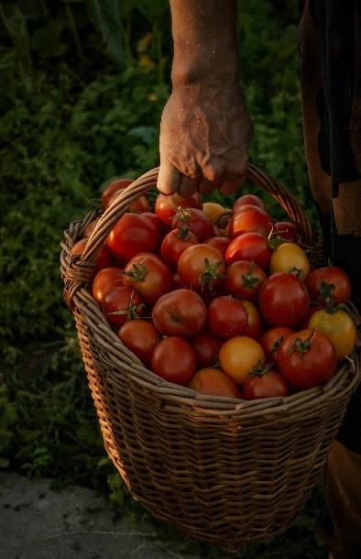
Commitment for life supports
Fairtrade Foundation, which is one way in which your congregation can bring about justice as part of the
global fair-trade movement.
Photo credit: © valentina-ivanova-9dP1n8WliJ0-unsplash
2025 Harvest Service
The Commitment for Life 2025 Harvest Service ‘Harvesting Hope’ is now available on the website and for download. bit.ly/44WfyfV

Harvest Prayer
Lord of the Harvest, you are the creator of the world, and everything we see causes us to praise you.
We praise you for the harvest of the land, the sea, and sky.
We praise you for our harvest of food.
We praise you for the harvest of industry.
On this harvest day, we remember the farmers who work tirelessly on the land.
On this harvest day, we remember those in the global south who are facing challenging times with climate disruption and unfair prices.
On this harvest day, we give thanks for the work of Fairtrade Foundation as they seek to raise awareness to fair trade and bring justice to some of the poorer parts of the world.
Amen.

Fairtrade Fortnight was established in 1997 and is the longest-running awareness campaign for fair trade.
This is a two-week campaign dedicated to raising awareness about fair trade. It encourages consumers to make ethical choices when purchasing products.

The event highlights the importance of fair wages, ethical sourcing, sustainable farming practices, invest in communities and businesses, and improve living standards.
Fairtrade works with farmers and workers in more than 1,900 producer organisations across 68 countries.

Resources: Check the website: www.fairtrade.org.uk/what-is-fairtrade

Ways in which you can support:
- Choose Fairtrade Products: Look for the Fairtrade logo on products such as coffee, tea, chocolate, bananas, and clothing. Use your Commitment for Life key fob as a reminder to buy Faritrade products.
- Host Fairtrade Events: Organize events in your community or workplace to raise awareness about fair trade.
- Educate and Advocate: Learn more about fair trade and its impact on producers. See www.fairtrade.org.uk/what-is-fairtrade
- Buy Fairtrade Gifts: Consider purchasing Fairtrade gifts for special occasions. These gifts not only delight the recipient but also support fair trade producers.
- Worship: Consider integrating Fairtrade into the life of your place of worship and become a Fairtrade Place of Worship see bit.ly/4fmp7sk Hold events during Fairtrade Fortnight or create a display or a Fairtrade theme within a service.

