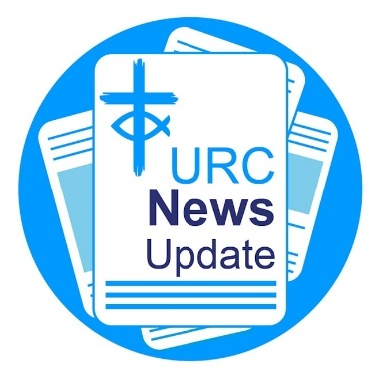
News Update July 2025

Keeping you informed with the latest news from around the URC

Second oldest local URC celebrates its 400th anniversary
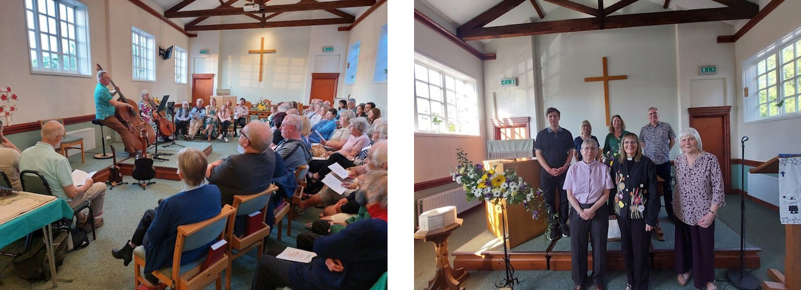

Friends past and present gathered at the second oldest church in the URC, and one of the oldest nonconformist churches in the country, for a special celebration. On 11 May, Epping URC celebrated its 400th anniversary. To mark the event, a special service, which included a concert and a talk reflecting on the church’s 400-year history, was held. Also included in the celebrations were special video messages from its twinned congregation at Mbare UPCSA in Harare, Zimbabwe, and a presentation by the junior church.
Learn more about Epping URC and its 400th anniversary.

General Assembly 2025


General Assembly 2025 takes place from 4-7 July at The Hayes Conference Centre in Swanwick. Items on the agenda include an update on the Church Life Review, a review of the URC retirement policy for ministers and CRCWs, the criteria for 13 new pioneering posts, Place for Hope mediation team launch, the 2025 Community Awards and much more
Full round-ups of each day's business and the decisions made will be published on the URC's news page. Papers to be discussed are available on the General Assembly page.
CWM gains new member churches
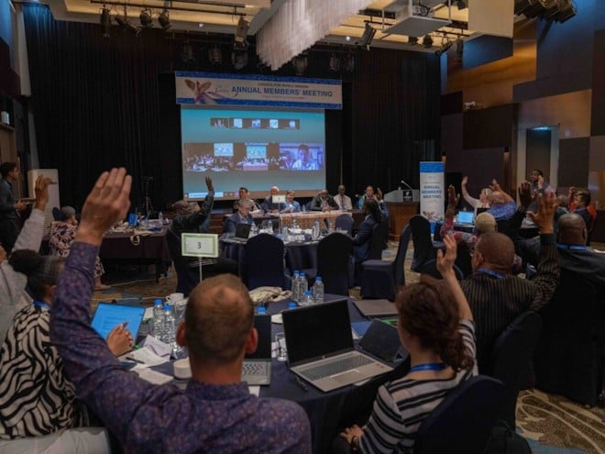
The Council for World Mission (CWM) welcomed four new member churches into its global family on the second day of its annual members' meeting, held in South Korea from 16-18 June. The four new churches are: the Presbyterian Church of Mauritius, the Presbyterian Church of Trinidad and Tobago, the Presbyterian Church of Vanuatu, and the Cook
Islands Christian Church.
Learn more about the historic decision.
Image: ©CWM

Churches Together England welcomes Tessa Henry-Robinson

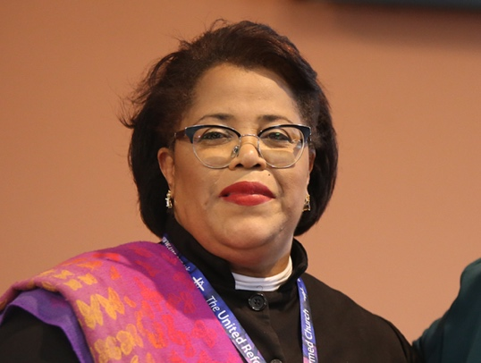
The Revd Dr Tessa Henry-Robinson, who was inducted as Moderator of the Free Churches Group in April and who also acts as one of the Presidents of Churches Together in England (CTE), spoke to CTE’s Senior Communications Manager, Sarah Ball (SB) about her deep-rooted commitment to Christian unity, her ecumenical upbringing in Trinidad and Tobago, and her belief that unity is not about erasing difference but embracing it with love, humility, and shared purpose. Read the interview.

St Paul's Cathedral gains a new Honorary Ecumenical Canon
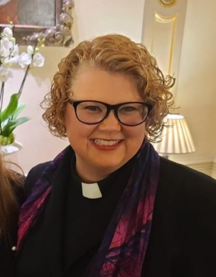
The Revd Jennifer Mills-Knutsen, Senior Pastor of the American International Church, a United Reformed Church in the Thames North Synod, has been made an Honorary Ecumenical Canon of St Paul’s Cathedral. The title of Honorary Ecumenical Canon is appointed to those from other Christian denominations to recognise their contributions to the broader Christian community and promoting interdenominational unity. Jennifer said: "I am humbled and honoured by the Bishop’s invitation
and recognition.”

National Synod of Wales Moderator made Ecumenical Canon

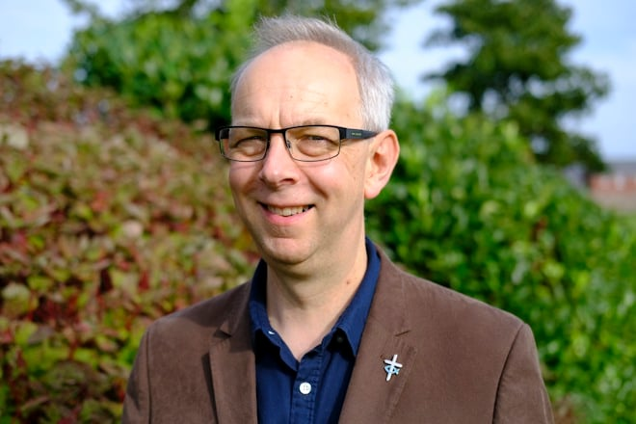
The Revd David Salsbury, Moderator of the United Reformed Church National Synod of Wales, is to be made an Ecumenical Canon of Newport Cathedral. In total, the Rt Revd Cherry Vann, the Bishop of Monmouth who leads the Diocese of Monmouth within the Church in Wales, appointed three new Canons to the cathedral. They all will be installed at a service on 16 November. David called the appointment an honour and a privilege. Learn more about David's new appointment.
Become a URC minister

Ministers of churches that are members of either Churches Together in Britain and Ireland, the Council for World Mission, or the World Communion of Reformed Churches (WCRC) wishing to transfer to the URC can seek a Certificate of Eligibility to come on to our Roll of Ministers. Please submit your application by 31 July. For full details, please email ministries@urc.org.uk

Free trees from the Woodland Trust

The Woodland Trust is giving away hundreds of thousands of trees to communities and is currently taking applications for tree packs to be delivered in November 2025.
Get your free pack.

Go with Greta to Transcarpathia
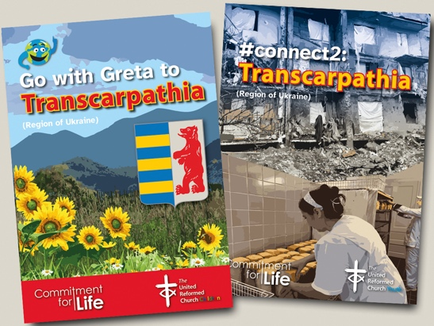
The latest Go with Greta (for children) and #connect2 (for young people) resources are now available. Created with Commitment for Life, the aim of the resources is to help children and young people engage with the URC’s mission across the world, this time looking at a region of Ukraine. Download a free copy, alternatively email to order direct from Children's and Youth Work.

Free Google My Church guide
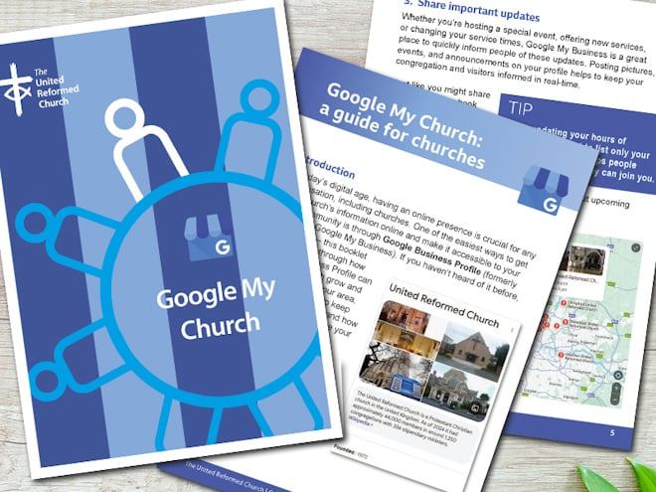
In a digital-first world, your church’s online presence is often the first point of contact for new visitors. Our free "Google My Church" guide walks you through everything you need to know about setting up and managing your church’s Google Business Profile (formerly Google My Business).
Download the URC's free guide.

EM2 summer retreat
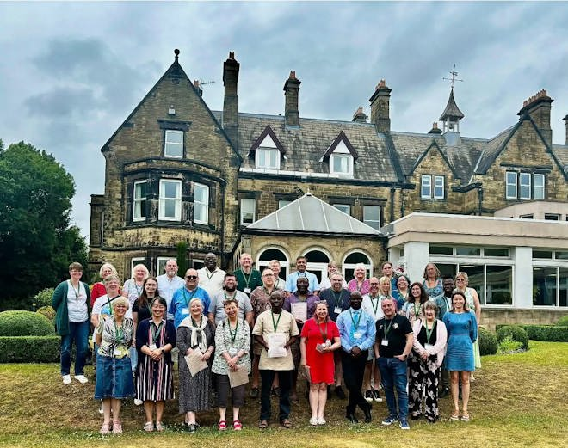
Ministers and Church Related Community Workers came together last month at The Hayes for the Education for Ministry Phase Two (EM2) Summer Retreat for a time of shared learning, reflection, and encouragement. Led by EM2 chaplains Samantha Sheehan, Sohail Ejaz and Tim Searle, with support from Philippa Linton, the Education and Learning Administrator, the retreat offered space to explore new ministry contexts alongside others on the same journey. Ministers on Certificates of Eligibility also joined what proved to be a joyful and uplifting weekend.
PCT representatives visit Mission team
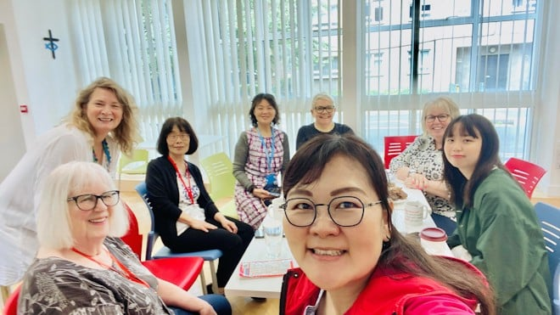
The Mission team recently welcomed the Revd Kelly Wang and Libitina Kuo, a minister and youth representative from the Presbyterian Church in Taiwan, at Church House. They were accompanied by Yufen Chen, who leads the Taiwanese Fellowship at Lumen, one of the fellowship’s lay leaders, and Barbara Redmond, Global Partnership Coordinator in the North West Synod. Kelly and Libitina enjoyed cakes and conversation with Revds Jenny Mills, Nicola Furley-Smith and Lindsey Brown before heading off on an open-top bus tour. Afterwards, they travelled north by train with Barbara for two weeks of Synod engagements.

Download or print News Update

A downloadable version of News Update, formatted for print, and for churches to copy and paste into church newsletters or magazines will be available within a week of this edition being published. Download your printable version of News Update.

Share your good news

If you have a good news story that can inspire, raise hope or show God's work in action then please let URC Communications know. We would love to help share your news across the denomination and in local news outlets. Email the URC Comms Team or call
07976 753 950.

Reform magazine

Reform magazine – one year subscription. Reform is a fresh and challenging magazine exploring theology, ethics, personal spirituality and Christian perspectives on social and current affairs. The magazine is for thinking people who enjoy reading about Christian ideas from a range of viewpoints. It features writing from journalists, academics, politicians, campaigners, scientists and religious leaders. As well as high-profile interviews, in-depth features and book, music and film reviews, Reform carries letters and regular light-hearted columns. The magazine is by the United Reformed Church but has readers from all Christian denominations, as well as readers from other faiths and from no faith tradition. The digital edition costs £18, the printed and posted edition costs £29.50 and for both it’s £35.50. For postage to Europe the cost is £49, and for the rest of the world the cost is £65. Subscribe to Reform magazine.

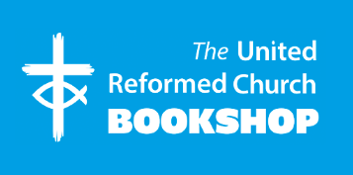
Please order online using the URC Bookshop’s easy-to-use website http://www.urcshop.co.uk/ or by calling 020 7916 8629.
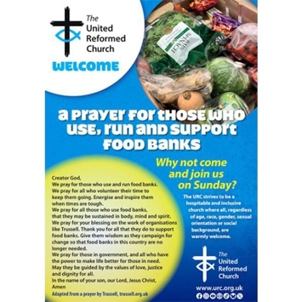
Food banks prayer poster - A free poster for you to place in rooms used by those who use, run and support od banks, aimed at connecting volunteers and users of food banks with the church with a dedicated prayer and an invitation to Sunday worship. Printed in A2 size with A3 on the reverse to suit your needs. Postage and package applies. A prayer poster for those using weight loss clubs is also available.

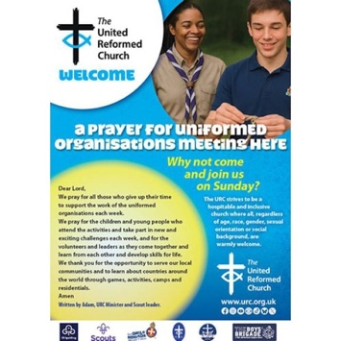
Uniformed organisations prayer poster - A free poster for you to place in rooms used by uniformed groups, such as Scouts, Guides, Boys’ Brigade, Girls’ Brigade or Pilots, aimed at connecting the members and parents of those groups with the church with a dedicated prayer and an invitation to Sunday worship. Printed in A2 size with A3 on the reverse to suit your needs. Postage and packaging applies.

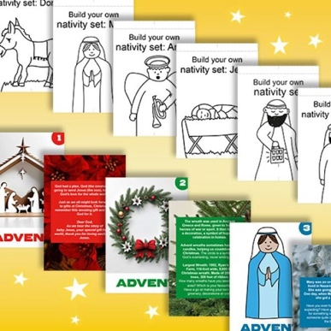
Advent 2025 Resource - a gift for churches to give to families.
A box of postcard sized cards – one for each day in Advent. Featuring characters from the Christmas story with fun facts and activity ideas on the reverse. Designed to be reusable, displayed like bunting or in other ways, the box includes a DIY nativity set. Pre-order at £4.25-£4.50 per pack (plus P&P) by 1 September to avoid disappointment. Contact children.youth@urc.org.uk for a grant towards the cost.

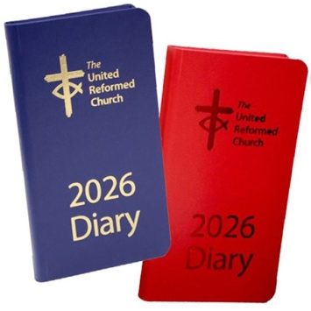
2026 URC Pocket Diaries, available in blue or red, includes the following: calendars to 2028, year planners to 2028, notable dates
for the URC and the wider Church, metric measures, Lectionary readings, Assembly officers and URC staff, useful addresses, Assembly committee details, and more. £9 +p&p.

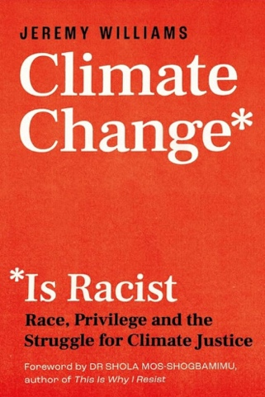
Climate Change Is Racist by Jeremy Williams. When we talk about racism, we often mean personal prejudice or institutional biases. Climate change doesn’t work that way. It is structurally racist, disproportionately caused by majority white people in majority white countries, with the damage unleashed overwhelmingly on people of colour. The book looks at environmental facts, hear the experiences of the people most affected on our planet and learns from activists leading the change. £6.49 +p&p.


URC logo lightweight eco-friendly reusable raincoat Available in URC blue, purple, yellow or pink, the new URC lightweight, branded, waterproof raincoat comes with a drawstring hood, elasticated sleeves and popper fastenings. One size fits all older children and adults (tested on an XXL male!). £5.99 +p&p.

Synod news

Eastern
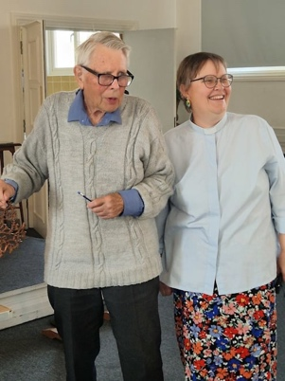
Burnham-on-Crouch URC recently thanked Stan Deacon for his long service as an Elder. Stan, who approaches his 90th birthday, is retiring after many years of service. He first became a deacon in the Burnham-on-Crouch Congregational Church when he was 21 and has served faithfully over the years since then, with a few breaks and including being Church Secretary for 40 years. He is now going to have a well-earned break, except for leading worship from time to time. The church expresses thanks for his faithfulness and love over the years.

Yorkshire
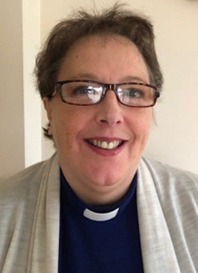
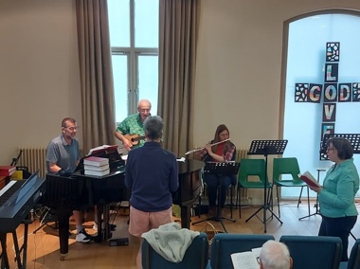
To celebrate the 50th anniversary of the creation of the local ecumenical partnership between Skipton URC, Broughton Road Methodist Church and Gargrave Road Methodist Church on Whit Sunday in 1975, and later joined by Trinity Methodist Church in 2023, the Music Group at Trinity St Andrew’s in Skipton held a "Big Church Singathon" on 24 May. Over 14 hours, from 8am-10pm, the church’s music group sang and played the first verse of 790 hymns in the Singing the Faith hymnbook, raising more than £1,631 for charity in the process.

East Midlands
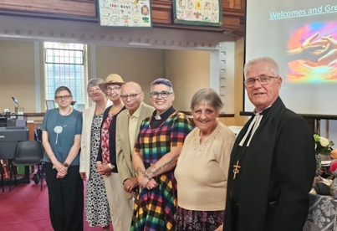
The Kettering Area Churches Partnership was inaugurated and the Revd Helen Wakefield-Carr inducted as minister at Desborough URC last month. The Revd Geoffrey Clarke, East Midlands Moderator, presided and the Charge to Minister and Churches was given by Richard Knott, the Synod's Children & Youth Development Officer.

Southern
The Revd Bridget Banks has retired early from her role as Southern Synod Moderator on health grounds. Bridget served as Synod Moderator since 2020 and before that with local churches in Crawley. The Revd Jenny Mills, Deputy General Secretary (Discipleship), said: "We are grateful for all the ways in which she has shared the gospel message of love through her calling and faithfulness. She will be missed.”

What's On

GEAR monthly prayers

Monthly prayer meetings organised by the Group for Evangelism and Renewal in the URC (GEAR) take place on the first Thursday of every month from 8-9pm. To keep updated and for details of how to join, visit the group's Pray4URC Facebook page.

URC children's conference
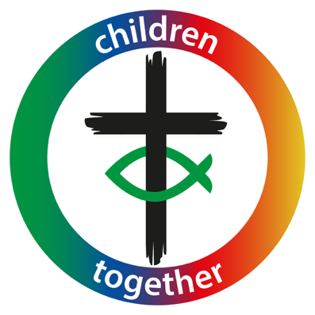
URC Children’s Workers Together 2025 conference takes place 28-30 November at Highgate House Conference Centre in Northampton. This year's theme is "participation" and the keynote is Peter Privett of the Godly Play and Child Theology Movement. Peter is also co-author of Through the Eyes of a Child.
To book your place, please email children.youth@urc.org.uk. Full weekend places cost £210. Funding is available through Synods or Pilots.

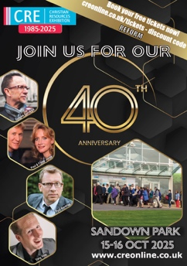
CRE 40th anniversary

Join the Christian Resources Exhibition's 40th anniversary at Sandown Park from 15-16 October. Book your tickets using the discount code "Reform".

Free Church Choirs concert
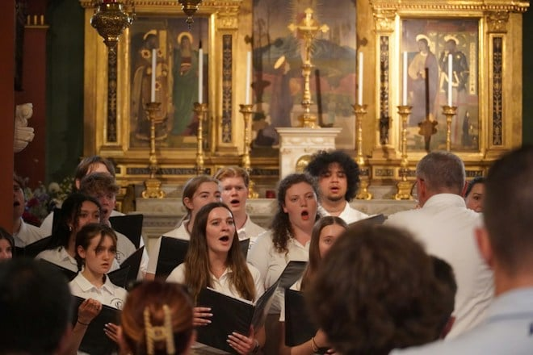
Free Church Choirs' is recruiting singers for its biennial Festival of Church Music, taking place this year on 11 October at Coventry Cathedral along the theme of "justice and freedom". Choirs and individuals are invited to join the choir of hundreds of voices in praising God.
Visit Free Church Choirs for full details and to keep updated.
Join a URC youth group on pilgrimage to Taizé

Would you like to join a URC Youth group on a Taizé Pilgrimage? A URC Youth group will be taking part in a Taizé Pilgrimage for 18-25s from 10-17 August. The trip is expected to cost no more than £350-£400 for the week. Bursaries are available to help with the cost. For more information and to register your interest by 18 July, please contact trainingpa@urc5.org.uk
Alternatively, visit the Taizé website.

Recruitment
URC vacancies and beyond

Ministers of other churches wishing to transfer to the URC can seek a Certificate of Eligibility to come on to the denomination's Roll of Ministers. Applications are welcome from ministers who are members of churches that are either a member of Churches Together in Britain and Ireland, the Council for World Mission, or the World Communion of Reformed Churches.
Apply by 31 July.

Property Administrator, East Midlands Synod
Contract: Part-time, 20 hours pw, 12-month fixed-term contract for Maternity Cover
Salary: £33,502 FTE (pro-rata).
Closing date: 13 July
For an application pack (no CVs) please contact: admin@urc5.org.uk

Accreditations Sub-Committee Convenor
Ministries Committee is looking for a convener for its Accreditations Sub-Committee to start in July. The convener will need to have working knowledge of the formal ministries of the United Reformed Church.

Represent the United Reformed Church on the Milton Mount Foundation Board
Are you passionate about education and the life of the Church? The Milton Mount Foundation is seeking a United Reformed Church (URC) member to join its Board of Trustees and help guide its mission of educational support.

