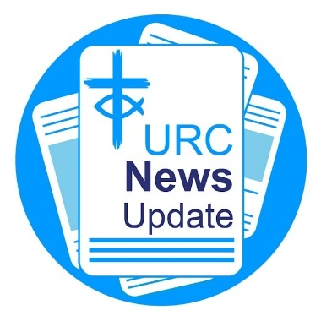News Update June 2025

Keeping you informed with the latest news from around the URC.

Local churches raise thousands for Christian Aid Week.

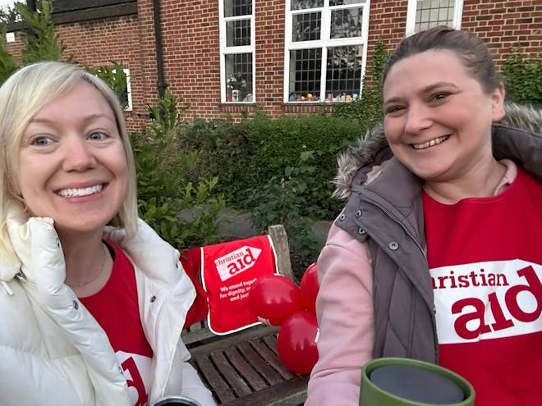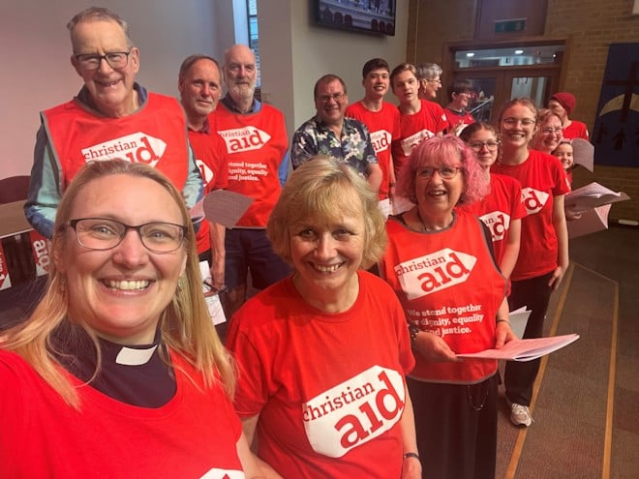

Local United Reformed Churches have raised thousands of pounds in support of Christian Aid Week. Christ Church Petts Wood in Southern Synod took on a 70K walking challenge in solidarity with millions of people who have to walk long distances for clean water or to sell their produce. The epic feat started at 5am on 16 May and ran to 12.30am on 17 May, totalling 19 hours and 27 minutes. More than £1,500 was raised in the process. Woking United Reformed Church organised a round-the-clock Praise-athon and youth camp-out, following the success of their Bible Read-athon in 2023. The epic feat saw the church raise £10,665. The Revd Lucy Brierley, Minister of Woking URC, said her congregation was thrilled with the amount raised. "This money will be shared with Christian Aid’s local partners who are making a real difference in communities around the world.”

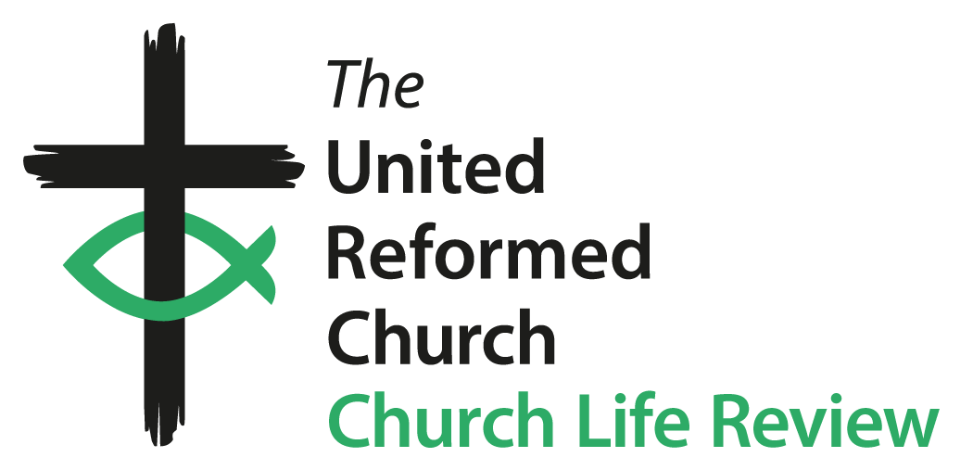Church Life Review update

The Church Life Review (CLR) Steering Group has agreed a vision, mission, and strategy statement for the programme to help audiences across the denomination get a brief overview of what the CLR is all about. Read the statement. Keep updated with the CLR on its dedicated webpage (<https://bit.ly/3Fxq2Zp>).

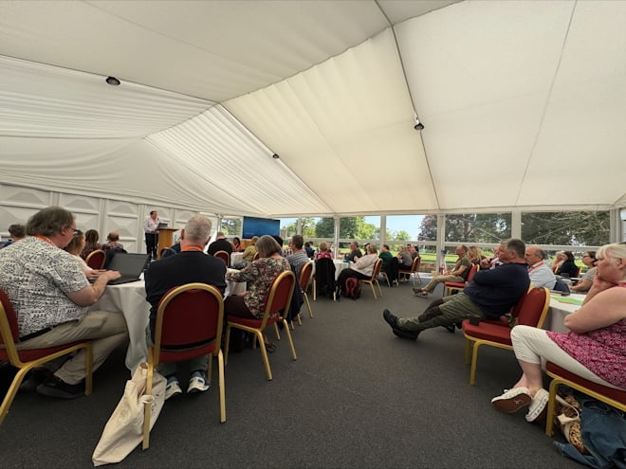Future of Education & Learning

More than 70 church leaders and educators recently gathered to explore the future shape of education and learning within the United Reformed Church. Learn all about the discussions held, themes explored and next steps (<https://bit.ly/3SCo9xp>).

A group of children in a classroom in Tanzania.
URC primary school launches campaign for new library

Barrow URC Primary School is helping to build a brighter future for girls and needs the support of the wider denomination. The primary school is hoping to raise the final £4,000 to fund a library block for a new girls' secondary school at The Bethany Project in Tanzania. With £7,000 already raised, the Barrow community is nearly at the finish line. "The vision to build a girls’ secondary school on the site will provide a safe and empowering environment for girls, protecting them from barriers such as poverty, early marriage, and unwanted pregnancy,” Headteacher Nicola McArdle said. "A library opens doors, sparks imaginations, and helps build confidence, curiosity, and independence. It’s a vital part of giving these girls the opportunities they deserve. Every single contribution, no matter how big or small, will make a real and lasting difference to the futures of these girls.” Learn how you can make a donation (<https://bit.ly/43INta3>).

National Churches Survey: help ensure the future of churches

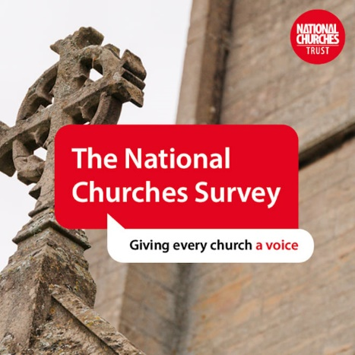The National Churches Trust is carrying out a survey to help politicians, the media, and the wider public better understand the challenges churches face and to highlight the vital work they do. Your response will provide essential evidence to build a clearer picture – to tell a stronger, more informed story about your church, and others like it, so that some of the biggest challenges facing churches can be addressed to help ensure their future. The survey closes on 30 June. Complete the survey (<https://bit.ly/43vuZet>).

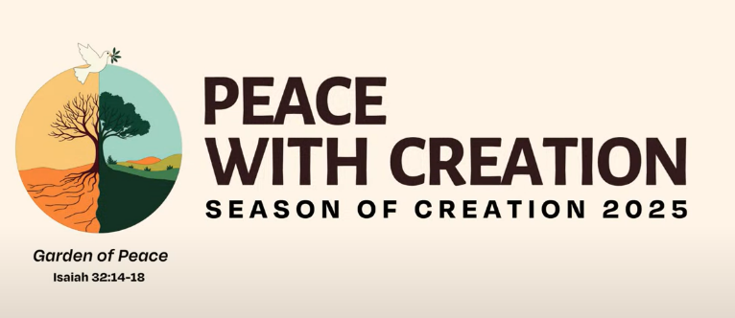Season of Creation suggestions

Suggestions for the Season of Creation are being sought. The URC's Public Issues team is hoping to share resources and ideas that have worked well so more churches can join participate in this year's events. Ideas so far include, a climate Sunday service, a nature ramble, developing a church garden, and holding a pet service. If you would like to contribute a suggestion or an example, please email [roo.stewart@urc.org.uk](mailto:roo.stewart@urc.org.uk).

Calculate your church's social value

The National Churches Trust has created a free online calculator to help churches calculate the social and economic value they bring to their local community. The results help demonstrate how churches positively impact their local area and can provide useful information for grant applications or fundraising. Access the calculator (<https://bit.ly/457H1fh>).

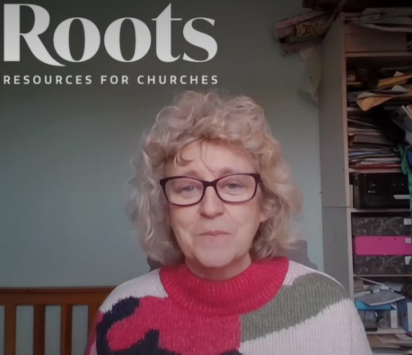Ideas for all-age ministry

Dr Sam Richards, Head of Children's and Youth Work for the URC, spoke with Roots for Churches in collaboration with Intergenerate, to shares ideas and invaluable advice to churches just starting on their intergenerational journey. Watch "First Steps on the Intergenerational" on Roots For Churches' YouTube channel (<https://bit.ly/4mLVgfW>).

Free welcome bag ideas

Bags of Welcome offer a way for local churches to demonstrate their warm welcome to children, young people and those with additional needs. A welcome bag contains a variety of resources to enable everyone to engage with services, and to know they belong and are valued. Use this free guide (<https://bit.ly/4dMfimx>) for ideas to fill your Bags of Welcome.

Learn about working with young people today

Join members of the five northerly synods' Children and Youth Work Team online as they journey through Youthscape Essentials together. Covering 30 subjects over 10 sessions, Youthscape Essentials increases skills and understanding about working alongside young people today. Each session is standalone, but you can join in as many as you can. Learn all about Youthscape Essentials. Book your place here (<https://bit.ly/3FNl6iW>) and enter the course code 1245085. Dates: 23 June, 28 July, 26 August, 22 September, 27 October, and 24 November. Time: 7-9pm.

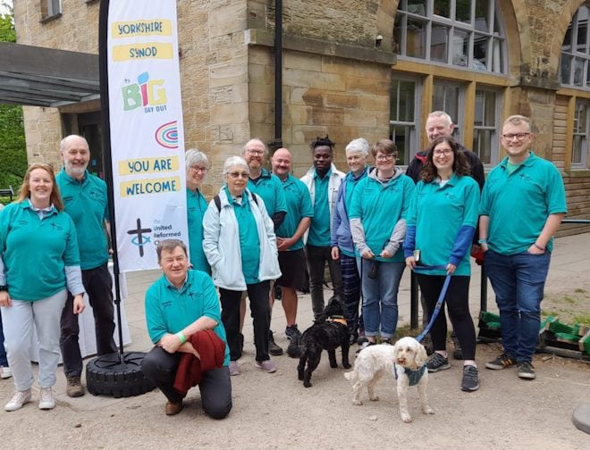Fun and fellowship at Yorkshire Synod's Big Day Out

Yorkshire Synod held its Big Day Out, an all-age family fun day, on 17 May. With plenty of activities on offer, there was something for everyone to enjoy, from Forest Church, godly play, Bible study, prayer walks, family crafts, outdoor games and much more. Tony Harris, the Children, Youth and Family Enabler for the NOW Mission and Care Group, said: "What a wonderful Big Day Out we all had. Lovely weather, great venue, new friends and lots to do." Learn more about the Big Day Out (<https://bit.ly/3ZJwDqf>).

Download or print News Update

A downloadable version of News Update, formatted for print, and for churches to copy and paste into church newsletters or magazines will be available within a week of this edition being published. Download your printable version of News Update (<https://bit.ly/3Fq1Bgu>).

Share your good news

If you have a good news story that can inspire, raise hope or show God's work in action then please let URC Communications know. We would love to help share your news across the denomination and in local news outlets. Email the URC Comms Team ([pressoffice@urc.org.uk](mailto:pressoffice@urc.org.uk)) or call 07976 753 950.

Church and community and engagement

The next edition of the URC Church & Community Engagement Newsletter will be published at the end of this month. It is packed full of information, resources and means of encouragement to enable churches and disciples to be even more present and engaged within their local neighbourhood and with communities as an expression of God’s love and mission. More than two hundred subscribers from local churches and Synods now directly receive this useful resource; if you are not already subscribed, please email Samara Andrews ([samara.andrews@urc.org.uk](mailto:samara.andrews@urc.org.uk)), Administrator (Community Engagement and Public Issues), to receive a copy.

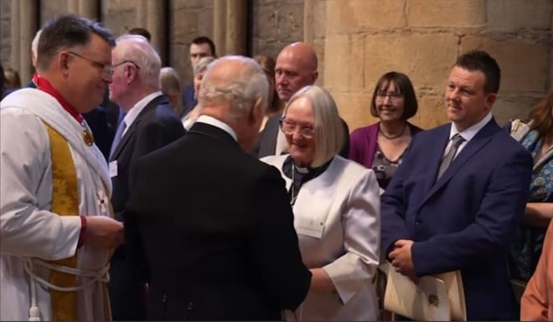URC members honoured by King

The outstanding Christian service of two URC members was honoured by King Charles on Maundy Thursday. East Midland Synod’s Revd Louise Gee, and John East, a former Elder from Central URC in Darwen, attended a ceremony in Durham Cathedral for the annual presentation of Maundy Money just before the Easter weekend. Learn more about the service and presentation (<https://bit.ly/4kpRTd0>).

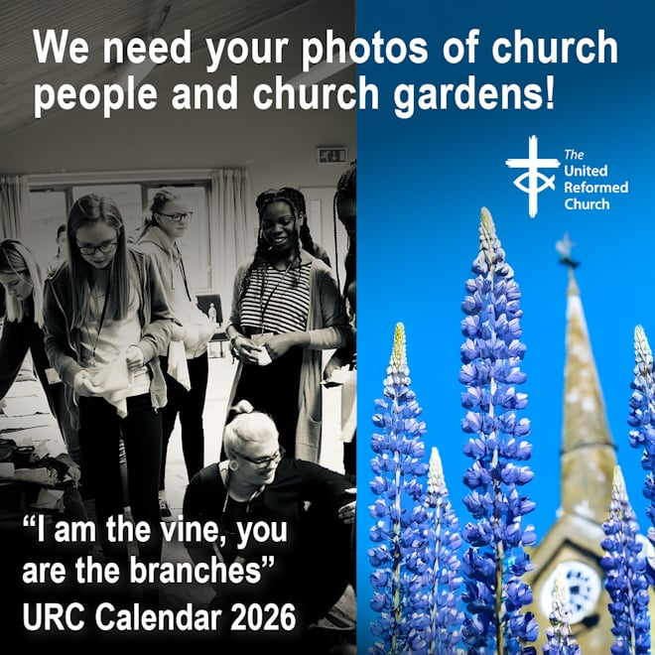Photos wanted for URC 2026 Calendar

Your photos are needed for the URC 2026 Calendar - Seeds of Hope. Based on the verse from John 15, "I am the vine, you are the branches", next year's calendar will feature images of people and plants connected to the URC. Learn all you need to know including submission guidelines (<https://bit.ly/3SCOBHk>). The calendar has again been generously supported by Edwards Insurance.

URC members honoured by King Charles

The outstanding Christian service of two URC members was honoured by King Charles on Maundy Thursday. East Midland Synod’s Revd Louise Gee, and John East, a former Elder from Central URC in Darwen, attended a ceremony in Durham Cathedral for the annual presentation of Maundy Money just before the Easter weekend. Learn more about the service and presentation (<https://bit.ly/4kpRTd0>).

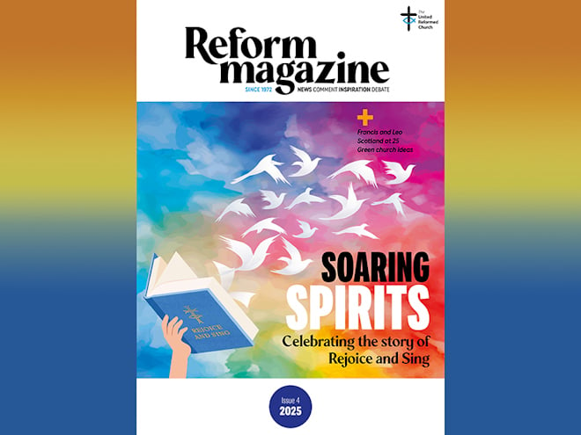Inside Reform magazine

Popes and Moderators feature strongly in the latest edition of ***Reform*** (<https://bit.ly/43GLoLJ>). Editor Stephen Tomkins is in conversation with the incoming Moderator of the URC’s General Assembly, Catriona Wheeler. She explains how her career as a lawyer and her work as a member of the URC combine to inform a thoughtful and measured approach to her new role. One of Catriona’s predecessors as URC Moderator, Tessa Henry-Robinson, was recently inaugurated as Moderator of the Free Churches Group. Reflecting on the group’s future purpose, she says, “We are called to live as if we have seen the mountaintop.”

We look back at the life of Pope Francis, asking the question: “What difference did he make?”. Stephen Tomkins looks forward to the likely priorities of the new pope, Leo. And with good timing, the URC’s Evangelism and Ecumenical Officer Lindsey Brown describes a recent visit to Rome by members of the Roman Catholic-URC Dialogue Group to present a new resource pack that will support Catholic and URC congregations to make their own local journeys of mutual understanding.

Elsewhere, ***Reform*** reports on celebrations – in Coventry, of the URC’s hymn book Rejoice & Sing, and in Scotland, of 25 years since the URC in the UK and the Congregational Union of Scotland united to form the United Reformed Church as it now exists. Plus, the URC’s Head of Public Issues, Roo Stewart, looks forward to the Season of Creation, beginning on 1 September, with some great examples of how local churches are connecting with creation and the Creator. The Issue 4/2025 edition of ***Reform*** is available from 8 June. Subscribe to Reform digitally or in print (<https://bit.ly/3Zg1kU5>).

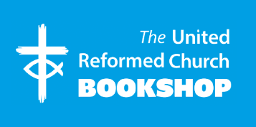

Please order online using the URC Bookshop’s easy-to-use website <https://urcshop.co.uk> or by calling 020 7916 8629.

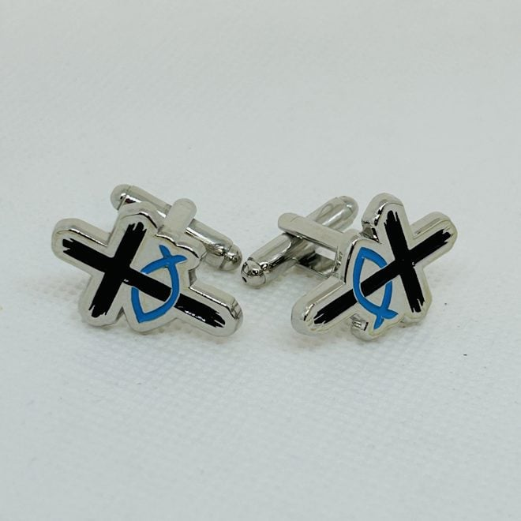

**URC Logo Cufflinks** (<https://bit.ly/440mY1c>) - A pair of enamel cufflinks featuring the URC logo. An ideal gift for anyone who wears shirts for work or worship. In line with the URC’s eco-policy, these are supplied in a paper envelope rather than a plastic case. £4.99 +p&p.



**Sing and make music pin badge** (<https://bit.ly/4dNlMSd>) – A 3cm x 3cm soft enamel metal pin badge with the words from Ephesians 5:19: "Sing and make music from your heart to the Lord." Supplied with a butterfly clasp. Designed on silver with cyan and royal blue lettering, musical notes and the URC cross and fish logo. £2.99 +p&p.

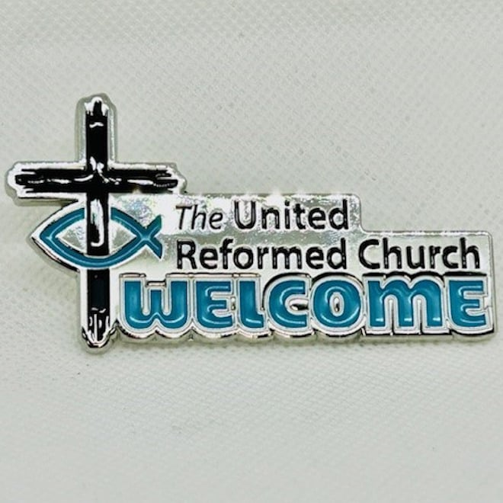

**Welcome & URC pin badge** (<https://bit.ly/4598BZt>) - A URC pin badge featuring the the world WELCOME and the URC logo. Ideal for those who welcome people into church, Elders, leaders and others with a local or Synod role in the URC. Made from soft enamel zinc alloy in silver, white and blue. Available with pin or magnetic fastening. £2.99 +p&p.



**Advent 2025 resource** (<https://bit.ly/4n0zeX8>) - Get ready for Advent with Children's and Youth Work's postcard-sized countdown! Each day reveals a festive surprise or a character from the Christmas story and is packed with fun facts and activities. Includes a DIY nativity and doubles as beautiful bunting.

Pre-order by 1 September at the URC Bookshop. Please email the Children's and Youth Work team ([children.youth@urc.org.uk](mailto:children.youth@urc.org.uk)) for a grant towards the cost available.

Synod news

Wales

Congratulations to Barry Uniting Church which has been awarded a Gold Eco Church Award by A Rocha UK. This award is the fourth Gold Eco Church in Wales, and the first United Reformed Church in Wales to achieve the incredible milestone. Barry Uniting Church is a local ecumenical partnership between Windsor Road United Reformed Church and Porthkerry Road Methodist Church.

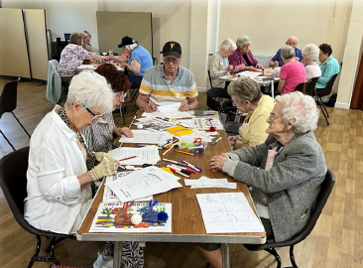North Western

Radcliffe and Stand URC enjoyed a fun-filled "holiday at home" with an Australian twist! Activities included boomerang-making, a kangaroo drive, crafts, quizzes, and a scavenger hunt. Tasty bush tucker like steak burgers and Anzac biscuits topped off the day. A fantastic time was had by all - no passport needed!

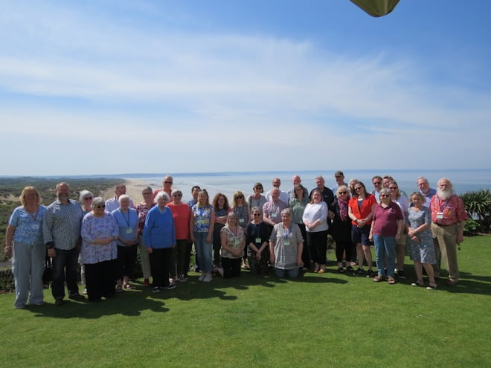South Western

The South Western Synod gathered for its Spring School, where members enjoyed the warm weather while learning from A Place for Hope about the dynamics of change and time with the Revd Tim Meadows, URC General Assembly Moderator, who reflected on Philip, the Ethiopian Eunuch and diversity.

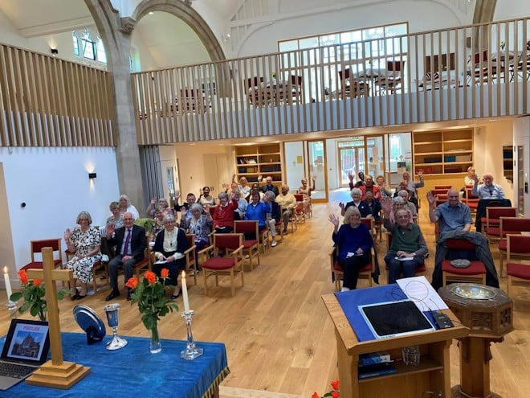Thames North

The congregation and friends of St Margaret’s URC in Finchley recently gathered to celebrate a special service of rededication to mark the church’s refurbishment. Now transformed into a bright, warm and welcoming space, the building radiates new life. The uplifting service was led by the Synod Moderator, and Revd Dr John Campbell added a joyful touch with a spirited hymn set to the tune of *Keel Row*.

What's On

New Stepwise stream

Faith-filled Conversations is a new Stepwise stream available to help you explore how your faith story shapes the conversations you have and how those conversations shape the world around you. In this six-session journey, you will: ✔ reflect on your Christian journey ✔grow in confidence sharing your story ✔ learn from how Jesus used conversations ✔ tackle difficult topics with grace ✔ recognise God’s presence in everyday life ✔ support others as they explore faith. The stream includes group learning, mentoring support, and flexible preparation. It can be undertaken online or in-person. Register your interest with your local church of synod. Alternatively, please email Marion Brown ([marion.brown@urc.org.uk](mailto:marion.brown@urc.org.uk)), Stepwise & Digital Learning Programme Administrator.

Volunteering crisis point

Are you having problems with recruiting volunteers, negativity, volunteering simply not operating well, or conflict within those who are working on your projects or in your church? If so, join the Church Urban Fund's free, practical webinar "Volunteering Crisis Point - what to do when volunteering goes wrong", with expert Julia Hill. The webinar takes place on 4 June from 11am-12pm. Register to attend (<https://bit.ly/4mIYtwK>).

Faith in the City at 40

2025 marks the 40th anniversary of the publication of Archbishop Runcie’s influential Commission on Urban Priority Areas reports. The "Faith in the City @ 40 (North)" conference taking place on 12 July from 10am-4pm at Victoria Hall, Lower Ground Floor, Norfolk Street Sheffield City Centre, S1 2JB, is one of a series of events across the country offering a chance to reflect on the theology and practice of urban mission, then and now. Learn more about ticket prices and how to book (<https://bit.ly/3SCQJyO>).

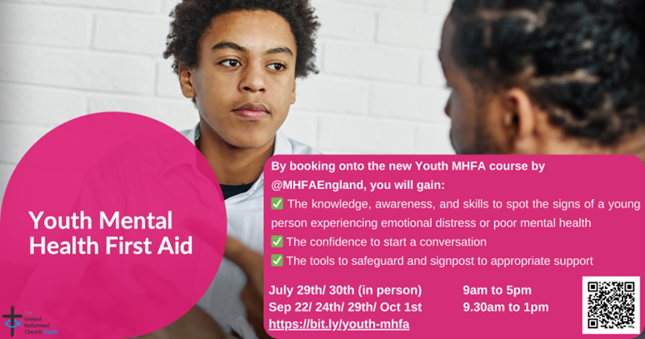Youth mental health training

New dates are available for the Southern Synod's Youth Mental Health First Aid training course. The in-person session takes place at Church House in London from 29-30 July from 9am-5pm and online takes place on 22-24 September and 29 September-1 October. Places are subsidised for URC participants. On the course you can learn how to spot signs of mental ill health, how to start support conversation, and where to signpost for help. Book your space (<https://bit.ly/4dWDtik>).

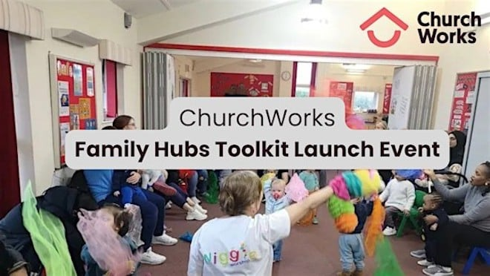ChurchWorks Family Hubs Toolkit launch

As a ChurchWorks partner, the URC is working collaboratively with Spurgeons and the Gather Movement to promote an online family hubs toolkit. The ChurchWorks Family Hubs Toolkit will equip both local authorities and churches with an understanding of one another’s assets, a shared language and vision, and next steps for collaboration. An online launch of the toolkit takes place on 24 June from 2-3.30pm. Register to attend (<https://bit.ly/3SDl6Fc>).

Recruitment

URC vacancies and beyond ([**https://bit.ly/3HjL26u**](https://bit.ly/3HjL26u))

Trustee – Congregational Fund Board

At the heart of the Congregational Fund Board lies a strong commitment to supporting ministers and students in times of financial need. The Board is currently seeking a trustee to represent the United Reformed Church. Must be a member of the United Reformed Church and commit to a term of four years. Closing date: 13 June.

Community Engagement Manager – Emmanuel Church, Eastbourne

Salary: £19,300 for 25 hours per week with 28 days paid holiday (pro rata).

Hours of work: 8:30am – 1:30pm Monday to Friday.

(As a flexible employer, we are willing to consider some variation to this).  
The appointment is subject to an enhanced DBS disclosure.

Closing date for applications: 13 June.

Advocacy Coordinator – The Joint Public Issues Team

Salary: £40,000 – £45,000 depending on experience

Location: London (Hybrid – at least two days per week in the office)

Closing date: 4 June

Commission Secretary – Ministerial Discipline Process

The URC’s Ministerial Discipline Process is looking for a Commission Secretary, effective from July 2025, but with ample shadowing time of the present post-holder built in.

Accreditations Sub-Committee Convenor

Do you have a passion to support people who release the church in its local community to flourish in faith, hope and love? Then this could be the opportunity for you! Ministries Committee is looking for a convener for its Accreditations Sub-Committee to replace its current convenor who will complete their term at the July 2025 General Assembly. The convener will need to have working knowledge of the formal ministries of the United Reformed Church.