## Template for Person Specification for Convenor

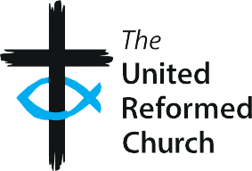

### Person Specification

#### Role: Convenor of [X] Committee

|  |  |  |
| --- | --- | --- |
| **Requirements** | **Essential** | **Desirable** |
| Experience and Knowledge | * Experience in convening/ chairing meetings * Leadership experience, ideally in a committee or governance role * Experience in facilitating discussions and building consensus | * Understanding of the principles of safer recruitment or a willingness to learn * Knowledge of URC governance structures, policies and procedures or a willingness to learn |
| Skills and Abilities | * Good communication skills, both written and verbal, with the ability to engage and influence diverse stakeholders * Ensure effective oversight of   processes and procedures   * Work collaboratively with a diverse range of people * Good IT skills including   Microsoft Office, Zoom and  email | * Ability to facilitate both online and in-person meetings * Ability to support the development of committee members * Strong public speaking and presentation skills |
| Other | * Member of the United Reformed Church * Commitment to embedding principles of Equality, Diversity & Inclusion |  |