United Reformed Church Commitment for Life July/August 2025



Committed to supporting our global partners **ZIMBABWE**

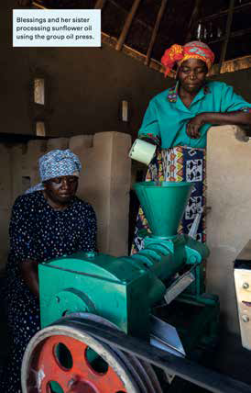**hen the family farm began struggling,**



Action for Fairer Tea – Brew it Fair

Do you enjoy a cuppa? How do you like it – with sugar? Strong? With milk?

Apart from water, tea is the world’s most popular drink.

However, it is more than a drink, it’s a daily ritual,

a comfort, enjoyed during a break or while catching up with loved ones. In Britain we drink over 100 million cups of tea every day!

However, behind every cuppa lies an untold story – the people who carefully

pick the tea leaves and carry up to 30 kilograms on their backs at a time. They face poverty, unsafe working conditions and

climate change, leaving them unable to plan for their future.

Fairtrade

[Do it Fair: Campaigning](https://www.fairtrade.org.uk/do-it-fair/) [for Change in the Tea](https://www.fairtrade.org.uk/do-it-fair/) [Industry](https://www.fairtrade.org.uk/do-it-fair/) are asking the UK government to Brew it Fair. Act by signing their petition [Sign | Fairtrade](https://action.fairtrade.org.uk/page/171071/petition/1?ea.tracking.id=landing_page_button)

[Foundation](https://action.fairtrade.org.uk/page/171071/petition/1?ea.tracking.id=landing_page_button) and calling on the government to take stronger action in the tea industry. In addition, why not purchase Fairtrade Tea?

**W**

**Blessings’ husband moved to the city to find work.**

“Things were hard,” remembers Blessings. “We were living hand-to- mouth and had to wait for provisions to be sent

from my husband. I found life really tough – doing everything on my own, trying to get something out of the land in drought. When I managed to harvest something, I

Photo credit: © Christian Aid

couldn’t get decent prices.”

Blessings tells how things

changed for herself and the wider community with the coming of BRACT, a *Commitment for Life*

sponsored project in Zimbabwe. “The project taught us about disaster risk management,

and this helped us plan what we need to do in case of droughts and even price

fluctuations. The ‘climate smart’

agriculture training made us realise we can use less

fertilisers, farm without cattle

to help us plough and still get a harvest even when the

rainfall is low. We can also grow feed for our livestock in our fields and make hay for the cattle and goats. This was all completely new to us.”

Thank you to you for your wonderful support for BRACT through *Commitment for Life*. People all across Zimbabwe, like Blessings and her family, have had their lives transformed.

[commitmentforlife@urc.org.uk](mailto:commitmentforlife@urc.org.uk) [www.bit.ly/URCFL](https://www.bit.ly/URCFL)