United Reformed Church Commitment for Life July/August 2025



Committed to supporting our global partners **IOPT**

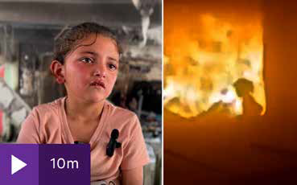 **he Israeli bombing of Gaza continues unabated.**

A distressing video shared to social media shows six-year-old Ward Jalal Al-Shaikh Khalil escaping a blaze at the Fahmi Al-



Action for Fairer Tea – Brew it Fair

Do you enjoy a cuppa? How do you like it – with sugar? Strong? With milk?

Apart from water, tea is the world’s most popular drink.

However, it is more than a drink, it’s a daily ritual,

a comfort, enjoyed during a break or while catching up with loved ones. In Britain we drink over 100 million cups of tea every day!

However, behind every cuppa lies an untold story – the people who carefully

pick the tea leaves and carry up to 30 kilograms on their backs at a time. They face poverty, unsafe working conditions and

climate change, leaving them unable to plan for their future.

Fairtrade

Do it Fair: Campaigning for Change in the Tea Industry are asking the UK government to Brew it Fair. Act by signing their petition Sign | Fairtrade

Foundation and calling on the government to take stronger action in the tea industry. In addition why not purchase Fairtrade Tea?

Photo credit: Channel Four News

**T**

Jargawi in Gaza City school following an Israeli air strike. Among the reportedly thirty-six people killed in the strike were Ward’s mother and two siblings. Her father is in intensive care in hospital.

“I walked through the fire all by myself. The rubble fell on them ...

I want to see my sisters, to be with them, but they’re dead. I want to be with them ... I love Mama as big as the sky and the earth and the stars.”

Watch the Channel Four news report [here](https://www.channel4.com/news/how-one-five-year-old-girl-escaped-an-israeli-airstrike-on-a-school-in-gaza) <https://bit.ly/C4ward>

Please continue faithfully in your prayers – personal and congregational – for Gaza. Thank you to our *Commitment for Life* Supporters, you have raised significant sums of money in support of our partners in Gaza and the West Bank. Just this past week we were able to send an additional

£9,000 over and above the £70,000 we have already sent.

However, while church fund raising is a blessing, it is clearly not enough. We must demand significant action from the UK government in keeping with its obligations under international law. Otherwise, the political leaders in the UK risk significant future legal challenges under international law for aiding and abetting a genocide.

We are grateful to the Quakers in the UK for taking the lead in calling out the UK government for the continuing terrible loss of life.

*Commitment for Life* will continue to pray and work for peace with our partners. You can see the Quaker Statement to the UK Government on Gaza here [www.bit.ly/45lclau](https://bit.ly/45lclau)

[commitmentforlife@urc.org.uk](mailto:commitmentforlife@urc.org.uk) [www.bit.ly/URCFL](https://www.bit.ly/URCFL)