United Reformed Church Commitment for Life July/August 2025



Committed to supporting our global partners **BANGLADESH**



Action for Fairer Tea – Brew it Fair

Do you enjoy a cuppa? How do you like it – with sugar? Strong? With milk?

Apart from water, tea is the world’s most popular drink.

However, it is more than a drink, it’s a daily ritual,

a comfort, enjoyed during a break or while catching up with loved ones. In Britain we drink over 100 million cups of tea every day!

However, behind every cuppa lies an untold story – the people who carefully

pick the tea leaves and carry up to 30 kilograms on their backs at a time. They face poverty, unsafe working conditions and

climate change, leaving them unable to plan for their future.

Fairtrade

[Do it Fair: Campaigning](https://www.fairtrade.org.uk/do-it-fair/) [for Change in the Tea](https://www.fairtrade.org.uk/do-it-fair/) [Industry](https://www.fairtrade.org.uk/do-it-fair/) are asking the UK government to Brew it Fair. Act by signing their petition [Sign | Fairtrade](https://action.fairtrade.org.uk/page/171071/petition/1?ea.tracking.id=landing_page_button)

[Foundation](https://action.fairtrade.org.uk/page/171071/petition/1?ea.tracking.id=landing_page_button) and calling on the government to take stronger action in the tea industry. In addition why not purchase Fairtrade Tea?

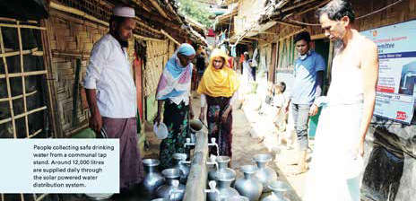**ince 2017, nearly a million Rohingya refugees fleeing persecution in Myanmar have moved to Cox’s Bazar, a coastal city in Bangladesh, creating the largest refugee**

Photo credit: © Christian Aid

**S**

**camp in the world.**

Facilitating water, sanitation, and hygiene services in the refugee camps is a core focus of *Commitment for Life’*s humanitarian response partner. In Camp 15, the largest and most densely populated camp in Cox’s Bazar, the organisation has installed a sewage treatment plant, repaired and installed latrines, wash cubicles and solar-run water points, and provided solid waste management, impacting the lives of nearly 71,360 people.

Being a hilly and densely populated area, Camp 15’s demand for water is high. Through Christian Aid, *Commitment for Life* provides the means by which water can be supplied to around 9,500 people. Every day, around 12,000-14,000 litres of treated drinking water is supplied through the solar-run water system to residents.

To manage this water distribution, we follow a ‘Community-based distribution approach’ to create ownership among the refugees. In each sub-block, user committees are formed, comprising five members (all are women) to manage the water collection points. These committees manage the water distribution schedule, maintain the tap stands

and spread awareness messages about waterborne diseases to the

community. The success of the waste management plant serves as an example for other camps, demonstrating that sustainable waste

management practices not only help to keep the environment clean but also provide economic opportunities for the local community.

[commitmentforlife@urc.org.uk](mailto:commitmentforlife@urc.org.uk) [www.bit.ly/URCFL](https://www.bit.ly/URCFL)