Many people in Eastern Synod, both lay and ordained, are thankful for his inspiration, his teaching, his guidance and his love for Jesus lived out in his service to the United Reformed Church. We know that this will be echoed by others across the denomination.

Neil is a person of great integrity, thoughtfulness and humour whose creativity allows him to both express his faith through art and help the Church reflect on issues in imaginative ways.

He has often been called on to serve on the General Assembly Facilitation Group and through careful listening and consultation has enabled the Assembly to find acceptable wording for a resolution.

Eastern Synod wholeheartedly recommends Neil Thorogood to serve as Moderator of General Assembly.

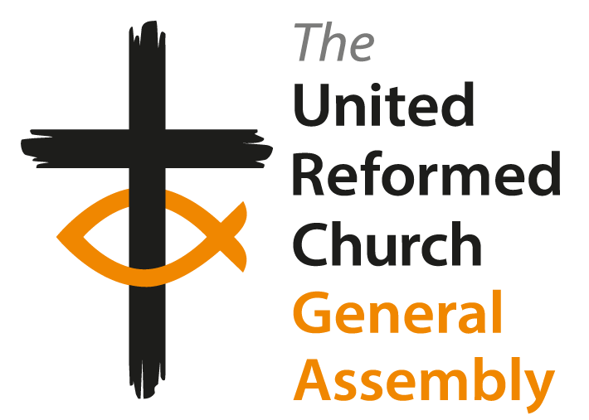

**Election of the Moderator of the   
General Assembly 2026-2027\***

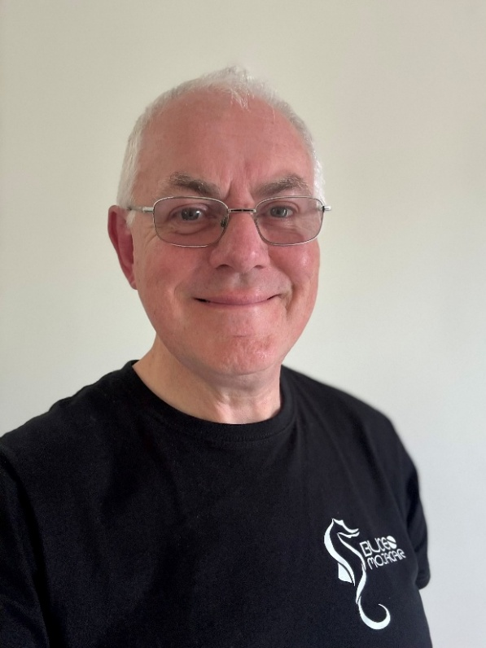**The Revd Dr Mitchell   
Bunting (Bungie)**

Mitchell Bunting (Bungie) received a unanimous endorsement from the March meeting of the National Synod of Scotland to the nomination for Moderator of General Assembly 2026/27.

The meeting reflected upon his vast experience in all things ‘ecumenical’, and on his pastorate ministry within Scotland in particular.

Following Ordination, he began as minister at Carrs Lane Church Centre and overall, his ministry included five years in Galilee as Director of the Sea of Galilee Centre in Tiberias, an appointment by the Church of Scotland who were in partnership with the Arab Episcopal Church in Scotland. Bungie was also Minister of Augustine Church Edinburgh, Ecumenical Officer for the National Synod of Scotland and Minister of the North of the Clyde Cluster (four churches).

In order to support his ministry, Bungie has invested time and effort in his ministerial education. Certificate in Theology (Mansfield) Post grad Diploma in Ethics & Theology of Communication (New Coll, Edin), MTH in Ministry (New Coll, Edin) and DMin (Pittsburgh/New Coll, Edin) focussing on the use of scientific language in the preaching and anti-nuclear campaigning of George Macleod (founder of the Iona Community).

Bungie is now retired and has more time to give to his interests and hobbies which include video, photography, music and computers. In the 1980’s Bungie began a ministry of clowning.

On retiring he bought a motorboat to explore the Firth of Clyde and currently teaches and guides for a SCUBA diving club which has helped to develop his interest in underwater photography and in surveying marine life.

To support this interest Bungie has gained a Certificate in Higher Education in Natural Sciences and is currently undertaking an online course in Marine Biology (Newcastle). He also has undertaken Dive Master training and certification.

Bungie is married with three sons, the oldest two born in Nazareth, and since 1982, has been a member of the Iona Community.

**J Adamson, Synod Clerk, 2025**

**(*Subject to Resolution)**

**The Revd Neil Thorogood**

Neil was born in Sydney, Australia whilst his parents were serving as missionaries in the Cook Islands, returning to the UK in 1970.

After completing a degree in Geography, Neil was accepted for ministry training. Before training, he served as a short-term Mission Partner, teaching English in Taiwan with the Council for World Mission. He then trained at Mansfield College where he met and married Jenny.

Neil has served the church over the last 33 years: the Halifax Group of Churches (1992–1999) and Welwyn Garden City URC and Panshanger Ecumenical Church (2000–2005). He was then called to Westminster College, Cambridge where he served first as Director of Pastoral Studies (2005-2013) and then as Principal until July 2020.

Since then, he has returned to pastoral ministry, serving as minister of Trinity-Henleaze URC in Bristol and Thornbury URC. His wisdom, combined with his caring and approachable nature, is evident through his many roles, including his role as Convenor of the South Western Synod’s Discipleship & Service Committee and as a member of the Executive Committee of the South Western Synod.

It has been said that Neil has the URC in his DNA. It is certainly true that all of these experiences and influences have helped to shape Neil's life and his heart for Christ, alongside a willingness to serve.

In his spare time, Neil is active as a visual artist. During the Covid lockdown period, he made small sketches each day and published them on Twitter (now X). These pictures were the basis of his book *Talking Pictures*, published by the URC.

We wholeheartedly recommend this gentleman of God to serve as Moderator   
of General Assembly.

**From the meeting of the South Western Synod**

**(*Subject to Resolution)**

***Additional statement from Eastern Synod***

Neil Thorogood spent 15 years in Eastern Synod during his time at Westminster College, Cambridge, as Director of Pastoral Studies and later as Principal.

***Continued overleaf >>>***