United Reformed Church Commitment for Life May/June 2025

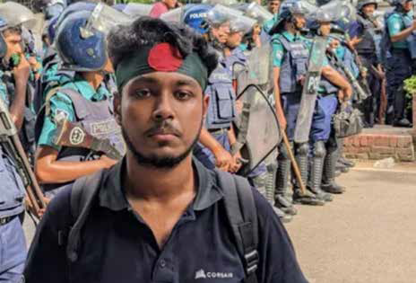

*Storie*

*S*

Moving

Committed to supporting our global partners **BANGLADESH**

Two opportunities to get involved

**Christian Aid Week 11 to 17 May, 2025**

This year the focus is on Guatemala. Please go to **www**[**.bit.ly/4co1Apj**](https://bit.ly/4co1Apj)

**The Great Big Green Week – ‘Together for good’ 7 and 15 June, 2025**

Do you have a passion to tackle climate change and protect nature?

*Commitment for Life* is a member of The Climate Coalition that brings people together to demand action on the climate. The Great Big Green Week will take place between 7 and 15 June.

Get your resource pack here

**www**[**.bit.ly/42qxg8R**](https://bit.ly/42qxg8R)

# hen Maydul Hassan was first mugged, he thought he had hit rock bottom (see Al Jazeera, 4 March, 2025). But within a week, the 21-year-old student was battered and

Photo credit: Maydul Hassan. © Maydul Hassan – all rights reserved

**W**

**robbed again – this time in front of the police, who, according to Hassan, did nothing. Hassan participated in the student-led uprising that helped to unseat long-time Prime Minister Sheikh Hasina. But Hassan wonders what the country has become. “The nation is drowning in crime, no one seems to care.”**

Hassan’s ordeal is not an isolated case. Over 170 million people call Bangladesh home, but the country is experiencing a terrible crime wave. Since the fall of Sheikh Hasina’s government, walking the streets has become extremely risky. According to Al Jazeera, in January 2025 alone the police reported 242 cases of mugging and robbery across Bangladesh – the highest number in six years. At least 294 murders were recorded. Robberies, muggings and abductions are all on the rise.

All the more reason for *Commitment for Life* to continue its work through its Christian Aid partners in Bangladesh. We assist some of the poorest communities, empowering them, even during this politically, environmentally, and economically fraught time.

[commitmentforlife@urc.org.uk](mailto:commitmentforlife@urc.org.uk) [www.bit.ly/URCFL](https://www.bit.ly/URCFL)