**Template** **for Person Specification for**

**Member of Committee**

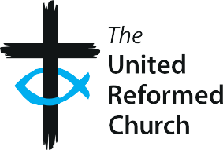

### Person Specification

#### Role: Member of [X] Committee

|  |  |  |
| --- | --- | --- |
| **Requirements** | **Essential** | **Desirable** |
| Experience and Knowledge |  | * Knowledge of URC governance structures or a willingness to learn |
| Skills and Abilities | * Work collaboratively with a diverse range of people * Good IT skills including Microsoft Office, Zoom and email |  |
| Other | * Member of the United Reformed Church |  |

## 