## Equality, Diversity and Inclusion Form

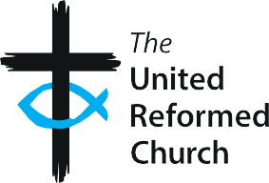

#### Date of Birth:

Please circle below the answers that apply to you.

#### Sexual Orientation:

* Heterosexual/Straight
* Bisexual
* Gay
* Lesbian
* Other
* Prefer not to say

#### Religion/Belief:

* Buddhist
* Christian
* Hindu
* Jewish
* Muslim
* Sikh
* No religion/belief
* Other
* Prefer not to say

#### Are your day-to-day activities significantly limited because of a health problem or disability which has lasted, or is expected to last, at least 12 months?

* Yes
* No
* Prefer not to say

#### Cultural/Ethnic Origin:

* White/British
* White/Irish
* White/Other
* Mixed/White & Black Caribbean
* Mixed/White & Black African
* Mixed/White & Asian
* Mixed/Other
* Asian or Asian British/Indian
* Asian or Asian British/Pakistani
* Asian or Asian British/Bangladeshi
* Asian or Asian British/Chinese
* Asian or Asian British/Other
* Black or Black British/Caribbean
* Black or Black British/African
* Black or Black British/Other
* Arab
* Gypsy/Traveller
* Any other ethnic group
* Prefer not to say

#### Gender:

* Female
* Male
* Non-Binary
* Transgender
* Intersex
* Other
* Prefer not to say