United Reformed Church Commitment for Life March/April 2025



*Storie*

*S*

Moving

Committed to supporting our global partners **ZIMBABWE**

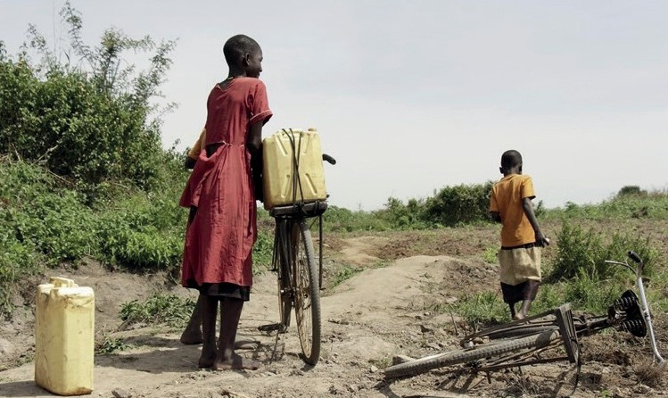**he BBC reports that the worst drought in living memory is devastating**



Facing the conflict

in Ukraine

***Commitment for Life* is pleased to be supporting the work of our URC partner churches in Hungary and**

**in Transcarpathia, Western**

**Ukraine.**

NATO expansion into Ukraine has been met by a

devastatingly bloody, Russian

special military operation. The conflict has led to the mass dislocation of ordinary Ukrainians. People have fled to the safer, western parts of

Ukraine and into neighbouring

countries like Hungary.

Our partner churches are doing brilliant work to support these refugees. Watch our CFL video:

[**https://youtu.be/lK9s_v4ebPU**](https://www.youtube.com/watch?v=lK9s_v4ebPU)

and support our appeal here:

[**https://gofund.me/d99524e8**](https://gofund.me/d99524e8)

Photo credit. Charles Nambasi, Pixabay

**T**

**southern Africa, leaving close to 70 million people without sufficient food and water.**

People living in the Mudzi district of northern Zimbabwe dig down into the bone-dry riverbed of the normally flowing Vombozi river. Using shovels and buckets, they desperately trying to extract the last drops of water.

Along the riverbed there are a number of dug up holes, large enough to fit a single bucket. The water is used to bathe children, do laundry, and give cattle a drink.

Gracious Phiri, a 43-year-old mother of five, says that she now must walk up to three hours every day to fetch water. “I have never seen anything like this.”

Food is also in short supply in Zimbabwe, where 7.7 million people face hunger. Children have been badly impacted, with hospital admissions for moderate to severe malnutrition increasing. Often, ground baobab fruit is stirred into a porridge for extra nutrients.

Your donations to Commitment for Life are helping our local partners install boreholes with solar power. This is one way to help people deepen their resilience in the face of climate change. See this video for more information: [**https://youtu.be/Ux9hZp5_aWg**](http://youtu.be/Ux9hZp5_aWg)

[commitmentforlife@urc.org.uk](mailto:commitmentforlife@urc.org.uk) [www.bit.ly/URCFL](http://www.bit.ly/URCFL)