United Reformed Church Commitment for Life March/April 2025



*Storie*

*S*

Moving

Committed to supporting our global partners **IOPT**

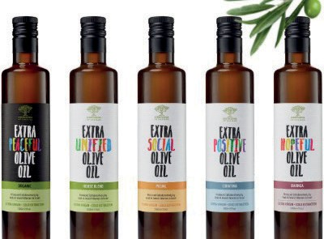

Can olive oil create hope?” That is the question that Israeli political activist



Facing the conflict

in Ukraine

***Commitment for Life* is pleased to be supporting the work of our URC partner churches in Hungary and**

**in Transcarpathia, Western Ukraine.**

NATO expansion into Ukraine has been met by a

devastatingly bloody, Russian special military operation.

The conflict has led to the mass dislocation of ordinary Ukrainians. People have fled to the safer, western parts of Ukraine and into neighbouring countries like Hungary.

Our partner churches are doing brilliant work to support these refugees. Watch our CFL video:

[**https://youtu.be/lK9s_v4ebPU**](https://www.youtube.com/watch?v=lK9s_v4ebPU)

and support our appeal here:

[**https://gofund.me/d99524e8**](https://gofund.me/d99524e8)

Photo credit: image from the Sindyanna website

**“**

Hadas Lahav set out to answer, together with her Palestinian business partner Hanan Zoabi. Together they set up Sindyanna in 1996, a start-up aiming to build a sustainable income for Israeli and Palestinian women.

In 2015 they expanded their product lines to include a variety of olive oil, nut pastes, honey, carob syrup, olive oil soaps,

and the much-prized za’atar spice. Sindyanna also opened a visitors’ centre in Kafr Kana in

the Galilee, where its warehouse is now based. It was one of the most memorable stops for the 2019 URC educational trip to

the Holy Land.

Lahav says, “Faced with the chaos and violence that we have experienced over the past year, Sindyanna is striving to

continue spreading our message of equality and co-existence.

We are happy to report that our sales have grown both internationally and in the local market with record breaking results... [We are] all united in the hope that we can make an impact and set an example for a better future for Palestinians and Israelis.”

Commitment for Life is honoured to support the wonderful work

of this incredible endeavour. For more information on Sindyanna, go to: [**www.sindyanna.com**](https://www.sindyanna.com/)

[commitmentforlife@urc.org.uk](mailto:commitmentforlife@urc.org.uk) [www.bit.ly/URCFL](http://www.bit.ly/URCFL)