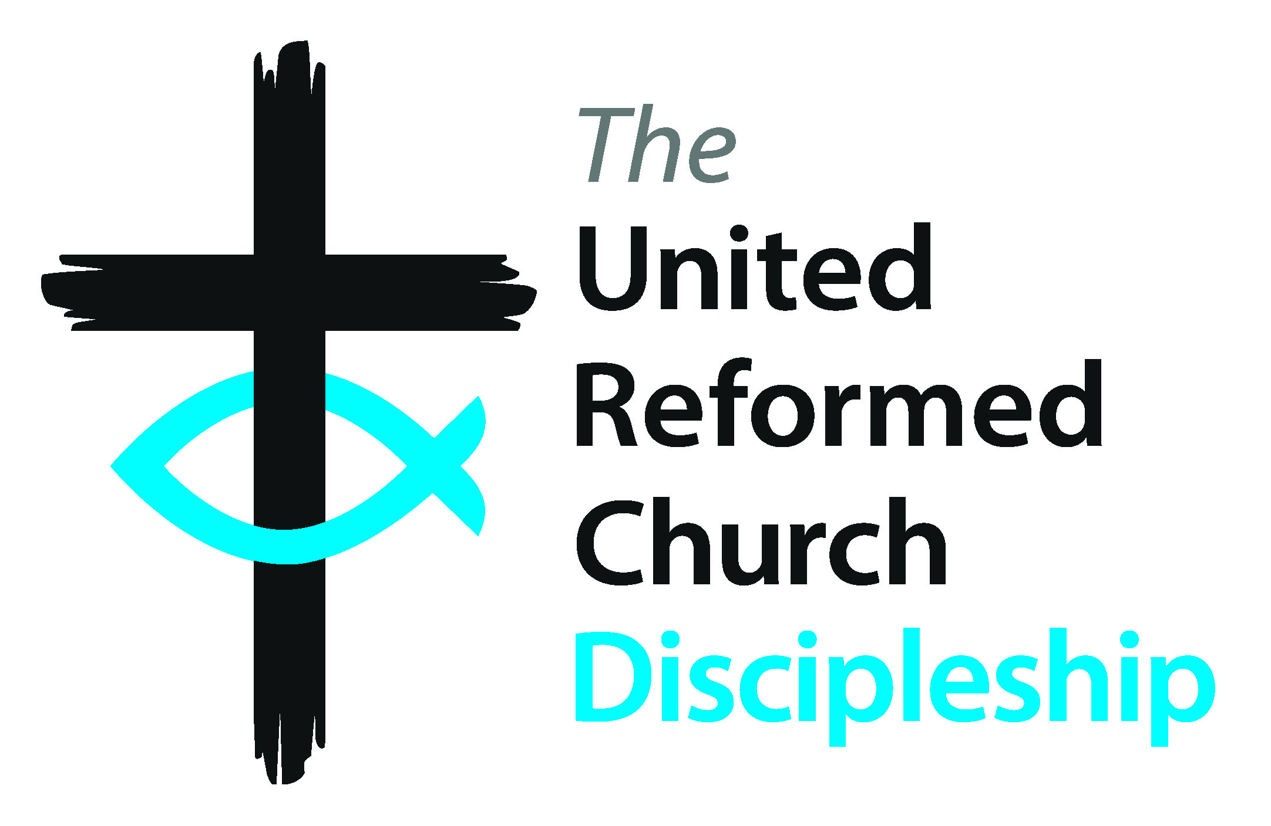

Education for Ministry Phase 2 (EM2)
Assembly element of EM2
Information for Churches served by an EM2 Minister*

Education for Ministry 2 (EM2) is a phase of supported learning, providing opportunities for continuing ministerial formation, evidence of ongoing individual development, and promoting habits of lifelong learning and connection, with the wider URC through the provided EM2 programmes. Participation in EM2 is required of all newly ordained Ministers of Word and Sacrament/ CRCWs.
Support from the local churches/projects that the Minister serves is an integral part of this programme. Appreciating the need for time to engage with the programme and complete reflections as well as attend sessions, plus encouragement to continue to learn whilst serving as a Minister, is vital. For further information contact your Synod EM2 Officer.
The EM2 programme usually spans 3 years and consists of three parts: 1. The EM2 Minister’s relationship with their linked EM2 Ministry Mentor. 2. The synod network of EM2 Ministers with participation in relevant synod events (overseen by the Synod EM2 officer). 3. The Assembly EM2 programme. The completion of EM2 is authorised by the Synod. There is funding provided for both the Assembly programme and individual learning opportunities.

All EM2 Years

Annual Summer Retreat
- Residential event from Friday afternoon to lunch on Sunday
- Reflective sessions and worship

Enrichment Webinars
- Online seminars scheduled for four times each academic year with input from the 3 Resource Centres for Learning and the Children and Youth Development Team+
- Topics run on a three-year cycle

Reporting and reflections:
- Reflections on Ministry feed into the reporting process overseen by the Synod EM2 Officer

EM2 Year One

EM2 Induction and day visit to Church House
- Reminder of EM2 programme
- Tour of Church House and introduction to departmental secretaries and staff
- Introduction to Church House systems and support
- Meet with the General Secretary
- Worship with, and introduction to, the Cohort Chaplain
- Signposting to support and resources

Requirements
- Attendance at the EM2 Induction and visit to Church House in first year
- Attendance at the 4 webinars each year
- Attendance at the annual Summer Retreat
- Pastoral Supervision from Induction or Commissioning (overseen by Ministries)
- Participation in the Synod programme (overseen by the Synod EM2 Officer) and an ongoing supportive relationship with a Ministry Mentor, arranged by the Synod

