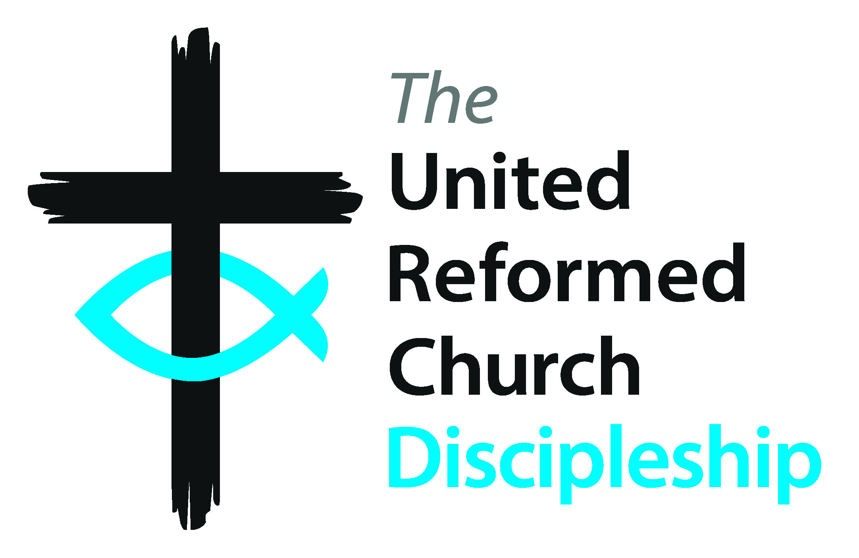

**Education for Ministry Phase 2 (EM2)**



**Assembly element of EM2**

Information for all EM2 Ministers*

Education for Ministry 2 (EM2) is a phase of supported learning, providing opportunities for continuing ministerial formation, evidence of ongoing individual development, and promoting habits of lifelong learning and connection, with the wider URC through the provided EM2 programmes. The EM2 programme will involve Synod and denominational staff and our Resource Centres for Learning and usually spans 3 years and consists of three parts: 1. The EM2 Minister’s relationship with their linked EM2 Ministry Mentor. 2. The synod network of EM2 Ministers with participation in relevant synod events (overseen by the Synod EM2 officer). 3. The Assembly EM2 programme.

# All EM2 Years

## Annual Summer Retreat

* Residential event from afternoon refreshments on a Friday to lunch on the Sunday
* Reflective sessions and worship
* News sharing
* Relaxed meals together and time out
* Led by Cohort Chaplains and the Secretary for Education and Learning

**Enrichment Webinars**

* Online seminars scheduled for four times each academic year with input from the 3 Resource Centres for Learning and the Children and Youth Development Team+
* Topics to run on a three-year cycle

**Support from Cohort Chaplain who:**

* acts as a pastoral carer not connected to the structures of ministry and is available as needed a listening ear
* stays with the cohort through the three years and contributes to worship at EM2 events

# EM2 Year One

**EM2 Induction and visit to Church House**

* Reminder of EM2 programme
* Tour of Church House and introduction to departmental secretaries and staff
* Introduction to Church House systems and support
* Visit with the General Secretary
* Worship with, and introduction to, the Cohort Chaplain
* Signposting to support and resources

**Requirements**

* Attendance at the EM2 Induction and visit to Church House in first year
* Attendance at the 4 webinars each year
* Attendance at the annual Summer Retreat
* Pastoral Supervision from Induction or Commissioning (overseen by Ministries)
* Participation in the Synod programme (overseen by the Synod EM2 Officer)