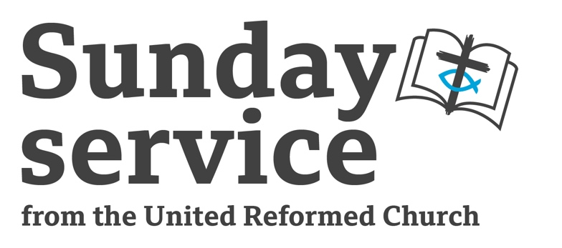
Sunday 16th March 2025
The Second Sunday in Lent
The Revd Fiona Bennett

Call to Worship

We are on a Lenten journey
from a wilderness to a garden.
A journey of pruning and planting,
of seeking and discovering.
God of transformation and new life, in our Lenten journey
we offer you our worship & praise.

Opening Prayer

Holy Loving One,
as we journey with Jesus through this season of Lent,
we remember the wilderness, where the seeds of his calling took root
as he planted wholeness, rather than egotism;
watered with integrity, rather than achievement;
nourished with love, rather than fear.

We give thanks for Jesus’ wise choices;
we praise the Spirit’s abundant growth;
we worship you, Holy Source of all Life.

As we travel through Lent, may we grow in Jesus’ image:
planting seeds of wholeness and turning away from egotism;
watering with integrity and turning away from achievement;
nourishing with love and turning away from fear.
That we may be strengthened by your wisdom,
flourish as we trust your abundance,
and blossom in your loving companionship.

We unite our prayers together in the Lord’s Prayer or Jesus Prayer,
using a form of words which are worshipful for us…

All Age Activity

The Long Game

Watercolour painting. Painting with water colours is not a fast way to paint. Watercolour painting involves many layers of wetting, then painting then drying and repeating the process. To get gradual blended strengths of colour is a slow process. As an activity you could try creating simple water colour skyscapes or any other activity (knitting, kneading bread, sanding wood) which take a reasonably long time to do and do no offer instant results. As you paint / sand / knit take time to talk together about thing in your life which have taken a long time to develop or to change. God is at work transforming us and our world into the people and place God created us to be, but it is a long story and a long project which we travel in faith.

Readings

Genesis 15:1-12, 17-18 | Luke 9:28-43

Sermon Notes

Genesis

This story takes place only 3 chapters after God’s initial call to Abram & Sara. They are a very busy 3 chapters with challenging stories. Abram and Sara have visited the land which God promised to their descendant, but still no pregnancy for Sara. Abram is reassured with a covenant, but still no pregnancy for Sara. Waiting in faith, holding to God’s promise is a theme which runs throughout the whole of Scripture. Like many stories in Genesis, this story of Covenant is about more than one human’s adventures. It encapsulates and demonstrates the human desire for surety in the midst of uncertain times. Abram, and we the readers, are invited to find that surety by putting our faith in the Holy One who promises Life in abundance but who is weaving a story much longer, broader and wiser than we can imagine.

Luke

If you try to explain the 21st Century science of this story I think there is a risk that you may miss what it is trying to say. It is a story of symbolism and wonder. Moses and Elijah represent the Law and the Prophets – encapsulating all of the faith story which has gone before. The voice out of the cloud reminds the disciples (and the readers) of Jesus baptism – the point where his ministry began. Now acknowledging the bigger story he is part of and the life he has lead, his story turns toward Jerusalem. The turn to Jerusalem is not comfortable or reassuring for the disciples. At points it will look like all has failed and is lost. The transfiguration offers a shocking and mysterious glimpse of that bigger story for the disciples then, and us today, to hold onto and remember when life’s journey gets hard and uncomfortable, God’s promise hold true.

Prayers of the People

God of hope
with Abraham and Sarah we pray for all in our world who are searching for a home, for security and supportive community. We think on people across our world today who are refugees due to war, violence and climate change. May your long story of Hope strengthen them and transform our world.
God of hope, may your Kingdom come,
May your will be done on earth as in heaven.

God of love
with Moses we pray for all in our world who are held in bondage by addiction,
abuse, poverty, oppressive laws, cultural norms. May your long story of Love strengthen them and transform our world.
God of love, may your Kingdom come,
May your will be done on earth as in heaven.

God of Justice
with Elijah the prophet we listen for your voice calling humanity today
to be the community and the people you created us to be, where all life can flourish.
May your long story of Justice strengthen them and transform our world.
God of hope, may your Kingdom come,
May your will be done on earth as in heaven.

God of peace,
with Jesus we pray for all who are working in our world today for change
through non-violence, vulnerability and grace.
In our daily lives and in the long story of our world,
may your way of peace steer us towards your Realm
where all will know abundant life.
God of hope, may your Kingdom come,
May your will be done on earth as in heaven. Amen.

Offering and Dedication

Praise God from whom all blessing flow.
Praise God all creature here below.
Praise God above, You heavenly host.
Praise Maker, Christ, and Holy Ghost.

Blessing

May the blessing of God almighty
Creator, Christ, and Comforter
be with us this day and everyday, Amen.

Hymn Suggestions
 | RS | CH4 | StF | MP
Will you come and follow me | 558 | 533 | 673
Jesus Calls Us | 355 | 509 | 250 | 359
Through the love of God our Saviour |  | 562 | 639
My Life Flows On |  | 565
Holy Wisdom lamp of learning |  | 604
Thanks to God Whose Word Was Spoken | 319 | 605
All my hope on God is founded | 586 | 192 | 455 | 16
There’s a Wideness in God’s Mercy | 353 | 187 | 416 | 683
Guide me O Thou | 345 | 167 | 465 | 201
Lord of all hopefulness | 531 | 166 | 526 | 882
RS – Rejoice & Sing | CH4 – Church Hymnary 4 | StF – Singing the Faith | MP – Mission Praise

