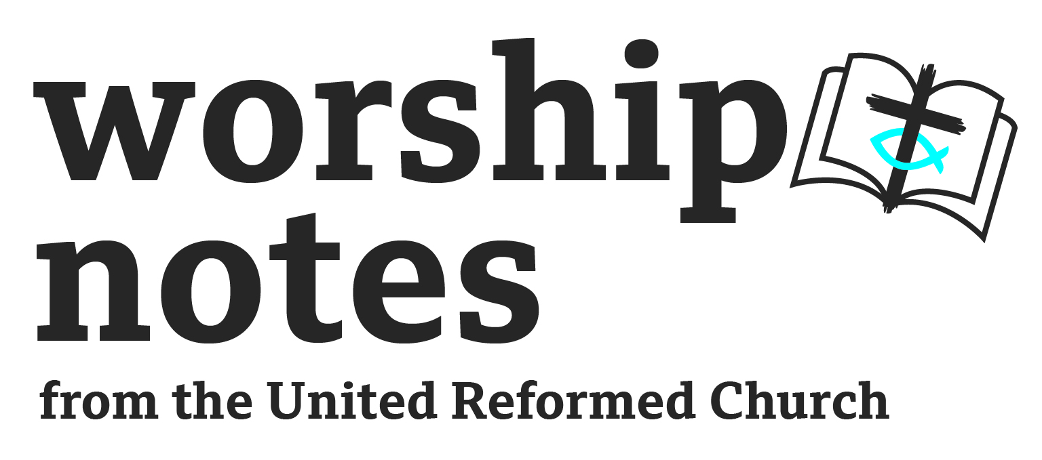

Sunday 26th January 2025
Epiphany 3
The Revd Andy Braunston

Who’s Agenda?
Call to Worship

The Psalmist says: How clearly the sky reveals God's glory! How plainly it shows what he has done! Each day announces it to the following day; each night repeats it to the next. No speech or words are used, no sound is heard; yet their message goes out to all the world and is heard to the ends of the earth.

Prayer of Approach and Confession

May the words that we use in our worship be formed by God,
focused on Jesus and filled with the Spirit.
God the Father,
we stand in awe of you, the one who spoke and brought the world into being,
who shaped our bodies and breathed into us the gift of life.
Majestic, awesome and wonderful,
yet at the same time, tender, loving and kind,

God the Son, we stand in awe of you,
who became incarnate
to live on this planet alongside us.
You showed us how life should be lived,
and paid the price in full on the cross.
God the Spirit, we stand in awe of you,
the one alongside the Father at creation;
you inspired and strengthened his Son on earth,
and came in your fullness to be our companion,
to lead and inspire your people today.
Creative God, by your word comes life.
Forgiving Son, by your word comes love.
Empowering Spirit, by your word comes liberation.
Speak your word to us now and our lives shall proclaim your glory. Amen.
A Prayer of Confession
God, you gave us the power to speak.
Words enable us to tell each other what is happening,
how we are feeling, why we are behaving in the way we are.
Sometimes someone cannot speak the words,
or cannot communicate because the language is strange,
or is afraid to say what needs to be said.
There are times when I did not speak;
I was distracted, I was silenced.
I was afraid of the consequences
or even said words that meant nothing.

Forgive us when we did not speak as we ought.
And in the knowledge that you are indeed a forgiving God
let your word come alive in our words.
Let our words become Good News.
Let the Gospel be welcomed by all.
We pray in the name and spirit of Jesus Christ. Amen.

The Lord’s Prayer

Readings

Nehemiah 8.1-3, 5-6. 8-10 | St Luke 4.14-21

For all the Family

Give everyone a rectangle of paper, about the size of a postcard, and a pen or pencil. Read Luke 4.17-19 slowly and clearly. Invite them to write or draw a prayer on their paper as they listen to the words read aloud. Allow a few extra moments for people to finish, then ask everyone to roll their paper up like a scroll and exchange it with someone else. The 'scrolls' could be used as prayer reminders during the week at home.

Prayer for Illumination

O Lord, your Word is a lamp to our feet and a light to our path.
Give us grace to receive your truth in faith and love,
and strength to follow on the path you set before us;
may your kingdom come and your will be done.
In the name of Christ Jesus our Lord. Amen.

Sermon Notes

St Luke

The first two verses follow the account of the temptation of Jesus and take us into his ministry in Galilee. The driving force is the Holy Spirit. The primary locations of Jesus' ministry and his own religious practice are the synagogues. His work is clearly within Judaism rather than alongside or against it, and he was well received. And he goes to the synagogue because it was his custom to do so. Regular practice of going to the synagogue or church is not a bad thing.
The synagogue was a centre for learning, community life and the administration of justice as well as worship. Worship at the altar was in the one Temple. In the many synagogues, people gathered around the word. We do not know exact details about synagogue worship at the time of Jesus, but it is worth noting

- Probably a number of men read from the scrolls of the Scriptures during public worship on the Sabbath beginning with the synagogue leader, who would be followed by perhaps as many as six other members of the congregation.
- We do not know whether a fixed lectionary was followed, or whether the reader could make a choice of the passage.
- We note that ‘the scroll of the prophet Isaiah’ was given to Jesus so the book, at least, was already prescribed.
- The Law and the Prophets were to be read while standing.
- A prayer would probably have been recited before the reading began.
- Preaching and teaching was done sitting down.
- There would have been offerings to the poor.

From his upbringing, Jesus would have felt at home in any of the synagogues he visited. Whilst his message may have been extraordinarily powerful, there was nothing extraordinary about him speaking in the synagogues in Galilee.
Jesus does not choose the passage in Isaiah at random. The servant song is given to him. Perhaps it is not an accident? It is however significant that the passage mentions:

- the Spirit - remembering Jesus' baptism and the empowering of his ministry (v. 14);
- anointing – the Messiah would be God's anointed one;
- the poor, the captives, the blind and the oppressed – those who were marginalised or excluded who needed the good news of liberation but who were ill served by society and organised religion;
- the year of the Lord's favour – the year of Jubilee when there is amnesty, liberation and restoration.

The words that Jesus reads from Isaiah do not all come from one passage but contain elements of three (Isaiah 61.1-2; 58.6; 42.7). These words from Isaiah place the poor and the oppressed front and centre, Jesus declares to the people of his home village, ‘Today this Scripture is fulfilled in your hearing’. Imagine reading such a bold piece of Scripture in your home church, among people who have known you since you were a child and saying that the promise contained in these words has come to its fulfilment. II wonder what their reaction was - disbelief, surprise, through to shock and, perhaps, mockery?

This Word is no longer a future hope but is actually beginning to be realised in the person of Jesus, a sort of mission statement or manifesto. Apart from the scripture reading, Luke presents the first public word of Jesus' ministry as 'today'. Jesus' ministry and the future ministry of the Church is about now, The Word, God-with-us.

Nehemiah

The Book of Nehemiah gives a narrative account of some of the events behind the later Isaiah prophecies. It describes how the first exiles returned from Babylon, by permission of their Persian rulers, and the hardships and dangers that they faced.

The need to rebuild from ruins is precisely the challenge faced by Nehemiah and Ezra. The Exile in Babylon is over, but Jerusalem, and the Temple in particular, has been ruined. The very centre of the people’s worship is in a mess. The people face a decision: to rebuild or live in the ruins. Nehemiah’s first priority was to restore some kind of wall right around the city of Jerusalem. This was to create safety but also to restore self-respect to the population.

This passage can be seen as another step in the restoration process: the public reading and interpretation of the Law for the whole community. In today’s reading, however, we witness how the Word of God forms the solid basis for the renewal of the life of worship. Though the Temple is rebuilt – a symbol and sign of God’s reign – it is the Law of God that sets people free to serve.

The people want to live as God’s people again and understanding the Law is a crucial step in knowing their roots and cementing their identity. To do that they must come face to face with whom they are and how far they have fallen short of embodying God’s people whilst in exile. The Law’s ability to clarify how humans have fallen short of God’s hopes and expectations for us is useful for pointing toward the necessity and gift of God’s grace.

Intercessions

O Lord
your Word contains truth for each new generation.
Thank you for fresh and exciting reminders
of the power and glory of your sovereign love.
Help us to seek the wisdom to use your words wisely
to pray for who cannot speak or who are inarticulate,
who depend on others to speak for them

Thank you for your word which reminds us
of your concern for justice for the poor and oppressed.
Help us to announce your good news;
to proclaim your liberty to those held captive;
to work and pray for a better world.

Thank you for your word which reminds us
of the ways in which you want us to live.
Help us to share the hope we have in you;
to proclaim your love for every individual;
to work and pray for new life for humankind.

Thank you for your word which reminds us
of our calling as members of Christ's body.
Help us to be united in love and respect for one another;
to proclaim your salvation to the world;
to work and pray under the guidance of your Spirit. Amen.
Offertory and Dedication

Generous God, giving abundantly
more than we can know or ask,
our promise is to justly share
ourselves in celebration of your word.
Take our gifts to use in your service, Amen.

Blessing

Go to bring good news to the poor,
to proclaim release for all who are imprisonoed,
recovery of sight for the blind and let the oppressed be valued
in the name of the Father, Son and Holy Spirit.
And the blessing of God Almighty
Father, Son and Holy Spirit
Be amongst us and remain with us
This day and for evermore. Amen.

Hymn Suggestions
 | RS | CH4 | StF | MP
O sing a song of Bethlehem | 201
A Stranger Once Did Bless The Earth (also goes to Sussex Carol) | 198
Born in the Night, Mary’s Child | 188 |  | 193 | 62
Thy hand, O God, has guided | 567 | 511 | 692 | 705
The Church’s One Foundation | 566 | 739 | 690 | 640
Jesus Stand Among Us | 565 |  | 30 | 381
Glorious Things of Thee Are Spoken | 560 | 738 | 748 | 173
God’s spirit is deep in my heart | 576 |  | 404
Go Forth and Tell | 574 |  |  | 178
God is Working His Purpose Out | 573 | 235 |  | 189
Colours of Day | 572 |  | 167 | 1039
The kingdom of God is justice and joy | 200 |  | 255 | 651

RS – Rejoice & Sing | CH4 – Church Hymnary 4 | StF – Singing the Faith | MP – Mission Praise

