United Reformed Church Commitment for Life Jan/Feb 2025



*Storie*

*S*

Moving

Committed to supporting our global partners

**A prayer for Gaza, Lebanon, and Syria**

As they took down that bruised and broken body from empire’s cross, Oh God, the disciples could not have dreamed that in a mere three days, Jesus would rise again in glory. Jesus gave himself over to death because he trusted that the same Love that birthed the universe would

birth new life amid empire’s death and destruction.

Oh God, we dare not lose hope now, and so we pray for the wounded, broken, and crucified people in Gaza, Lebanon, and Syria. We ask that you bring peace, joy, healing, equity, and justice to a people buried under the rubble of empire’s bombs, broken promises, forever wars, and grinding poverty.

May we place our faith once again, Loving God, in the hope of the risen Jesus.

May we trust that even the smallest act of solidarity will challenge impunity and can end injustice. Teach us that only Love can birth and multiply an abundance of peace, and laughter, and joy, in Jesus’ name. **Amen**.

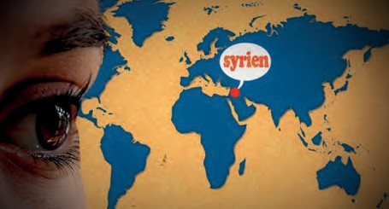***ommitment for Life* is the global justice**

Photo credit: kalhh on Pixabay

***C***

**programme of the United Reformed Church, working in partnership with**

**Global Justice Now**

**as well as Christian Aid in Bangladesh, Zimbabwe, and Israel and the occupied Palestinian territory.**

*Commitment for Life* is partnering with the Methodist Church’s

**All We Can**. We have come together to support people in Gaza and Lebanon. We would very much like you to pray for peace in the region. You could use the attached prayer in one of your services of worship.

Would you also consider donating to the appeal? In Gaza, your contribution will support a medical clinic. This is a wing of the Jerusalem Princess Basma Centre, which has been supported by **All We Can** for many years. In Lebanon, we are supporting the vital work of our URC partner church, the National Evangelical Synod in Syria and Lebanon (NESSL).

NESSL’s General Secretary is the Revd Joseph Kassab, writes:

We appeal to our partners… to persist in their prayers for Syria [and Lebanon]. We urge you to advocate for Syria’s future in your country, ensuring that this future becomes a sanctuary of safety, inclusion,

and freedom for Christians to practice their faith without persecution… The path ahead will be challenging, but it cannot be navigated without partnership in faith, prayer, and mutual

support. Your donations will go directly to these partners and will enable them to continue their vital work helping the most vulnerable in this conflict.

*Search: Just giving, Lebanon*

*Gaza justice appeal*

[commitmentforlife@urc.org.uk](mailto:commitmentforlife@urc.org.uk) [www.bit.ly/URCFL](http://www.bit.ly/URCFL)