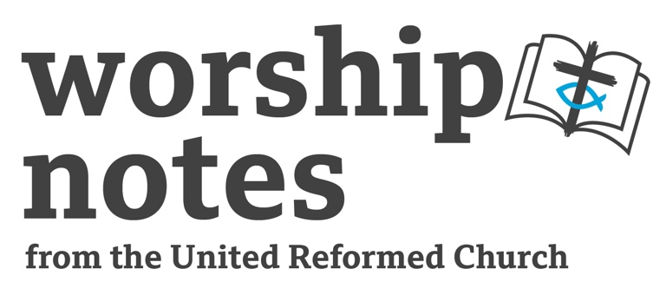
Christ the King
Sunday 24th
November 2024
The Revd Nicky Gilbert

Call to Worship

The Lord reigns, he is robed in majesty;
the Lord is robed in majesty and armed with strength;
indeed, the world is established, firm and secure.
Your throne was established long ago;
you are from all eternity.
Psalm 93 v 1-2
Opening Prayers

Jesus our King: we come to honour you.
You have promised to meet with us.
You have called us to come, so here we are.
To listen to your heart, to look for your path,
to think about your truth, and to learn about your love.
King of our hearts meet with us here, wherever here is Amen

Readings

John 18 v 33-37 | Psalm 132 1-12

All Age Talk | Introduction to theme

Cut out or draw a large crown, (nothing fancy) ask what people would do if they were king or queen, hopefully after they have said stay in bed, and eat chocolate all day, they will talk about things like making sure everyone had enough to eat! When they make a good suggestion add it to the crown as a ‘jewel’. When you have a few jewels talk about how Jesus is the sort of king who works for the good of others, not himself, and that when we do these good things we are being his loyal subjects. Jewels in his crown.

Sermon Notes

The psalmist is remembering the time that King David pledged to build a temple for God. Actually, it was not David who built the temple, he collected some of the materials, but it was his son Solomon who had the temple built. Sometimes it is ok to pass the task onto someone else, who can use our preparations.

Pilate is questioning Jesus just before he has him punished. He might be looking for a way out of punishing Jesus, or he might be looking to appease his own conscience that Jesus needed to be killed. Either way he seems not pleased with Jesus’s reply. To be a king in a Roman occupied country would be a death sentence. Perhaps Pilate is affronted, he was not a king, his power was mostly in the hands of his Roman overseers, he must have longs at times to have the power of a proper king, doing as he saw fit, making up his own rules instead of constantly having his interpretation of Romes rules questioned. Then Jesus upsets him further, “everyone who is on the side of the truth listens to me”. He has accused Pilate, of not listening and not being on the side of the truth! Pilate has no way to back out now and Jesus will suffer his wrath.

You might, drawing on these ideas reflect on the type of King Jesus is compared to the rulers, kings, and potentates the world sees.

Prayers for the World and Lord’s Prayer

Gracious God; we pray for the world you love.

We pray for kings and queens,
and prime ministers and presidents and all earthly rulers:
the loyal and compassionate, the trustworthy and honest,
the wise and the considerate.
Give them the strength to continue in wisdom.

We pray also for leaders who fall short of these high ideals,
for those who forget who they are meant to be protecting and supporting,
give them ears to hear the voices of those they have power over
and hearts to listen in compassion.

We pray for those who make big decisions,
doctors and teachers, nurses and aid workers, parents and police.
Help them to listen to the needs of others.

We pray for all those who have to live with the decisions of others.
The powerless, the landless and the disempowered.
We pray for our communities, for less division and more cooperation;
less anger and more understanding,
we ask that you show us how to be the best neighbour that we can be.

We pray for our families for all the love we find there,
and for grace and forgiveness when things get hard.

We pray for ourselves, you know when we fall short of being the best we can be,
you know when we find it hard to maintain our boundaries,
and when we fail in our compassion.

You know the things that keep us awake at night and the things we look forward to.
Guide and protect us dear King.
Help us to be the good subjects of your Kingdom.

All these things we pray about with hope and trust,
in the name of Jeus who loves us and who left us these words, Our Father…

Blessing

May God the Father who loves you,
Jesus the King who reigns over you,
and God the Spirit who empowers you,
be with you and those you love and pray for,
now and forever, Amen.

Hymn Suggestions
 | RS | CH4 | StF | MP
All hail king Jesus |  |  |  | 11
Crown Him With Many Crowns | 262 | 459 | 347 | 109
Hail to the Lord’s Anointed | 127 |  | 228 | 204
Immortal Invisible | 67 |  | 55 | 327
We have a king who rides a donkey | 210
The king of love my shepherd is | 552 | 462 | 479 | 649
Praise my soul the king of heaven | 104 |  | 83 | 560
God came in Jesus | 237
Be thou my vision | 489 | 465 | 545 | 51
Rejoice the Lord is King | 657 | 449 | 335 | 575
Christ of God unseen the image |  | 453
All Hail the Power of Jesus’ Name |  | 457 | 342 | 13
At the Name of Jesus | 261 | 458 | 317 | 41
Before the Throne of God Above |  | 466 |  | 975
Restore O Lord |  | 469 |  | 579
RS – Rejoice & Sing | CH4 – Church Hymnary 4 | StF – Singing the Faith | MP – Mission Praise

A Word Search

P | E | A | C | E | C | O | W | Q | S
R | X | W | R | U | L | E | R | G | J
A | P | I | G | S | C | A | T | M | U
B | Z | S | D | O | G | X | K | L | S
I | C | D | O | N | K | E | Y | A | T
T | L | O | V | E | I | I | B | Z | I
V | V | M | E | Z | N | F | N | F | C
F | N | B | I | R | D | G | H | R | E
R | E | T | E | R | N | A | L | O | J
E | M | A | N | U | E | L | K | G | G
Q | W | R | T | Y | S | E | A | L | N
G | C | H | R | I | S | T | V | B | M
Donkey
King
dove
Christ
Emanuel
peace
Ruler
Eternal
Justice
Wisdom
Kindness
Love
Bonus words; animals.

