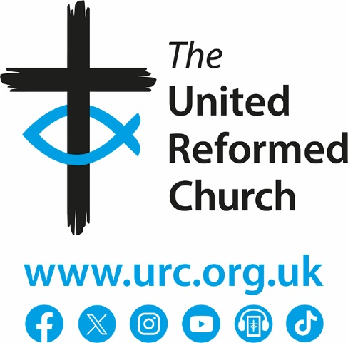

Safeguarding Committee Terms of Reference

Background

The Safeguarding Committee is a standing committee of the General Assembly, taking over and expanding the remit of the former Safeguarding Advisory Group, and is the body responsible for overseeing the implementation of General Assembly’s Safeguarding Policy throughout the United Reformed Church.

The development of this committee is partly in recognition of the need to develop the safeguarding infrastructure to implement lessons learned from the Past Case Review and the Independent Inquiry into Child Sexual Abuse (IICSA).

Membership

Convenor (nominated by the Nominations Committee, with sufficient recent experience and relevant skills drawn from one of the disciplines of social work, police, probation, health, education, not for profit)

Secretary (The URC Designated Safeguarding Lead)

A representative of the Synod Safeguarding Practice Group (nominated by that group)
A Synod Moderator

Up to two representatives nominated by the URC advocated survivors group

Two members (nominated by the Nominations Committee, with relevant complimentary skills and recent experience, including safeguarding children / young people, safeguarding adults at risk, safeguarding law, police, and employment)

Two external independent members, one of whom may be an ecumenical safeguarding colleague (with relevant complimentary skills and recent experience, including safeguarding children / young people, safeguarding adults at risk, safeguarding law, police, and employment)

Ex Officio
Deputy General Secretary (Discipleship)
Secretary for Ministries
Training and Development Coordinator

- Terms of Reference
- To monitor the implementation of the URC Safeguarding Policy Statement as agreed by the General Assembly, making recommendations to Mission Council and General Assembly as appropriate.
- To support the councils of the Church in the implementation of the safeguarding policy.
- To oversee strategic matters of safeguarding throughout the United Reformed Church.
- To recommend to the General Assembly changes to agreed policy from time to time.
- To act as a reference group for the URC Designated Safeguarding Lead.
- To ensure that Good Practice documents are updated, published, and circulated as appropriate.
- To monitor local church and synod compliance with the General Assembly’s Safeguarding Policy Statement and Good Practice and implementation of the strategic plan. To devise strategies for addressing identified weaknesses and non-compliance.
- To advise on the development and delivery of safeguarding training across the denomination.
- To encourage collaboration with ecumenical partners across the full range of safeguarding issues, including engagement in the development of public policy.
- To build a holistic understanding of the services which the United Reformed Church receives from external or other relevant agencies and contractors that support its safeguarding policies and practices.
- To receive learning lessons reports from cases and to consider any developments needed in response.
- To consider when external reviews of cases are required.
- To report in writing to each meeting of the General Assembly.

