# Youth Assembly 2025 - poster and postcard text

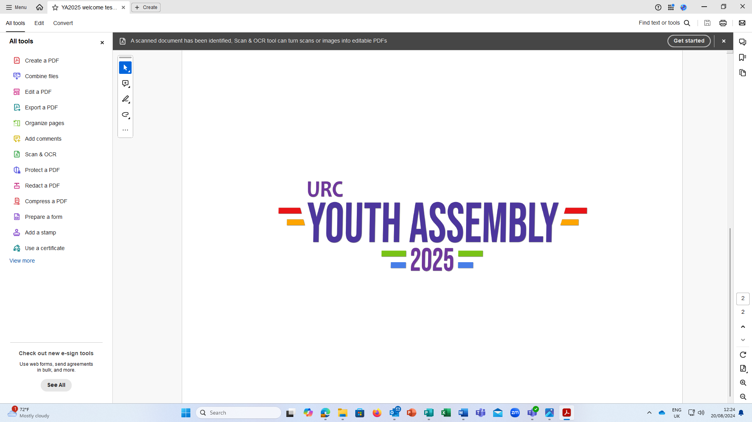

All Are Welcome [main title] *– logo in this style with URC cross replaced with a cross that is the continuation of the rainbow line, and all the text in URC blue rather than rainbow:*

arrive as strangers, leave as friends [subtitle]

7-9 March 2025

new venue with twin rooms and menu choices

Kings Park Conference Centre, Northampton, NN3 6LL

£120 early bird until1 December / £150 from 2 December until 2 February 2025

Please talk to your church and synod about help with funding.

Open to Year 10 / S3 students up to 25 years inclusive.

Book you place today: <https://linktr.ee/URCYouthAssembly>

or contact children.youth@urc.org.uk

A fun weekend to have your say, make friends and find fellowship

* Worship - Bible study, music, prayer spaces, late night communion
* Youth Decides - discussion on issues that matter to us - leading to action and engaging the wider church
* Workshops - grow your skills and thinking while exploring the theme
* Entertainment - campfire, karaoke, sports, games and more

For all young people with a connection to the United Reformed Church including:

[Boys Brigade, Girls Brigade, URCGSF, Pilots, Guiding, Scouts, URC Youth - logos]

Here’s a taste of Youth Assembly 2024 [QR code [link to video [United Reformed Church Youth - Youth Assembly 2024 (youtube.com)](https://www.youtube.com/watch?v=L1npXCWKfO0)]

