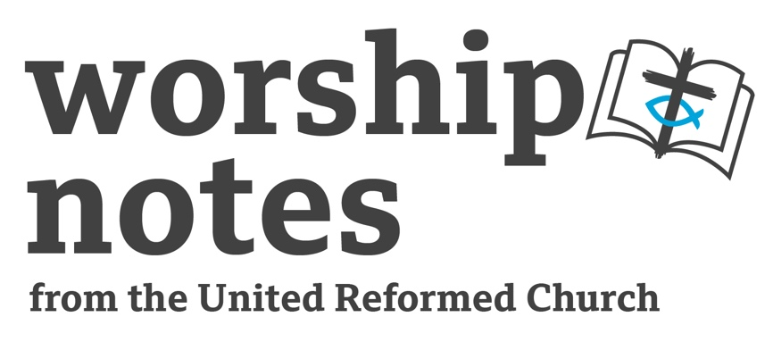
Sunday 27th October 2024
Proper 25 | Ordinary 30
The Rev’d Mark Rodgers

Call to Worship

When the Lord restored the fortunes of Zion,
we were like those who dream.
Then our mouth was filled with laughter
and our tongue with shouts of joy;
then it was said among the nations,
“The Lord has done great things for them.”
The Lord has done great things for us,
and we rejoiced.
From Psalm 126

Prayers of Adoration and Confession, Assurance of Pardon

Wonderful Abba
You do so much for your people, for the lame and the blind,
for the lost and the found, for the young and the old,
and we want to praise you with our shouts of joy.

Where there are barren lands you supply the streams of water,
where there are rocks to stumble you flatten the path.
And as we gather from all over we make our praises heard in adoration of you.

But Forgiving Mother
look upon us this day and bless us with your forgiveness
as we have not looked at the world and its people in the same way you do.
We have made life more difficult for some rather than easier,
we have taken away food, drink and resources from others where you give.
We have shepherded people away from us and from you, rather than gathering them in.
In your love and grace, please forgive us,
as sometimes, we do not know what we are doing.
And we ask this through your Son,
the one who opens our eyes to you and a new way of being. Amen

Shout, sing, dance, praise the Lord our God,
for Jesus came to this earth and spoke the words –
“your sins are forgiven”. Amen

Prayer for Illumination

God of all knowledge and understanding
give us now just a glimmer of what you know.
Help us to hear your word, understand its meaning,
and see what it means for You, us and the rest of your people. Amen

Readings

Jeremiah 31:7-9 | St Mark 10:46-52

All Age Activity

Print the FLY card activity which is at the end of these notes

Give out the cards face down, and if possible upside down, or at least not the right way up, to make it as difficult as possible. Once everyone has a card, ask them to turn it over and explain that you have given them a card with some unusual shapes on them. Ask people to describe the shapes. What could they be? A Spanish hat on its side? A house with the garage door open? A native American? An Arrow? A Space Invader?

Then tell the congregation that there is a word on the piece of paper. Ask that if they see it, to not shout out but to put their hand up. There should be a good mixture of those who can see it and those who can’t. Once a few minutes and puzzled faces have passed, tell them that it says FLY and that the letters are in white letters not the black shapes. You could have a card with the whole border coloured in black as this makes it easy to see.

This is a scotoma, a blind spot. In this instance they happen because we are taught to read black lettering on white paper but this card switched it around and our conditioning over the years made us blind to it. Sometimes our lack of faith in Jesus can make us blind to the possibilities of what we are capable of, or what our churches can do, because we have conditioned ourselves to think we are too old, or too few. Faith in Jesus can open our eyes to new possibilities.

Sermon Notes

Jeremiah 31:7-9 At this point we are just over halfway through the book of Jeremiah. At the point that we read the writer is sharing with us a prophecy describing God’s intentions after the destruction of the region at the hands of the Babylonians. Many exiles are living in Babylon and Jeremiah has a message for them from God, telling them that He will restore Israel, even though they have done wrong and sinned against God. But he is a loving and forgiving God and will bring them back to the land he promised their ancestors. Jews following the law understood from the book of Numbers that their sins would pass down the family line, so the hope of returning to Jerusalem for many families was zero. But through Jeremiah, God is giving the exiles a renewed hope, and presenting to them a vision of what is to come. Seeing a brighter future ahead is what gives everyone hope in all sorts of difficult circumstances. Mental health sufferers, prisoners, addicts, hospital patients, all need a brighter future to focus on to aid recovery or make their current situation bearable. What brighter futures are we offering those who are exiled from God?

Mark 10:46-52 A wonderful passage to really bring alive using Ignatian contemplation. Encourage the congregation to think about the scene to sense the heat, the dryness of the air, the noise of the crowds in a language we do not understand. The dusty tracks. And yet everything is black. And yet, as the all age activity proves, we can still have eyesight and yet not be able to see. Bartimaeus shouted out to Jesus as the “Son of David”. He knew who Jesus was without needing to see. Did the crowd know who Jesus really was? Sometimes the wise among us in church life and society in general are those on the margins or those we consider a pain, and we want to slap them down or shut them up. Perhaps we should consider the voices of everyone, no matter what we think of them. The most important point of the reading is that Jesus asked Bartimaeus the question, “What do you want me to do?” I love this question. It shows a God that does not presume, does not act without being asked first. Sometimes we think we know best for people, especially those who might be disadvantaged in some way, but Bartimaeus may have been happy blind, we cannot just presume. Do we just act, or do we ask the questions first?

Offertory

Giving Lord as you give wholeheartedly to us,
we bring our gifts and ourselves to you.
Bless what we offer you,
so that it may be used to help those who need it most,
and to open the eyes to the world
so that they may see the coming of Your kingdom. Amen

Prayers of Intercession

Loving, caring God
You are a God for everyone, from the rich to the one in the gutter.
To the disciples who wanted status to the man who wanted the basics.
We now turn our attention to those we can think of.
They are not everyone Lord, but they are the people we are worried about,
near and far.

We pray for those people caught up in conflict.
In warzones, gang violence, petty skirmishes or criminal acts.
We pray for everyone’s safety, and that peace will ensue,
leading to prosperity and growth.

We pray for all those with responsibilities for leading groups of people,
whether that be countries, states and councils, or big corporations.
May they make decisions with Christian values,
with the care of the people in mind, rather than power and profit.

We think of those in our own country where the darker nights
bring fear due to living alone,
or the thought of putting on the heating causes stress
as it is not affordable and has become a luxury.
We think of those who can only dream of putting on the heating
as they live on the streets.
We ask that solutions be found s
o that people do not feel scared, cold or need to be roofless.

We pray for our churches,
and ask that you bless us with a renewed sense of vigour and passion for your word. That we can reach out more to those who need to hear it the most,
and can be a place where people feel loved and belong.

And we pray for friends, family and ourselves.
Many are ill or in pain, many fear a diagnosis or do not feel themselves.
Be their strength and shield, offer them a healing hand,
and bless them and us with the knowledge that you love us and are with us at all times.

We pray all of this, in the name of your son, our Saviour Jesus Christ. Amen.

And let us bring all our prayers together by saying the one prayer that Jesus taught his disciples, saying - Our father…

Blessing

As Jesus asks “what do you want me to do?”
Let us leave her today to ask what we can do for others
with the love of God, in the name of Christ,
and with the warmth of the Holy Spirit, Amen

Hymn Suggestions
 | RS | CH4 | StF | MP
Come, now is the time to worship |  | 196 | 24 | 1040
Praise, my soul, the King of heaven | 104 | 160 | 83 | 560
To God be the glory | 289 | 512 | 94 | 708
Amazing grace | 92 | 555 | 440 | 31
Come Lord, to our souls come down | 361 |  | 493
Lord, I was blind | 358 |  |  | 433
Hills of the north, rejoice |  |  | 172
Now thank we all our God | 72 | 182 | 81 | 486
I watch the sunrise lighting the sky |  |  | 469
Great is thy faithfulness | 96 | 153 | 51 | 200
RS – Rejoice & Sing | CH4 – Church Hymnary 4 | StF – Singing the Faith | MP – Mission Praise



