United Reformed Church Commitment for Life Sept/Oct 2024



Moving

Committed to supporting our global partners **BANGLADESH**

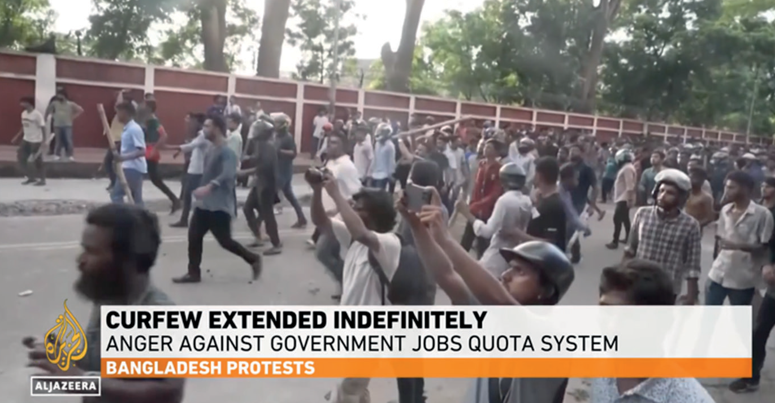

**angladesh has experienced unprecedented levels of student protest, possibly the worst in living memory. Over 100 people have died.**

**A Prayer**

We choose a world of justice, where resources are

not hoarded, but equally distributed; in which we work for a world made fit for future generations, caring for one another in peace.

We choose, **we choose God, for God is justice.**

We choose a world of peace, in which people no longer destroy one another, and

all are respected for their uniqueness.

We choose, **we choose God, for God is peace.**

We choose a world of love, in which God’s love for all is known, where each person is accepted and celebrated,

through whom God’s purpose for the world is fully revealed. We choose, **we choose God, for God is love.**

We choose a world of joy, where the joy of God in

all creation is fêted, where the goodness within all is gladly known.

**Where we join creation’s song of praise.**

**We choose. We choose God. Amen.**

Photo credit: Al Jazeera

B

What started as peaceful protests on university campuses transformed into nationwide unrest. The government imposed a massive communications blackout, shutting down the internet and phone services.

University students were protesting a quota system for government jobs. A third of public sector jobs are reserved for the relatives of veterans from the war for independence in 1971. Students have argued that the system is discriminatory. Most people in the country agree.

It is vital that our partners can continue their work in support of some of the poorest people

in Bangladesh. Please pray for the country and for our partners. For more information on these protests, see this Al Jazeera article: [bit.ly/4dzGofd](https://bit.ly/4dzGofd)

*Support Gaza here*

[commitmentforlife@urc.org.uk](mailto:commitmentforlife@urc.org.uk) [www.bit.ly/URCFL](http://www.bit.ly/URCFL)