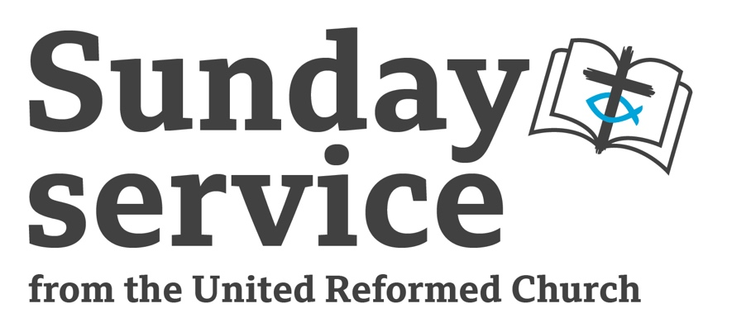
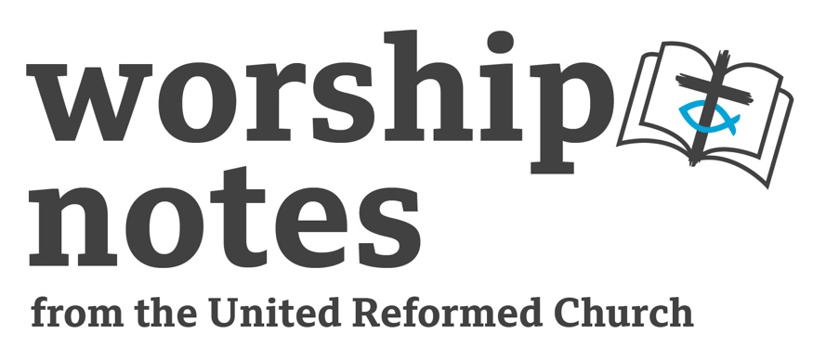
Sunday 29th
September 2024
Proper 21 | Ordinary 26
Jo Patterson

Responsive Call to Worship
Wait patiently for the Lord, he will turn and hear our cry,
He will lift us up, set our feet and give us a firm place to stand.

Put new songs in our mouths, hymns of praise to our God,
We will see the Lord and put our trust in him.

Come, let us seek, rejoice and be glad,
Let us always say “God is great”.
adapted from Psalm 40
Prayer of Praise

Let us pray together

Loving God, You are our protector, our guide, and our saviour. We meet this morning to praise all that you have done for us, the wonders that you give us in our world and in our lives. We turn to you in times of joy and in times of sadness knowing that you will always be there to walk with us. We come as your humble children, wanting to know you better and let you fully into our lives. We think of those who have faith in the most difficult circumstances, who show you their love when it is not easy. We are truly thankful for your presence in our lives and come together in the unity of the body of Christ, to worship, to praise your name, however we come to you today. Open our hearts to see your will and let your spirit be active in us today and always.
Prayer of Confession

Merciful God, You are our protector, our guide and our saviour. We bring to you our apologies, our wrong doings, our short tempers, our untruths and our difficulties. We are human and we get things wrong, at home, at work, in church, at school, with family, friends and neighbours. We do not look after our planet or ourselves as you would like. Knowing that we do not always do the right thing is difficult, but knowing that you are there for us can help us. Show us the best way. Accept our remorse as we know that you will forgive us, you will show us your love and we will be able to move forward. Teach us new ways of being your children in this world. And let us speak of you, knowing we are loved by your unconditional grace and mercy. Amen

Assurance of Grace
O God, your heart is full of mercy. May we hear and trust your words to each of us: ‘Your sins are forgiven.’ May we forgive each other and forgive ourselves. Thanks be to God. Amen.

The Lord’s Prayer

Use whichever version is comfortable for your setting. Or ask everyone to pray as they wish, using their own comfortable version or preferred language.

A Prayer For Illumination

Loving God, give us faith to receive your living word, understanding to know what it means, and the will to put it into practice; Through your Son Jesus Christ. Amen

Readings

Esther 7.1–6, 9, 10; 9.20–22 | Psalm 124 | James 5.13–end | Mark 9.38–end

All-age Introduction

Ask who is scared of something. Then a time when they have overcome something. Ask the children, young people and adults to share some event that has made them feel brave. What are the stories which make them think of bravery? You could provide some pictures, or slides if you have appropriate means, of brave people in your context with relevance to your groups.

It might be that they answer tales of traditional bravery… fairy tales or well-known heroic deeds. Encourage experiences from different contexts.

Today’s readings are about bravery in a more ordinary way, from Esther, a woman in a difficult position where there is no expectation but who does a very brave thing to save her people. And our gospel reading speaks of how we can be brave today – in the face of difficulty we are asked to speak and be heard.

Here is a link to URC resources for children and young people:
Here is a link to Roots Resources offering activities and ideas for all ages. It is a subscription service:

Sermon Notes

For my broadcast sermon I will use the Esther and Mark passages. I like to set the context of what has happened before and after, But if you know the context already you can skip to the possible sermon topics.

Esther 7:1–6, 9, 10; 9:20–22

The tale of a Jewish Queen of Persia, Queen to King Xerxes (also known as Ahasuerus). Set between 485-465 B.C., Esther is chosen as a replacement queen from the King’s harem when he falls out with his wife, Queen Vashti. It is worth setting the context, a lot happens before we get to this meal and the fulfilling of Esther’s petition - it is worth reading the rest of the book first, it’s a cracking story! But I’ve also provided a summary below. Also worth remarking that God is not named in this book.

Some ideas:

- The tale of bravery, where Esther a woman, from a Jewish background seems an unlikely person to save the day. Mordecai also takes a central and brave role. What does it take for us to do that today?
- What is the position of the women in this passage?
- What does deliverance mean in this story?
- The festival of Purim is still celebrated today Festivals could be a good topic. Why are they important? What do we still celebrate today and why?
- Finally, a more controversial topic – in Esther’s tale, does the liberation of one people come at a cost? Does the liberation of one group today always have a cost?

Psalm 124

A psalm of collective thanksgiving, always welcome and written to be repeatedly chanted or sung. Some ideas:

- This is probably about specific conflicts and enemies. But it does have a more general feel. Something speaks about national conflicts and where God is?
- The words build up as destructive and life changing, developing stronger images as the psalm continues. Perhaps even towards death. How far do we let things go before we understand the need for intervention? What do we need to hear to make us act?
- God is our mediator, and we are thankful. What does mediation look like in our Christian contexts today?

James 5.13–end

Written by James, Jesus’s brother, and the leader of the early church in Jerusalem. It is a guide to early Christian practice aimed at leading groups to a faithful life in Christ. James was fundamental in spreading the Word far and wide to gentiles as well as Jews. There is a focus on trusting in God, thinking about what you hear and forming new communities, but also about action, ‘faith and works’ is a well-known part of this book. Words are also important to James, seeking God’s wisdom and guidance in our use of language. And a focus on God rather than human concerns of power and wealth. Some ideas:

- What to do for those who need our help. The sick, the sinner, how do we as a church community approach this? And whose job is it?
- It can be difficult when judgments are made about people in our churches and our communities. Who do we help?
- The power of prayer – how different ways of prayer are helpful. What is a prayerful community?
- How do we speak about faith? And why? Is it to save as James suggests? Or is it about sharing what we know of the love of God to others? Who are ‘others’?

Mark 9:38–end

This passage is just after the transfiguration where Jesus has told three disciples not to tell anyone what they have seen. Then there is an exorcism of a young boy, followed by teaching about belief and prayer. Directly preceding our verses, the disciples have been arguing about who is most favoured or important. Jesus has also told them:

“The Son of Man is to be betrayed into human hands, and they will kill him, and three days after being killed, he will rise again.” But they did not understand what he was saying and were afraid to ask him.’

Those who want to be first must be last, and that the children are important. And it is this context that Jesus is talking about discipleship and social structures.

And so to the actual passage. Jesus is aware that his time is limited. Jesus is trying to speak of how we reorder the disciples concerns about their hierarchy but also how we reorder the world. And God is at the centre. In this new world, anyone is included, not just Jesus, not just as a faithful person, but a place where everyone can act. Some ideas:

- Children here represent the new way of levelling out our social understandings. All are valued, all are recognized as children of God. Do we recognize that or are we living in hierarchy?
- This passage sometimes focuses on a defensive use of ‘whoever is not against us is for us’ in that there are those against us! Another way to look at this is that there are many for us. Who are our partners? How do we work with others? Are there ways of embracing difference? Is there mutuality in our practice, we can all benefit from compassion and the outworking of God’s love?
- Purposefully harsh in the physical descriptions, this points us towards how difficult discipleship can be especially in managing change. Discuss how change can be slow and difficult. Should we do it even though it is hard?
- Using imagery of human bodies – how we act (hands), how we walk with God (foot), how we see the world (eye). How are we living a faithful life? A reflection on biblical understanding of the whole body, the church, the body of Christ are interesting additions here.

Affirmation of Faith

All Holy God, who gives us life and love, grace and mercy, and is glorified by all the earth…We believe and trust in you.

All Holy Son, who came to be with us and live like us, to show us new ways to challenge and to love the unloved… We believe and trust in you.

All Holy Spirit, who remains in and around us, helping us to love and serve, to tell the stories of hope and to fight for justice…We believe and trust in you.

This is our faith, the faith of the church, our faith in Jesus Christ our saviour
Amen.

Prayers of Intercession

Let us bring our hearts and minds to God. Let us pray.

Sisters and brothers in Christ, God invites us to bring our doubts and fears,
our joys and concerns, our petitions and praise, and offer them for the earth and all its creatures.

God of all creation. You are our holy and most wondrous God, who made this wonderful earth. We thank you for this world and all who live, work and play, within it. We bring to you our concerns for those in other nations. It is difficult to hear about the division present in the world. The places of famine and illness, drought and floods. We ask for your love and grace to guide those who are making difficult decisions. And to surround those innocent people caught up in these conflicts named to you today. We offer them to you, and any other international conflicts know particularly to us.

God of grace and mercy. We thank you for those who give their lives to service in this country. Politicians, government workers, servicemen and women, in armed services and domestic services. We are forever thankful for their work to serve and protect us. We offer them to you.

We lift to you those in medical services especially those who have to make difficult and life changing decisions. Give those in power your guidance that they may lead well, guide us in our national concerns and receive your wisdom.

We feel divided especially in the face of, racism, gender issues, disability, sexuality, privilege, mental health and other social injustices. And in the hate that sometimes fuels those debates. Hate is such a negative state to live in, let us not be tempted to use bitterness and frustration to hit out at others. Bring peace and calm to those who live in a state of hatred. Let us live in unity, as you would wish.

God of love and compassion. We look to you for guidance and love, as we know you will always love us. We pray about our local areas, our church and ourselves. We offer what we can, to our local communities, in the face of crime, poverty and injustice. Be with our faith leaders, local government representatives and community leaders as they try to tackle the issues of in our area. They are trying to do your work and sometimes this is fraught with difficulty and opposition. Let us ask those who live here what they want and work alongside them. Guide them support them so they can flourish and enable the community to come together in unity and peace.

God of healing. We come to others we know who are suffering, in poverty, with money concerns, unemployment, grief, illness or loneliness. We hold them to you. Show them your compassion and teach us to do the same. We especially pray for those who have asked for the prayers of our churches.

God of thankfulness and grace. And finally we offer you ourselves. We do our best, but we are human and have our human concerns. In a moment of quiet we bring to you our private concerns, that only you can see in our hearts.

Merciful God, accept these prayers for the sake of your Son our Saviour, Jesus Christ.
Amen.

Offertory Prayer
Creator God, Receive all our gifts, those given today, those given at other times, those of money, talent and time. We are truly thankful for all that you freely give to us for the work of your Kingdom. Amen

Blessing

May the God who dances with creation,
Who embraces us with human love,
And shakes our lives like thunder –
Bless us and drive us out with power
to fill the world with her justice;

And the blessing of God almighty,
the Father, Son and Holy Spirit
be among you and remain with you always.
Amen.
Janet Morely – All Desires Known, Morehouse-Barlow Company, 1988

Hymn Suggestions
 | RS | CH4 | StF | MP
O God our help in ages past | 705 | 161 | 132 | 498
Tell out my soul | 740 | 286 | 186 | 631
Be thou my vision | 489 | 465 | 545 | 51
Put peace into each other’s hands | 635 | 659 | 712
There’s a spirit in the air | 329 | 616 | 398
What a friend we have in Jesus | 413 | 547 | 531 | 746
Take my life and let it be | 371 | 502 | 566 | 624
Lord of all hopefulness | 531 | 166 | 526 | 882
I the Lord of sea and sky |  | 251 | 663 | 857
Will you come and follow me | 558 | 533 | 673
Great is thy faithfulness | 96 | 153 | 51 | 200

RS – Rejoice & Sing | CH4 – Church Hymnary 4 | StF – Singing the Faith | MP – Mission Praise

