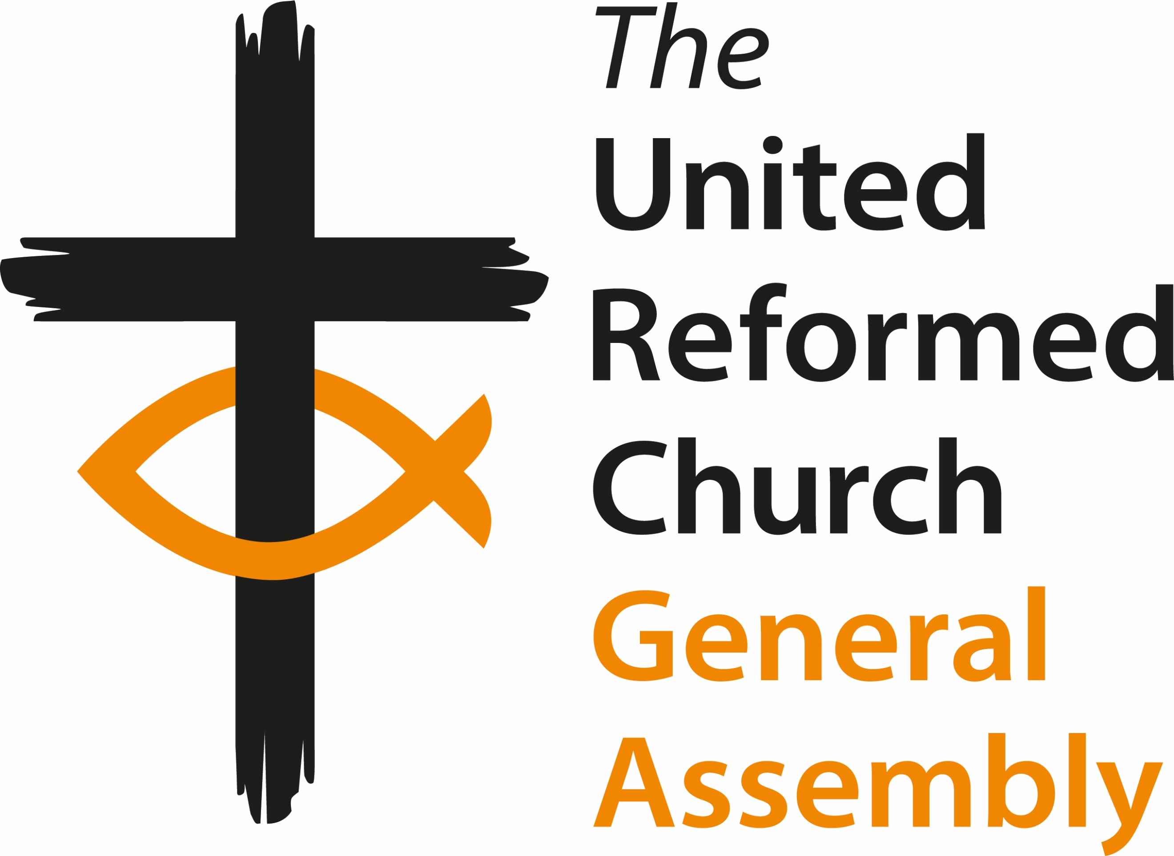**General Assembly**

Friday 12 July to Monday 15 July 2024

**Agenda**

**Friday 12 July**

**12:00 Arrivals and registration**

***13:00-14:00 Lunch (All attendees)***

14:00 Welcome and constitution of Assembly

Opening Worship

*16:00 Break (and access to rooms)*

**Session one**

16:30 Introductions and Greeting of Ecumenical Guests

Mock Resolution

Synod Moderators’ Report

Closed Session Paper A11

*18:30-20:00 Dinner*

**Session two**

20:00 Ministries papers, **H3**, **H5**, **H9**, **H11**

21:00 Evening prayer

**Saturday 13 July**

*7:45-9:00 Breakfast*

9:00 Worship and Bible study

9:50 Presentation of candidates for GA Moderator 2024-2025 and vote

**Session three**

10:10 Mission **I2**, **I3**, **I4**

*11:00 Coffee*

**Session four**

11:30 Moderator’s Address

Faith Wills video (from Christian Aid)

12:30 Community Awards

*13:00 Lunch*

**Session five**

14:15 Place for Hope (presentation)

15:00 Finance **G2**, **G3**, **G4**, **G5**

*16:00 Coffee*

**Session six**

16:30 Ministries **H7**, **H10**

*18.30 Dinner*

20:00 **Parallel Sessions**

A. Business Committee – **A1**, **A2** and Finance Committee – **G1** and Mission Committee – **I1**

B. Worship Faith and Order Committee – **F1** and   
Ministries Committee – **H1**

C. Communications Committee – **C1** and   
Equalities Committee – **E1**

D. Education and Learning Committee – **D1** and   
Children’s and Youth Work Committee – **B1**, **B2**

21:00 Evening prayer

**Sunday 14 July**

*7:45-9:00 Breakfast*

9.00 Prayer with Bible study

**Session seven**

9:35 Church Life Review Group **N1**

*10:00 Coffee*

10:30 Worship

**Session eight**

12:00 North Western Synod **X2**

Thames North Synod **X3**

*13:00 Lunch*

**Session nine**

14:00 En Bloc:

Business Committee **A3**, **A4**, **A5**, **A6**, **A7**, **A10**

Ministries **H2**, **H6**, **H8**

Law and Polity Advisory Group **P1**

Nominations **J1**, **J2**

Safeguarding **T1**

Eastern Synod **X1**

Items removed from En Bloc

Celebrating Jubilee Ministers and greeting ministers new to their   
URC roles

*15:30 Coffee break*

**Session ten**

16:00 Welcome to the new local church (assuming **X1** agreed)

Business Committee **A8**, **A9**

Ministries paper **H4**

*18:30-20:00 Dinner*

**Session eleven**

20:00 Remaindered business

21:00 Evening prayer

**Monday 15 July**

*7:45-9:00* Breakfast *(check out of rooms by 9:00)*

9:15 Worship and Bible Study

**Session eleven**

9:40 Moderator Elect 2024-2025 Acceptance Speech

Remaindered business

Miscellaneous Items

Address to the throne

*10:45 Break*

11:15 Closing worship:  
*Including induction of the Revd Tim Meadows*

*13:00 Lunch and departures*

*Leave by 2pm*