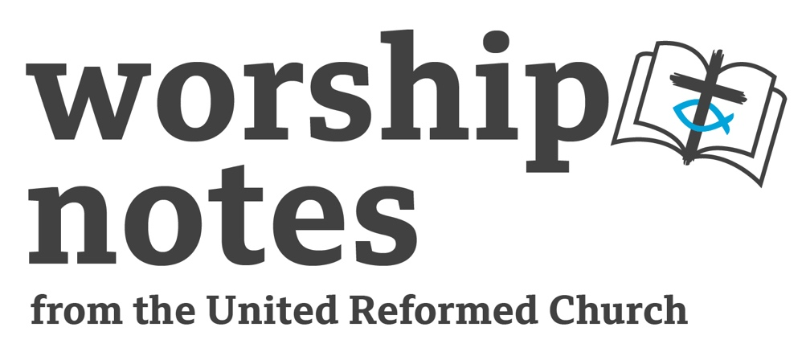

Trinity

12th June 2022

The Rev’d Dr Susan Durber

Call to Worship

Holy, holy, holy is God the sovereign Lord of all,
who was, and is and is to come!
Praise be to God; Creator, Son and Sprit,
praise be to God, the perfect Trinity of love.

Prayers of Approach

O God, Holy Trinity,
we arise today to praise you,
to confess our faith in you,
called by you and created by you.

Through the strength of Christ,
we arise today to praise you.
You are the light of the sun,
the splendour of fire,
the swiftness of the wind,
the depth of the sea,
the stability of the earth and the firmness of the rock.

Your strong Spirit upholds us,
your wisdom guides us,
you protect us and look over us,
you hear us and you speak to us.

We arise today,
and we call upon you,
the great and holy God,
the Three in One,
the Creator of all that is,
and we praise you and glorify you.
today and for ever, Amen.

Confession

O God of all holiness
as we are here in your presence
help us to be honest about ourselves and our world,
to recognise the good and the bad,
our strengths and our failures,
all that we have done wrong,
and all the ways in which you are blessing and affirming us.

We confess our sins,
and the sin of the world,
and we ask for mercy,
and the wisdom and courage to change.

Affirmation of Forgiveness

Let us hear for ourselves the words that Jesus said to so many,
‘Your sins are forgiven’ and ‘Be at peace’.

God the source of all life re-creates us each day,
Christ has, once for all, redeemed the world,
and the Holy Spirit works to empower us in goodness.

Thanks be to God, the Holy Trinity
of mercy, love and power, Amen.

The Lord’s prayer..

A Prayer of Inspiration

O God of all light,
open the eyes of our hearts,
that we may see not only the marks of words on the page,
but their inner glory and eternal light,
as your holy Word is read and proclaimed.
In the name of God;
source of all light, light of the world and light of our hearts,
Amen.

Readings

Psalm 8 | Romans 5: 1 - 5 | St John 16: 12 - 15

Sermon Notes

It is tempting to begin to preach on Trinity Sunday by saying how difficult it all is, how puzzling the doctrine of the Trinity can be, by making apologies for not knowing enough or not being able to explain it. People make jokes about how unfortunate they are to be preaching on this Sunday of all Sundays. But set that all that aside. Look instead at the Bible readings and really listen to them.

Psalm 8 is one of the most memorable and popular of the psalms. It is not ‘difficult’ – in fact the experience it describes resonates with many people. You don’t need lots of knowledge about the context of the psalm (not that we know much!), but simply to read it as you might a contemporary poem or reflection and to engage with the very human experience it describes.

Read the psalm slowly and carefully and imagine the experience that caused a human being to write. Have you had a similar experience perhaps? Maybe you have stood and gazed at the stars at night and wondered. Maybe you have been awestruck in a great building or in the midst of a powerful emotion found yourself overwhelmed. Do you identify with that feeling of God being wonderful, beautiful, holy, sovereign…? And can you follow that sequence of feeling so small – but also so honoured and privileged to be alive in such a creation as this one? Can you remember poems, symphonies, songs, paintings, memoirs or things that people have told you that this psalm somehow reminds you of?

What do you want to say about God, having searched your own experience in the light of Psalm 8?

The psalm says an extraordinary thing about us – that God has made us only a little lower than angels. And in the passage from Romans, Paul wrote of how we can ‘boast in our hope of sharing the glory of God’. Ponder that for a moment. What could it mean for human beings to share in God’s glory?

Trinity Sunday, you might say, is a day for celebrating awe before God. Psalm 8 does that too. But it also expresses awe before human beings as it names us as almost like angels. What does this say about the way we experience ourselves in the world? What good news could it bring to those who feel they are worthless and who suffer today? What will you say to encourage your hearers to celebrate the awesomeness of God and the wonder of humankind? How will you convey today, on Trinity Sunday, the wonderful holiness of God and the promise that God comes to share that glory with us?

An Affirmation of Faith

We believe in the one God,
Eternal Trinity,
from whom, through whom and for whom
all created things exist.
God alone we worship;
in God we put our trust.
We worship God
source and sustainer of creation,
whom Jesus called Father,
whose sons and daughters we are.
We worship God
revealed in Jesus Christ,
the eternal Word of God made flesh;
who lived our human life,
died for sinners on the cross;
who was raised from the dead,
and proclaimed by the apostles, Son of God;
who lives eternally,
as saviour and sovereign,
coming in judgement and mercy,
to bring us to eternal life.
We worship God,
ever present in the Holy Spirit;
who brings this Gospel to fruition,
assures us of forgiveness,
strengthens us to do God’s will,
and makes us sisters and brothers of Jesus,
sons and daughters of God.

We believe
in the one, holy, catholic and apostolic Church,
united in heaven and on earth;
on earth, the Body of Christ,
empowered by the Spirit
to glorify God and to serve humanity;
in heaven, eternally one with the power,
the wisdom and the love of God in Trinity.

We believe that, in the fullness of time,
God will renew and gather into one,
all things in heaven and on earth through Christ,
and be perfectly honoured and adored. (The URC Statement of Faith)

Prayers of Thanksgiving and Intercession

O God, we thank you for the gift of yourself as Holy Trinity,
for the revelation that you are as you are in Jesus,
and that you are present with us in and through the Holy Spirit.
Thank you for the invitation to share in the loving community at your heart.
Give us such a true and deep sense of your holiness and beauty,
of your strength and your love,
that we may receive the gift of your presence with us.

Holy, holy, holy…
Holy, holy, holy is the God of all creation!

O God, we thank you for the holy gift of human life;
for people who love us and befriend us,
for food to eat, for beauty to enjoy,
for work and leisure, youth and age.
We thank you for the mysteries that delight us
and the sense that life is a wonder.
Help us to know already, in this world, the holiness and mystery of eternity.

Holy, holy, holy…
Holy, holy, holy is the God of all creation!

O God, we thank you for the world you have made;
for its diversity and beauty,
and for all the people who inhabit it with us.
We pray that we will learn how to treasure the holiness of the world
and all of its people and lands.
We pray and long for a just and lasting peace in every place.
Help us to be peacemakers and advocates for justice
as you give us power and purpose wherever we are.

Holy, holy, holy…
Holy, holy, holy is the God of all creation!

O God, we thank you for our friends and our families,
for our neighbours and colleagues.
Help us to honour them all as your holy children
and to be attentive to the holiness in each person.
We pray for those who are ill or in any kind of distress or trouble.
Touch them with your peace
and help us to bring them comfort and hope,

Holy, holy, holy…
Holy, holy, holy is the God of all creation!

O God, we pray together
in a time of silence…
offering the deepest prayers of our hearts
and waiting on the holiness of your love…

Holy, holy, holy…
Holy, holy, holy is the God of all creation!

O God, we thank you
for those we have known who have died.
May we never forget them
but continue to honour them with our living.
And may we, with them, find our eternal rest in you.

A Prayer for the Day

Eternal God,
whose beauty is known in creation,
and whose wisdom is heard in the Scriptures,
be present with us today.
May Christ, who has shown us your face
and who carries us to your holy presence,
be among us.
And may the Spirit,
fire of creation and bearer of your love,
stir us into holy life,
today and always, Amen.

We pray these and all our prayers
to God the holy and eternal Trinity,
source of our being, saviour of the world, Spirit of all holiness.
Amen.

An introduction to and an Offertory Prayer

We offer to God;
the lives we lead each day,
the best of what we are and hope to be,
the resources we have and the money at our disposal.

God of all that is made,
take this money and make it holy,
fit for good work in the world.
Take our lives and equip us
for service among your people.
Take all that we have to offer this day
and make it a blessing for others. Amen

A Communion Rite

Invitation

This is the table of Christ;
all are invited, all are included, all are made welcome here.
At church or at home, together or separated,
in the communion we share,
Christ is with us.

We offer to you, O God,
this bread - the food we eat each day
this wine - made for joyfulness and celebration
and our selves… as we are and as you can remake us.
May all that we offer give glory to you
and bring hope and joy to the world, Amen.

Words of institution

On the night he was handed over,
Jesus took bread gave thanks, broke it and said,
‘This is my body, which is for you.
Do this to remember me.
In the same way he also took the cup, after supper, saying,
‘This cup is the new covenant in my blood.
Do this whenever you drink it, to remember me.’

Now, today, we answer your invitation
to join in the feast of life at God’s table,
to dance with the Holy Trinity in life,
to celebrate the great and holy mysteries.

We remember the last supper that Jesus shared with the disciples,
the meal at Emmaus when, risen, he was revealed to them,
and the breaking of bread among the first Christians.
We have shared the scriptures and now, in breaking bread
we come to meet with Christ and to celebrate the Gospel.

Prayer

Eternal God, we praise and give you thanks.
You created us and gave us life,
declaring us little lower than angels,
and your children with dignity and grace.
In Jesus Christ, you renewed all humankind,
and showed us what wonder there is in being human,
as from the tragedy of death you brought forth joy.
You were raised in power
and our world was lit with hope
as we glimpsed the glory of all creation.
With all those who have loved you throughout the ages,
we praise you too in our day and time.
Remembering your passion and resurrection,
knowing that you died for us and live for us,
we lay this table with bread and wine.

Come now, Holy Spirit of our God,
breathe on these things
and bring new life and joy to us through them,
that the risen Christ
may be present here
empowering us to be children of the God who made us,
and to live a holy and risen life.
In the name of God,
the holy and undivided Trinity, Amen.

The sharing:

The bread of heaven in Jesus Christ
The cup of salvation in Jesus Christ.

Music for contemplation and praise…

After Communion:

We thank you God, for this gift beyond words.
We pray that all your children may be fed with all they need to flourish.
We pray that peace may come in every place and overwhelm violence.
We pray that all creation may be honoured and find the harmony you intended.
We remember those who have died and resolve to honour their memory.
We pray that your awesome glory and beauty may be seen in our living
and that all creation may join in endless praise…
Amen.

Blessing

Go in peace to love and serve God;

the holy and undivided trinity.

And the blessing of God;

Father, Son and Holy Spirit,

be with you today and always, Amen.

Hymn Suggestions

Hymn | RS | StF | CH4 | MP
This day God gives me | 79
A Gloria or an Alleluia | 7, 8, or 9 | 752/753/755  756/757/758 | 751/752/753  760/762/647/741 | 174/177  29/30
I bind unto myself today | 36 |  | 639
We give immortal praise | 37 | 16
Immortal, invisible | 67 | 55 | 132 | 326
Key:
RS = Rejoice and Sing, StF = Singing the Faith, CH4 = Church Hymnary 4, MP = Mission Praise

The Rev’d Dr Susan Durber is the Moderator of the Faith and Order Committee
of the World Council of Churches

